Paros Island, Cyclades, Greece
A classic Cycladic island of whitewashed lanes, ancient marble, and turquoise coves — with a capital town that begins the moment you step off the tender.
⚓ Tender port (anchor in Parikia Bay) · 🕒 Typical call: 6-9 hrs · 💶 Currency: Euro (€) · 🗣️ Language: Greek (English widely spoken)
✍️ MY DAY IN PORT (FILL IN)
Ship / Date
In port | arrive ______ · all aboard ______
Booked excursion
Notes / meeting point
GETTING ASHORE
- Docking: Tender — ships anchor offshore; boats drop at Parikia ferry pier
- Walk to center: 0 min — tender lands in the heart of Parikia Old Town
- Best For: Cycladic architecture, beaches, Byzantine church, marble history
- Don't Miss: Panagia Ekatontapyliani (Church of 100 Doors) & Naoussa village
GETTING AROUND
- 🚕 Taxi: €4–30 — Metered taxis queue at the port. Base fare ~€3.50 plus ~€0.70/km daytime. Parikia to Naoussa runs €20–30; short in-town
- 📱 Rideshare: ✅ Uber, iMove
TOP THINGS TO DO
- Parikia Old Town & Church of 100 Doors — Walk the marble-paved lanes of Parikia's old town to the Panagia Ekatontapyliani, one of Greece's most important early Christian…
- Kolymbithres Beach & Naoussa — Ride the bus or taxi to Naoussa (15-20 min), then continue to Kolymbithres for its famous moon-like granite rock formations…
- Ancient Marble Quarries of Marathi — Visit the inland quarries where ancient sculptors sourced the legendary translucent Parian marble used for the Venus de Milo and…
- Day Trip to Antiparos Island — Take a ferry from Pounta port (taxi transfer from Parikia) for the 7-minute crossing to Antiparos.
- Livadia or Krios Beach — Livadia is a 15-minute walk from the tender pier — sandy, family-friendly, with sunbed rentals and tavernas.
BEST WALKS
- Parikia Old Town & Kastro Loop: 1.5 km · ~45 min · Easy — From the ferry pier, walk past the windmill into the old town, head up through narrow marble-paved…
- Pier to Livadia Beach: 1.2 km one way · ~15 min · Flat — A simple flat walk north from the tender pier along the coast to Livadia Beach, passing small cafes…
WEATHER · DAYLIGHT · MONEY
Month | High °F | Low °F | Rainy days
May | 72 | 63 | 3
Jul | 83 | 75 | 0
Sep | 79 | 72 | 2
Daylight: May 6:11AM–8:20PM · Jul 6:11AM–8:38PM · Sep 7:01AM–7:26PM
cruiseports.org/paros-island · Confirm terminal & all-aboard time with your ship

Paros Island, Cyclades, Greece — Port Map
Red = walkable sights · Amber = excursions farther out · P = cruise terminal
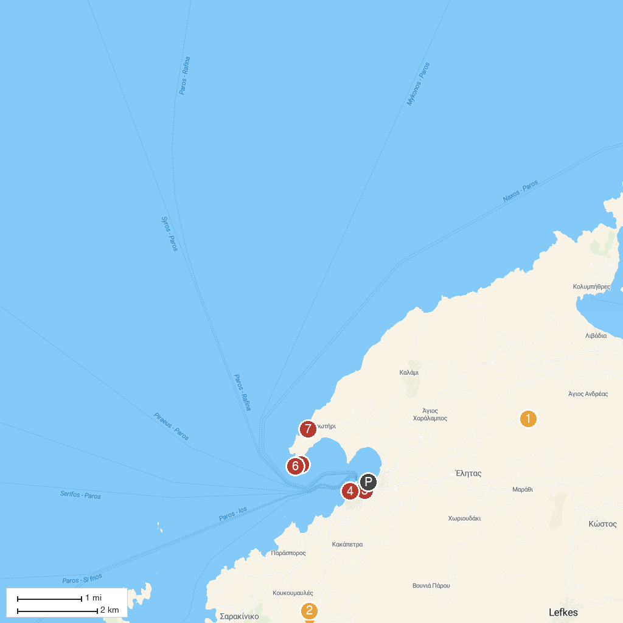
MAP KEY
1. Monastery Logovarda | 5. Church of Agios Fokas
2. Rofos Boat trip to turquoise water | 6. Agios Fokas Lighthouse
3. Holy Shrine of the Virgin Mary Ekatontapyliani | 7. Cave of Archilochos
4. Frankish Castle Paroikia
P. Cruise port / terminal
Map © MapTiler © OpenStreetMap contributors · cruiseports.org

