Patmos Island, Dodecanese, Greece
The 'Island of the Apocalypse' rises above the Aegean in medieval whitewash and stone — a UNESCO-crowned island where Saint John wrote the Book of Revelation, and where the mood is deliberately, beautifully quiet.
⚓ Mostly tender (small ships may dock) · 🕒 Typical call: 6–8 hrs · 💶 Euro · 🗣️ Greek (English widely spoken) · 🏛️ UNESCO World Heritage Site
✍️ MY DAY IN PORT (FILL IN)
Ship / Date
In port | arrive ______ · all aboard ______
Booked excursion
Notes / meeting point
GETTING ASHORE
- Docking: Tender to Skala port for most cruise ships; small vessels may dock at Skala pier
- Walk to center: Tender drops you in the center of Skala — shops and cafés immediate
- Best For: History, pilgrimage, medieval architecture, low-key Aegean beaches
- Don't Miss: Cave of the Apocalypse + Monastery of St. John — go early before afternoon closure
GETTING AROUND
- 🚕 Taxi: — Taxis wait near the port; the ride to Chora takes about 15 minutes. Note that only around 12 taxis serve the whole islan
- 📱 Rideshare: ❌ not available
TOP THINGS TO DO
- Cave of the Apocalypse & Monastery of St. John — Visit the sacred grotto where Saint John received his visions (~€4 entry), then continue uphill to the 11th-century fortress…
- Chora Medieval Village Walk — The hilltop capital is a labyrinth of whitewashed alleys, high stone walls, and hidden squares built to repel pirate raids.
- Kampos Beach Day — The island's most popular organized beach, 5.5 km from Skala, with shallow calm water, sunbeds, water sports, and a good taverna.
- ATV Island Loop — Rent an ATV from the waterfront and explore Patmos on your own terms — Chora, the windmills, Petra Beach with its volcanic…
- Island-Hopping Boat Trip — Local operators offer day trips from Skala to nearby uninhabited islets — Arki and Marathi — with pristine beaches and turquoise…
BEST WALKS
- Skala Waterfront Stroll: 1 km · Easy · 15 min — A flat waterfront loop through Skala — cafés, shops, the small church of Agia Paraskevi, and views…
- Byzantine Path: Chora to Skala: 3.5 km · Moderate downhill · 45–60 min — Take a taxi or bus up to Chora, then walk the ancient cobblestone path downhill.
- Walk to Meloi Beach: 1.5 km · Easy · 20 min — Head north from the port along a flat coastal path to Meloi Beach — a quiet, narrow strip shaded by…
WEATHER · DAYLIGHT · MONEY
Month | High °F | Low °F | Rainy days
May | 79 | 60 | 3
Jul | 95 | 73 | 1
Sep | 86 | 67 | 3
Daylight: May 6:21AM–8:30PM · Jul 6:22AM–8:48PM · Sep 7:11AM–7:36PM
cruiseports.org/patmos-island · Confirm terminal & all-aboard time with your ship

Patmos Island, Dodecanese, Greece — Port Map
Red = walkable sights · Amber = excursions farther out · P = cruise terminal
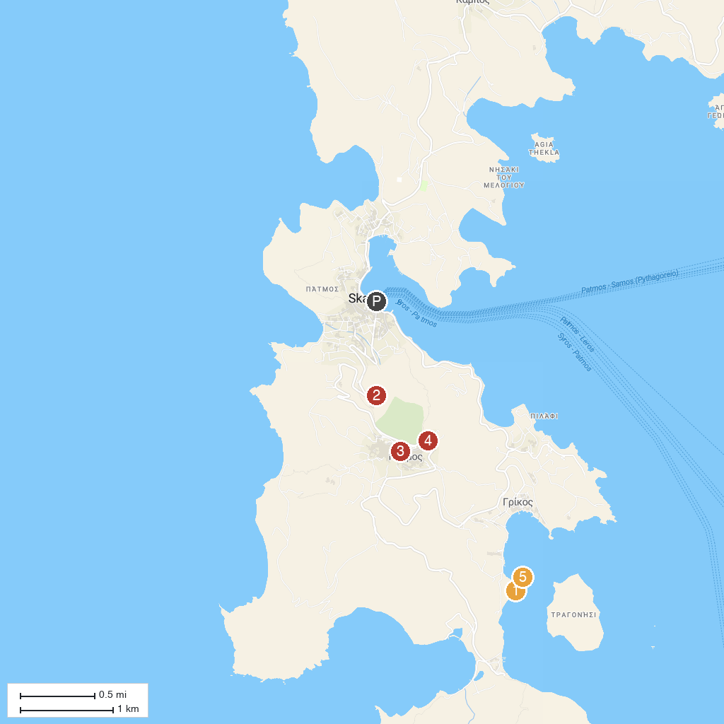
MAP KEY
1. Petra Beach | 4. Windmills of Patmos
2. Holy Cave of the Apocalypse | 5. Rock of Kalikatsou
3. Holy Monastery of Saint John the Theologian
P. Cruise port / terminal
Map © MapTiler © OpenStreetMap contributors · cruiseports.org

