Pauillac, Médoc, France
The Gironde sweeps you into the heart of Bordeaux wine country, where three of the world's five First Growth châteaux sit just minutes from the quay. Pauillac is small, unhurried, and completely extraordinary for anyone who cares about wine.
⚓ Pier (new 2024 terminal) or tender for larger ships · 🕒 Typical call: 8–10 hrs · 💶 Currency: Euro · 🗣️ Language: French · 🍷 Wine destination
✍️ MY DAY IN PORT (FILL IN)
Ship / Date
In port | arrive ______ · all aboard ______
Booked excursion
Notes / meeting point
GETTING ASHORE
- Docking: Pauillac-Trompeloup pier (opened 2024, up to 320 m vessels); very large ships may tender to central Quai Léon Perrier
- Walk to centre: ~20 min walk or short taxi/shuttle from the new pier; tender dock is right in town
- Best For: Wine lovers, château visits, Bordeaux day trips, cyclists
- Don't Miss: Village de Bages — a beautifully restored wine hamlet with bakery, bistro, and bike hire
GETTING AROUND
- 🚕 Taxi: €10–€20 (local) — Taxis typically meet ships on arrival. Short rides around Pauillac are inexpensive; transfers to Bordeaux run €80–€120+
- 📱 Rideshare: ✅ Uber
TOP THINGS TO DO
- Route des Châteaux by Bike — Hire an e-bike from Village de Bages or the tourist office and pedal the flat D2 road past Pichon Baron, Pichon Longueville…
- Grand Cru Château Tour & Tasting — Pre-booked visits to Château Lynch-Bages, Mouton Rothschild (with its famous artist-label museum), or Château Pichon Baron open…
- Bordeaux City Day Trip — A 50 km drive or one-hour train ride delivers you into a UNESCO World Heritage city.
- Citadel of Blaye by Ferry — A short ferry across the Gironde reaches Blaye's massive 17th-century Vauban fortification — a UNESCO monument with views back…
- Pauillac Lamb & Wine Lunch — Pauillac AOC lamb (milk-fed, extraordinarily tender) paired with a Médoc Cru Classé is one of France's great regional meals.
BEST WALKS
- Waterfront Promenade to Village de Bages: 4 km round-trip · flat · ~1 hr · easy — Head south along the riverfront quay past the Lafayette monument (commemorating the Marquis de…
- Town Centre Stroll: 1–2 km · 30 min · very easy — From the quay walk a few blocks inland to the Église Saint-Martin, a 19th-century neo-classical…
WEATHER · DAYLIGHT · MONEY
Month | High °F | Low °F | Rainy days
May | 69 | 53 | 11
Jul | 79 | 63 | 7
Sep | 75 | 59 | 8
Daylight: May 6:33AM–9:25PM · Jul 6:30AM–9:47PM · Sep 7:41AM–8:13PM
cruiseports.org/pauillac · Confirm terminal & all-aboard time with your ship

Pauillac, Médoc, France — Port Map
Red = walkable sights · Amber = excursions farther out · P = cruise terminal
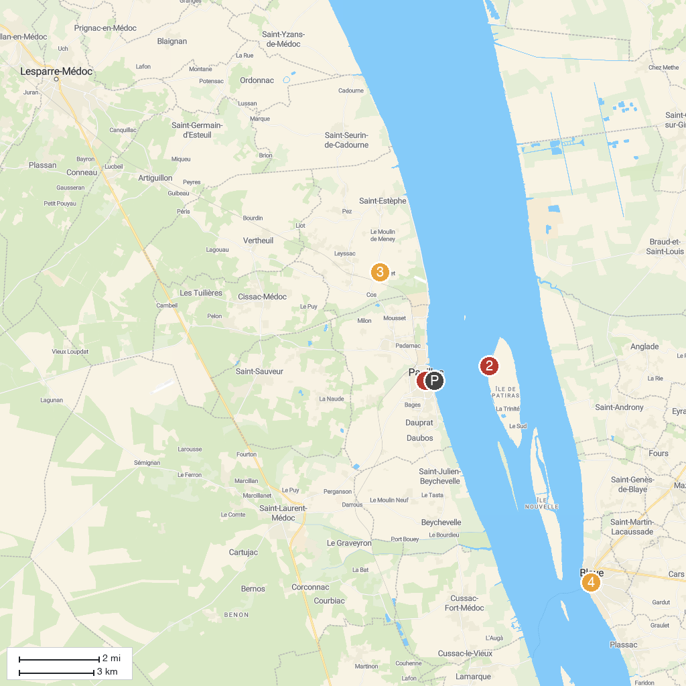
MAP KEY
1. Église Saint-Martin | 4. Villa Gallo Romaine de Plassac
2. Lighthouse Patiras | 5. Pole-nature Vitrezay
3. Château Le Crock | 6. Tourist Office of Blaye
P. Cruise port / terminal
Map © MapTiler © OpenStreetMap contributors · cruiseports.org

