Peenemünde, Usedom, Germany
A quiet harbor village hiding one of the 20th century's most consequential secrets — where the V-2 rocket was born, and modern spaceflight began in darkness.
⚓ Pier (direct dock) · 🚢 Small–medium ships only · 🕒 Typical call: 6–8 hrs · 💶 Currency: Euro (€) · 🗣️ Language: German
✍️ MY DAY IN PORT (FILL IN)
Ship / Date
In port | arrive ______ · all aboard ______
Booked excursion
Notes / meeting point
GETTING ASHORE
- Docking: Pier — ships dock directly at Hafen Peenemünde; no tender needed
- Walk to center: Museum 5–10 min walk; submarine 2 min from gangway
- Best For: WWII history buffs, Cold War enthusiasts, Baltic island exploration
- Don't Miss: Historical Technical Museum (V-2 rocket hall) and the Soviet U-461 submarine
GETTING AROUND
- 🚕 Taxi: ~€7–€20 — Local taxi firms serve the Usedom area (e.g., Usedom.Taxi based in Zinnowitz). Short in-village trips run roughly €7; lo
- 📱 Rideshare: ❌ not available
TOP THINGS TO DO
- V-2 Rocket Museum (HTM Peenemünde) — The headline attraction: the Historisch-Technisches Museum occupies the former WWII power station that fueled the rocket program.
- U-461 Soviet Submarine Museum — A Juliett-class Soviet ballistic-missile submarine — the largest conventional sub in the world — sits in the harbor and is open…
- Karlshagen Beach by Train — Usedom is home to some of Germany's finest Baltic beaches.
- Zinnowitz Seaside Resort — Hop the train south to Zinnowitz, a graceful 19th-century Seebad (seaside resort) with ornate beach villas and a famous pleasure…
- Bicycle Ride on the Baltic Bike Path — Rent a bike at the harbor and explore the flat Usedom coastal path.
BEST WALKS
- Harbor to History Walk: 1.5 km · 20 min · Flat & paved — A simple linear walk from the pier through the harbor waterfront to the Historical Technical Museum.
WEATHER · DAYLIGHT · MONEY
Month | High °F | Low °F | Rainy days
May | 60 | 49 | 10
Jul | 71 | 60 | 13
Sep | 65 | 56 | 10
Daylight: May 5:01AM–9:02PM · Jul 4:51AM–9:29PM · Sep 6:38AM–7:20PM
cruiseports.org/peenemunde-usedom · Confirm terminal & all-aboard time with your ship

Peenemünde, Usedom, Germany — Port Map
Red = walkable sights · Amber = excursions farther out · P = cruise terminal
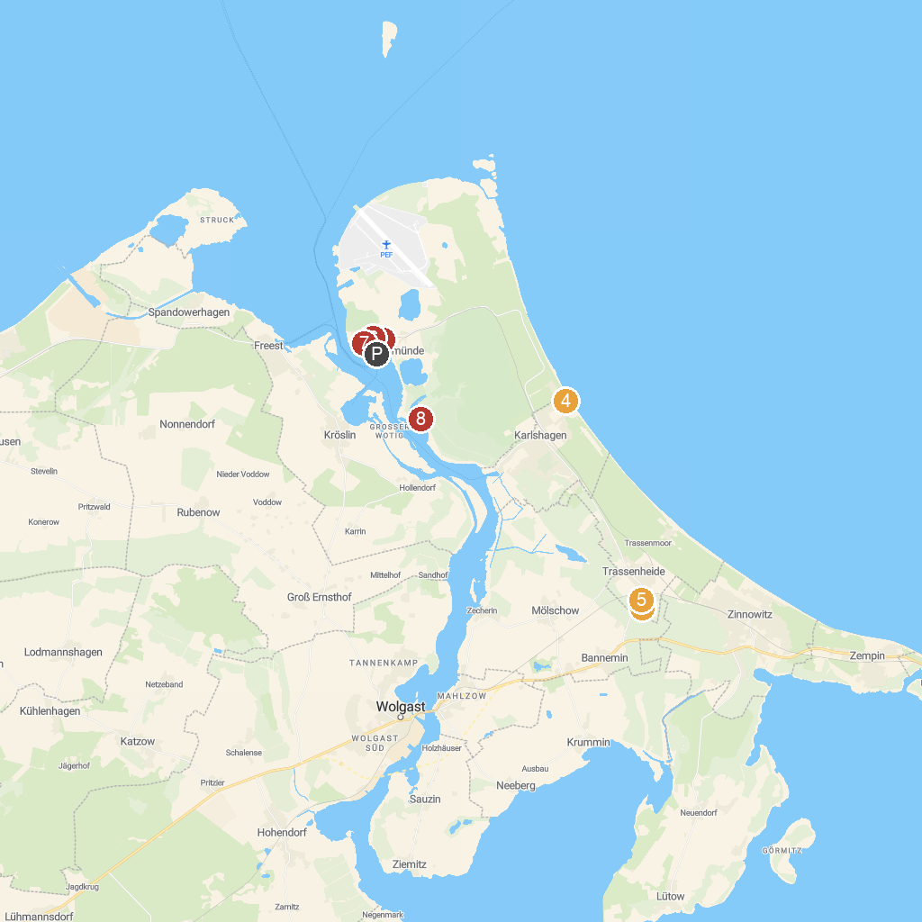
MAP KEY
1. Historical Technical Museum, Peenemünde | 5. Kinderland Trassenheide
2. The world is upside down | 6. Kraftwerk Peenemünde
3. Maritim Museum Peenemünde U-461 | 7. Museum ship Hans Beimler
4. Naturschutzzentrum Insel Usedom | 8. Station 16 - The bunkers in the Peene meadows
P. Cruise port / terminal
Map © MapTiler © OpenStreetMap contributors · cruiseports.org

