Penang (Georgetown), Malaysia
A UNESCO World Heritage city served straight off the ship — Georgetown's colonial streets are alive with iron-rod murals, Hokkien clan houses, and some of the best street food in Southeast Asia.
⚓ Docked (Swettenham Pier, Georgetown) · 🕒 Typical call: 8–10 hrs · 💵 Malaysian Ringgit (MYR) · 🗣️ Malay · English · Hokkien
✍️ MY DAY IN PORT (FILL IN)
Ship / Date
In port | arrive ______ · all aboard ______
Booked excursion
Notes / meeting point
GETTING ASHORE
- Docking: Swettenham Pier, Georgetown
- Walk to center: 5–10 min on foot
- Best For: Street food · Heritage · Street art
- Don't Miss: Chew Jetty & Boy on a Bicycle mural
GETTING AROUND
- 🚕 Taxi: RM 9–12 (~USD 2–3) — Taxis queue directly outside the terminal. Agree on a fare before boarding — most drivers quote fixed rates rather than
- 📱 Rideshare: ✅ Grab
- 🚌 Hop-on hop-off: ✅
TOP THINGS TO DO
- Georgetown Street Art & Clan Jetties — Hunt down Ernest Zacharevic's famous murals — 'Boy on a Bicycle', 'Children on a Longboat' — then walk the century-old Chew…
- Khoo Kongsi & Heritage Quarter — The lavishly restored Khoo Kongsi clan house — one of the grandest in Malaysia — anchors a dense historic quarter of shophouses…
- Kek Lok Si Temple & Penang Hill — Kek Lok Si is one of the largest Buddhist temples in Southeast Asia, with a towering pagoda and a bronze Goddess of Mercy statue.
- Penang Hawker Food Tour — Penang is Malaysia's hawker-food capital.
- Tropical Spice Garden — A beautifully landscaped hillside garden on the northwest coast showcasing over 500 tropical spice and herb plants, with guided…
BEST WALKS
- Street Art & Clan Jetty Loop: ~4 km · 2–2.5 hrs · easy — From the pier, walk to the waterfront Chew Jetty clan village, then loop through the UNESCO core…
- Little India & Kapitan Keling: ~2 km · 1–1.5 hrs · easy — A short sensory loop through Penang's Little India — garland sellers, banana-leaf restaurants, sari…
- Cheong Fatt Tze Blue Mansion: ~1.5 km · 45 min · easy — A short walk from the pier to the meticulously restored Blue Mansion — a Qing-dynasty indigo…
WEATHER · DAYLIGHT · MONEY
Month | High °F | Low °F | Rainy days
May | 83 | 76 | 29
Jul | 83 | 76 | 29
Sep | 86 | 78 | 20
Daylight: May 7:04AM–7:25PM · Jul 7:12AM–7:36PM · Sep 7:09AM–7:18PM
Representative sunrise/sunset — 2025, 15th of each month; local civil time including DST (Asia/Kuala_Lumpur). Source: Astral; not a forecast or climate average.
cruiseports.org/penang · Confirm terminal & all-aboard time with your ship

Penang (Georgetown), Malaysia — Port Map
Red = walkable sights · Amber = excursions farther out · P = cruise terminal
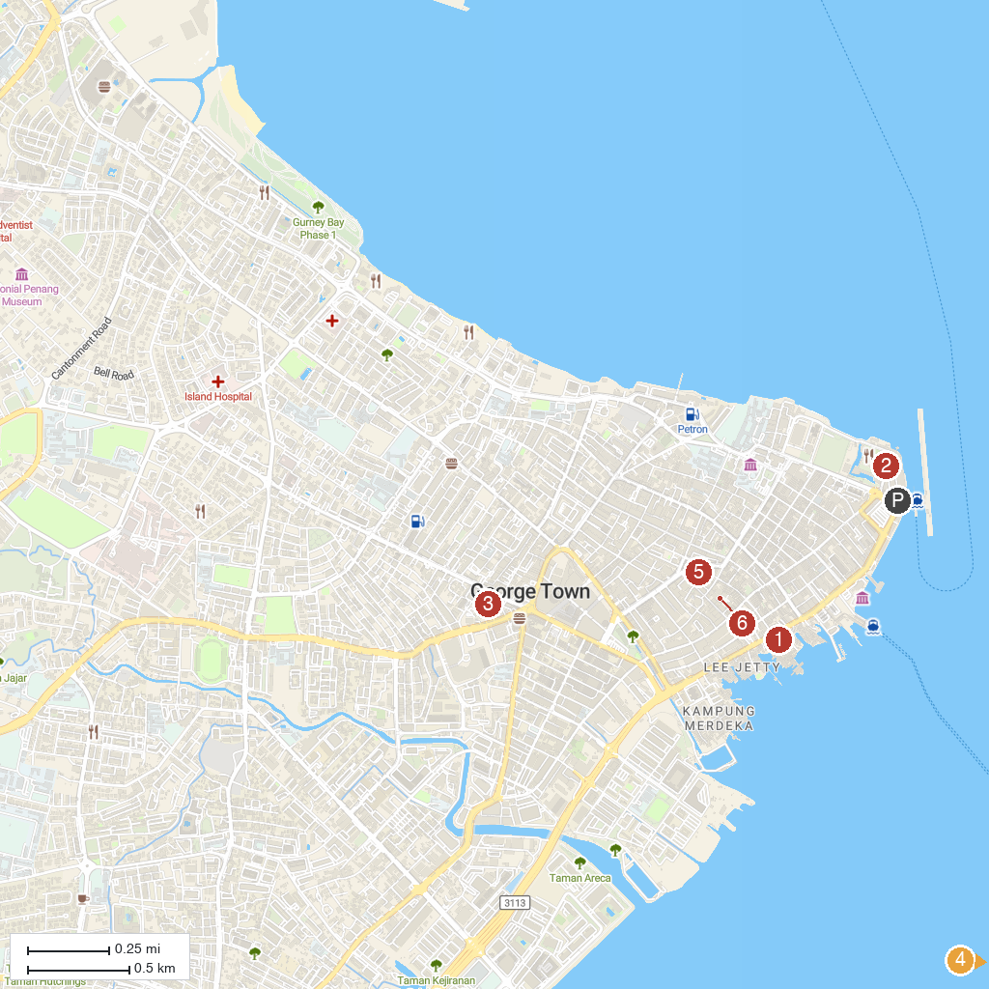
MAP KEY
1. Penang Snake Temple | 5. Penang Bird Park
2. Chew Jetty | 6. Sun Yat Sen Museum Penang
3. Fort Cornwallis | 7. Explore Balik Pulau
4. Church of Our Lady Of Sorrows (1888) | 8. Leong San Tong Khoo Kongsi
P. Cruise port / terminal
Map © MapTiler © OpenStreetMap contributors · cruiseports.org

