Pensacola, Florida, USA
Where five empires once planted their flags, Pensacola today offers Navy legends, impossibly white quartz sand beaches, and Gulf Coast seafood straight off the boat.
⚓ Pier (walk-off dock) · 🕒 Typical call: 7-9 hrs · 💵 USD · 🗣️ English · 🏖️ Beach shuttle needed
✍️ MY DAY IN PORT (FILL IN)
Ship / Date
In port | arrive ______ · all aboard ______
Booked excursion
Notes / meeting point
GETTING ASHORE
- Docking: Pier — walk off at Plaza de Luna downtown
- Walk to center: 5 min to waterfront; 15 min to Palafox St
- Best For: Naval aviation history, Gulf beaches, Southern seafood
- Don't Miss: National Naval Aviation Museum & Grits à Ya Ya at The Fish House
GETTING AROUND
- 🚕 Taxi: $10–15 — Taxis are available at the port. Short rides to downtown or the historic district typically run $10–15; confirm rate bef
- 📱 Rideshare: ✅ Uber, Lyft
- 🚌 Hop-on hop-off: ✅ Go Retro
TOP THINGS TO DO
- National Naval Aviation Museum — One of the largest aviation museums in the world, with 150+ restored aircraft including the Blue Angels' famous diamond formation…
- Pensacola Beach Day — Head across the bridge to Santa Rosa Island for some of the whitest, softest sand in the USA — pure quartz that squeaks underfoot.
- Fort Pickens & Gulf Islands National Seashore — A massive 19th-century brick fort on the tip of Santa Rosa Island that once held Apache leader Geronimo.
- Historic Pensacola Village — One ticket covers several museums in the Seville Historic District, including the T.T.
- Gulf Coast Seafood & Palafox Street — Walk Palafox Street, one of America's great main streets, then settle in at The Fish House or Atlas Oyster House for Royal Red…
BEST WALKS
- Waterfront to Palafox Street Loop: 1.5 miles · 30-40 min · Flat · Easy — From Plaza de Luna, walk north along the waterfront past the Maritime Park, then up to Palafox…
WEATHER · DAYLIGHT · MONEY
Month | High °F | Low °F | Rainy days
May | 80 | 68 | 11
Jul | 86 | 77 | 21
Sep | 84 | 74 | 14
Daylight: May 5:54AM–7:36PM · Jul 5:57AM–7:52PM · Sep 6:33AM–6:53PM
cruiseports.org/pensacola-fl · Confirm terminal & all-aboard time with your ship

Pensacola, Florida, USA — Port Map
Red = walkable sights · Amber = excursions farther out · P = cruise terminal
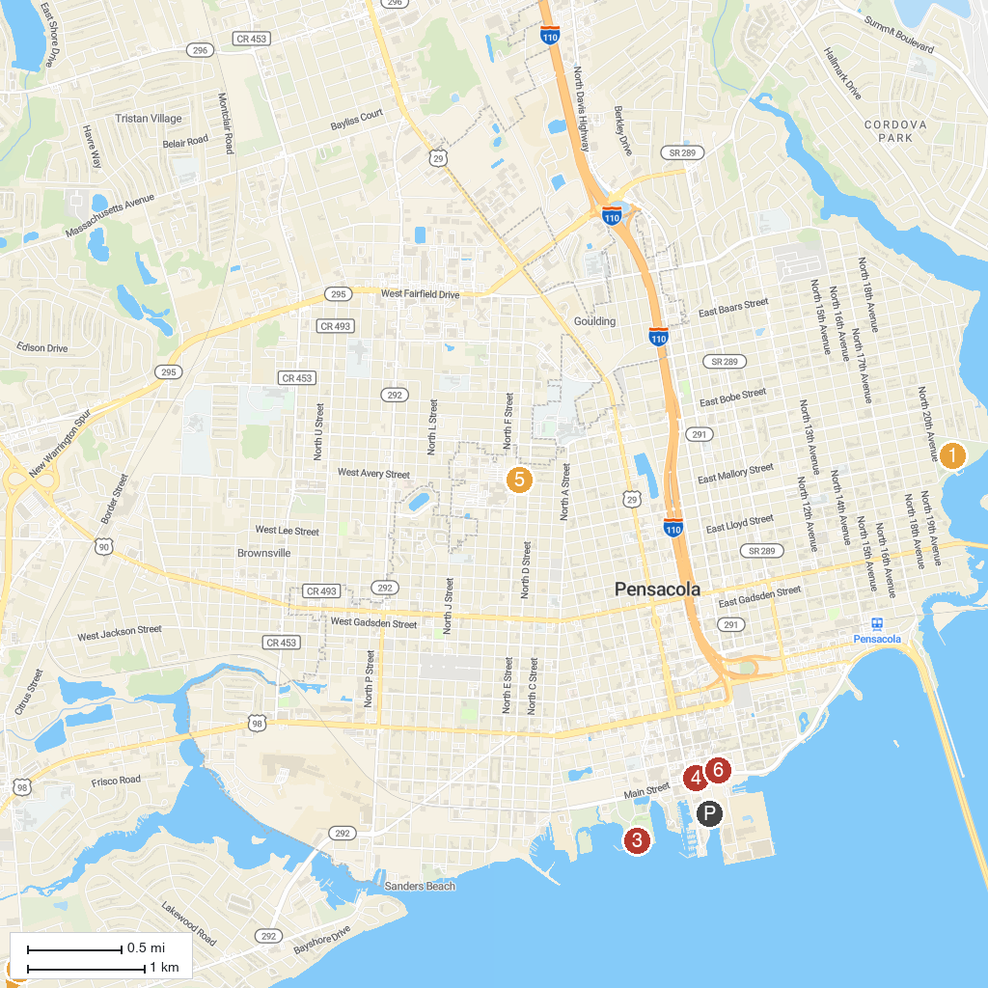
MAP KEY
1. Fort Pickens | 5. Vince J. Whibbs Sr. Community Maritime Park
2. Bayview Park | 6. Pensacola Museum of Art
3. Historic Fort Barrancas | 7. Go Retro
4. Pensacola Lighthouse & Maritime Museum | 8. Museum of Commerce
P. Cruise port / terminal
Map © MapTiler © OpenStreetMap contributors · cruiseports.org

