Philadelphia, Pennsylvania, USA
The birthplace of American democracy packs more history per square mile than almost any city on earth. One day here means cobblestone streets older than the nation, a world-class food hall, and a bronze Rocky Balboa waiting for your selfie.
⚓ Pier (direct dock) · 🕒 Typical call: 8–10 hrs · 💵 US Dollar · 🗣️ English · 🏛️ UNESCO World Heritage City
✍️ MY DAY IN PORT (FILL IN)
Ship / Date
In port | arrive ______ · all aboard ______
Booked excursion
Notes / meeting point
GETTING ASHORE
- Docking: Pier — ships dock at PhilaPort Cruise Terminal (new 2026) or Penn's Landing; no tendering
- Walk to center: Not walkable from the airport-area PhilaPort terminal; 10–15 min walk or ride-share from Penn's Landing if your ship docks downtown
- Best For: American history buffs, foodies, art lovers, families
- Don't Miss: Liberty Bell + Independence Hall back-to-back, then Reading Terminal Market for lunch
GETTING AROUND
- 🚕 Taxi: $20–25 — Taxis available at the Navy Yard cruise terminal. Metered fare to Center City (~5–6 miles); expect $20–25 depending on t
- 📱 Rideshare: ✅ Uber, Lyft
- 🚌 Hop-on hop-off: ✅
TOP THINGS TO DO
- Independence Hall & Liberty Bell — The room where the Declaration of Independence was signed followed by America's most iconic artifact, just a block apart.
- Reading Terminal Market — Operating since 1893, this indoor market under the old Reading Railroad headhouse has 80+ vendors — Amish bakers, DiNic's roast…
- Rocky Steps & Philadelphia Museum of Art — Run up the 72 stone steps at the PMA just like Rocky Balboa, snap a photo with the bronze statue, then step inside for one of…
- Museum of the American Revolution — A modern, immersive museum just steps from Independence Hall telling the full story of the Revolutionary War — including…
- Eastern State Penitentiary — Al Capone was housed here.
BEST WALKS
- Independence Mall to Penn's Landing: 1.5 miles · 30–40 min · Flat · Historic — Start at the Liberty Bell Center, walk one block to Independence Hall, then head east on Chestnut…
- Benjamin Franklin Parkway Cultural Walk: 1 mile · 20 min one-way · Broad avenue · Grand — Walk the grand diagonal boulevard from LOVE Park (Logan Square) past the Barnes Foundation and…
WEATHER · DAYLIGHT · MONEY
Month | High °F | Low °F | Rainy days
May | 73 | 54 | 12
Jul | 87 | 70 | 14
Sep | 79 | 62 | 10
Daylight: May 5:45AM–8:09PM · Jul 5:45AM–8:27PM · Sep 6:42AM–7:08PM
cruiseports.org/philadelphia · Confirm terminal & all-aboard time with your ship

Philadelphia, Pennsylvania, USA — Port Map
Red = walkable sights · Amber = excursions farther out · P = cruise terminal
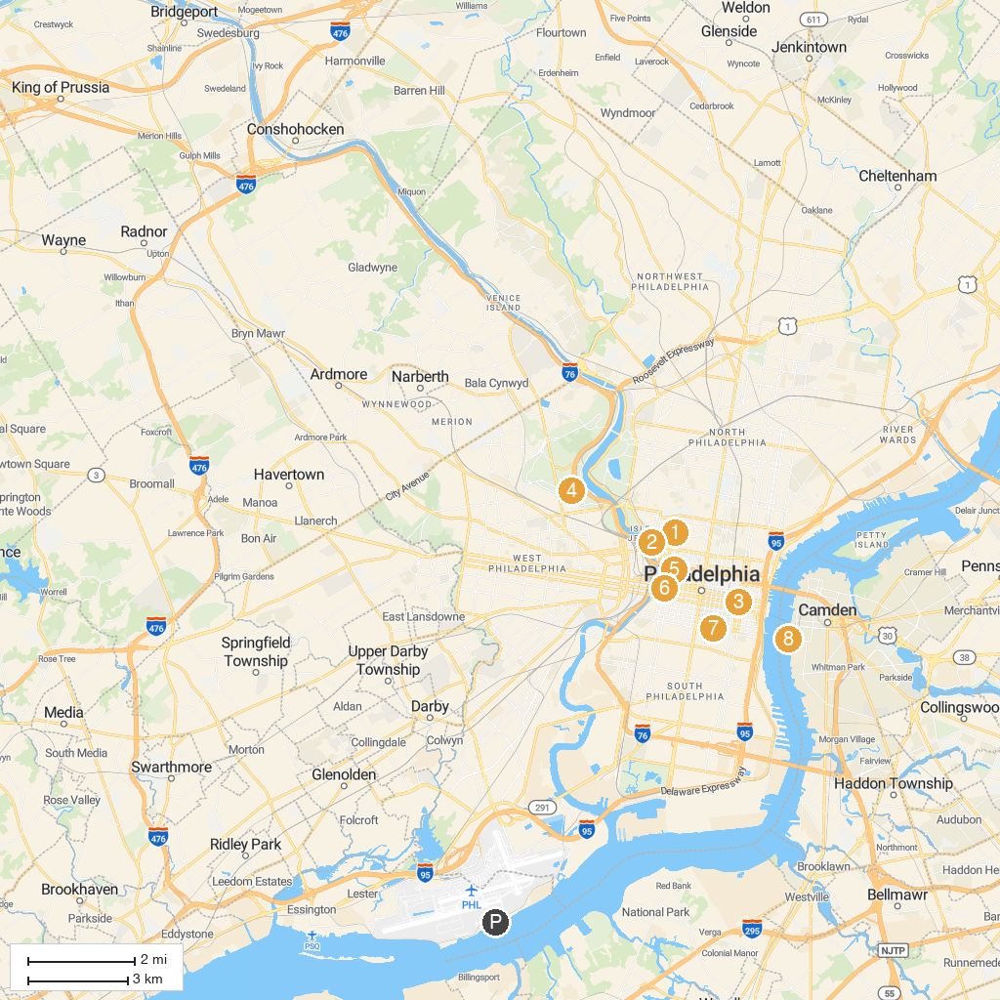
MAP KEY
1. Eastern State Penitentiary | 5. The Franklin Institute
2. Philadelphia Museum of Art | 6. The Mütter Museum at The College of Physicians of Philadelphia
3. Liberty Bell | 7. Philadelphia's Magic Gardens
4. Please Touch Museum | 8. Battleship New Jersey Museum & Memorial
P. Cruise port / terminal
Map © MapTiler © OpenStreetMap contributors · cruiseports.org

