Phuket, Thailand
Thailand's largest island rides the jade Andaman Sea — ancient Sino-Portuguese shophouses, a golden Buddha gazing from the hills, limestone karsts jutting from Phang Nga Bay, and beaches that live up to every postcard.
⚓ Tender port (ships anchor off Patong/Phuket) · 🕒 Typical call: 8–10 hrs · 💵 Thai Baht (THB) · 🗣️ Thai
✍️ MY DAY IN PORT (FILL IN)
Ship / Date
In port | arrive ______ · all aboard ______
Booked excursion
Notes / meeting point
GETTING ASHORE
- Docking: Tender — anchor in Patong Bay or off Phuket
- Tender to beach: ~10–15 min; swell-dependent
- Best For: Temples · Old Town · Phang Nga Bay
- Don't Miss: Big Buddha & Phang Nga Bay
GETTING AROUND
- 🚕 Taxi: 500–900 THB (–) — Taxis from Phuket Deep Sea Port (Ao Makarm) charge fixed fares: ~500 THB to Phuket Town (20 min) and ~900 THB to Patong
- 📱 Rideshare: ✅ Grab, Bolt
TOP THINGS TO DO
- Phang Nga Bay & James Bond Island — Limestone karsts erupt from emerald water in one of Asia's most iconic seascapes.
- Old Phuket Town & Thalang Road — The historic core is lined with 19th-century Sino-Portuguese shophouses painted in blues, pinks, and greens — a legacy of the…
- Big Buddha (Ming Mongkol) & Wat Chalong — The 45-metre white marble Big Buddha sits atop Nakkerd Hill with panoramic island views — visible from the sea on arrival.
- Ko Phi Islands — Ko Phi Don and the iconic cliffs of Ko Phi Leh (Maya Bay of The Beach fame) are a speedboat day trip from Phuket — about 45…
- Ethical Elephant Sanctuary — Several sanctuaries north of Phuket Town offer no-riding, walk-with-and-feed experiences with rescued elephants in natural…
BEST WALKS
- Old Phuket Town heritage loop: ~2.5 km · 1.5–2 hrs · easy — A slow wander through the Sino-Portuguese shophouse streets: Thalang Road for cafés and murals, Soi…
- Patong Beach promenade: ~2 km · 45 min · easy — A flat stroll along the Patong beachfront from the tender pier area south along the sand and beach…
WEATHER · DAYLIGHT · MONEY
Month | High °F | Low °F | Rainy days
May | 86 | 79 | 26
Jul | 85 | 78 | 22
Sep | 84 | 77 | 24
Daylight: May 6:08AM–6:37PM · Jul 6:16AM–6:48PM · Sep 6:16AM–6:26PM
cruiseports.org/phuket · Confirm terminal & all-aboard time with your ship

Phuket, Thailand — Port Map
Red = walkable sights · Amber = excursions farther out · P = cruise terminal
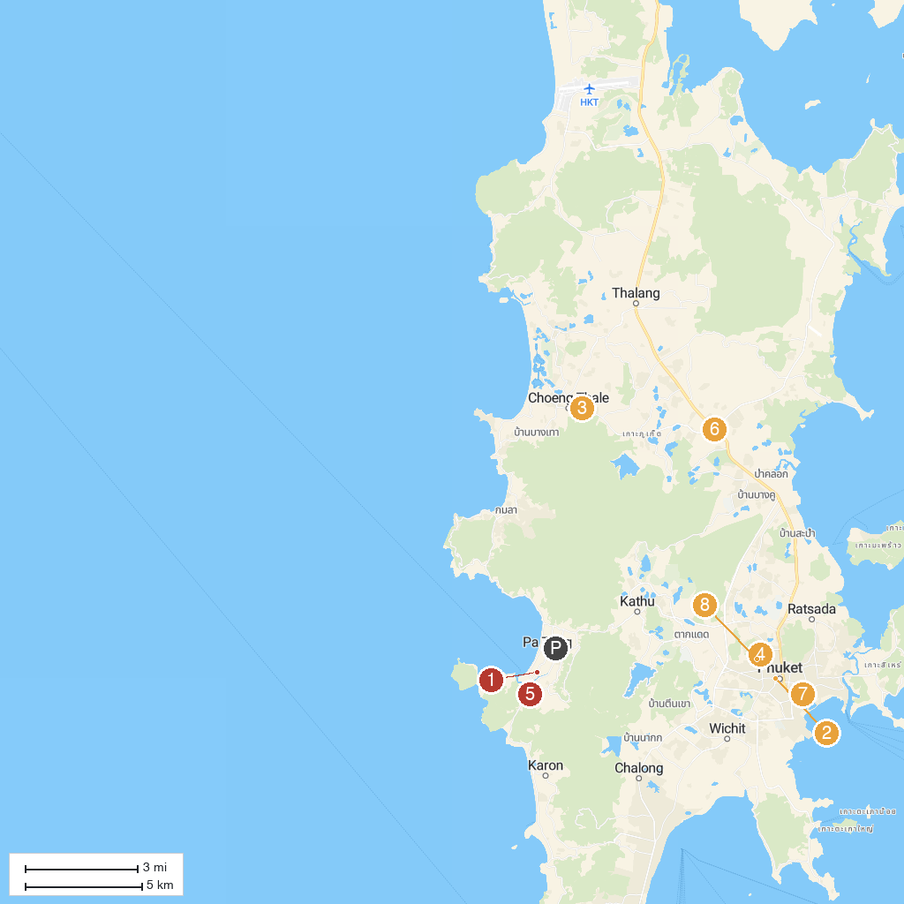
MAP KEY
1. OTOP Market | 5. Simon Cabaret Phuket
2. Phuket Old Town | 6. Thao Thep Krasattri and Thao Si Sunthon Monument
3. Wat Choeng Thale | 7. Nimit Roundabout
4. Wat Khao Rang Samakkhitham | 8. Khao Rang Viewpoint
P. Cruise port / terminal
Map © MapTiler © OpenStreetMap contributors · cruiseports.org

