Picton, Marlborough, New Zealand
Your ship weaves through the glassy fjords of the Queen Charlotte Sound before tying up in one of New Zealand's most scenic small towns. Wine country, birdlife, and stunning coastal walks are all within a short drive — or a water taxi.
⚓ Pier (Waitohi or Waimahara Wharf) · 🕒 Typical call: 7-10 hrs · 💵 NZD (cards accepted everywhere) · 🗣️ English · 🍷 Marlborough wine country
✍️ MY DAY IN PORT (FILL IN)
Ship / Date
In port | arrive ______ · all aboard ______
Booked excursion
Notes / meeting point
GETTING ASHORE
- Docking: Pier — Waitohi Wharf (central) or Waimahara Wharf (Shakespeare Bay, shuttle provided)
- Walk to Centre: 0-5 min from Waitohi Wharf; ~10 min shuttle + walk from Waimahara
- Best For: Scenic Sound cruises, Marlborough wine tours, coastal walks, wildlife
- Don't Miss: The sail-in through Queen Charlotte Sound — be on deck early
GETTING AROUND
- 🚕 Taxi: NZD 8–20 — Local taxis are available but limited in number. Base fare ~NZD 4 plus ~NZD 3/km; short ride to town center is inexpensi
TOP THINGS TO DO
- Queen Charlotte Sound Scenic Cruise — Glide through the deep, bush-fringed bays and coves of Queen Charlotte Sound with commentary on wildlife and history.
- Marlborough Wine & Sauvignon Blanc Tour — Picton is the gateway to Marlborough — New Zealand's most celebrated wine region.
- Motuara Island Bird Sanctuary — A water taxi takes you to this predator-free island sanctuary where you can spot South Island robin, saddleback, and the…
- Edwin Fox Maritime Museum — See the Edwin Fox — one of the world's oldest surviving merchant sailing ships (built 1853) and the only surviving vessel that…
- Queen Charlotte Track Day Walk — Water taxis drop you at Ship Cove (Meretoto) — Captain Cook's favourite New Zealand anchorage — for a guided or self-guided day…
BEST WALKS
- Foreshore Promenade & Town Stroll: 1-2 km • 20-30 min • Flat • Free — Walk the picturesque waterfront from the cruise wharf along the marina to Picton town centre.
- Bob's Bay Track: 2 km return • 45 min • Easy-moderate • Free — A short but rewarding bush walk from Picton town to secluded Bob's Bay — a quiet, sheltered cove…
- Harbour Lookout Walk: 1.5 km return • 30 min • Moderate (uphill) • Free — A short uphill track from the town centre rewards you with wide views over Picton Harbour, the…
WEATHER · DAYLIGHT · MONEY
Month | High °F | Low °F | Rainy days
May | 60 | 49 | 9
Jul | 54 | 43 | 11
Sep | 57 | 46 | 12
Daylight: May 7:25AM–5:14PM · Jul 7:46AM–5:13PM · Sep 6:26AM–6:13PM
cruiseports.org/picton · Confirm terminal & all-aboard time with your ship

Picton, Marlborough, New Zealand — Port Map
Red = walkable sights · Amber = excursions farther out · P = cruise terminal
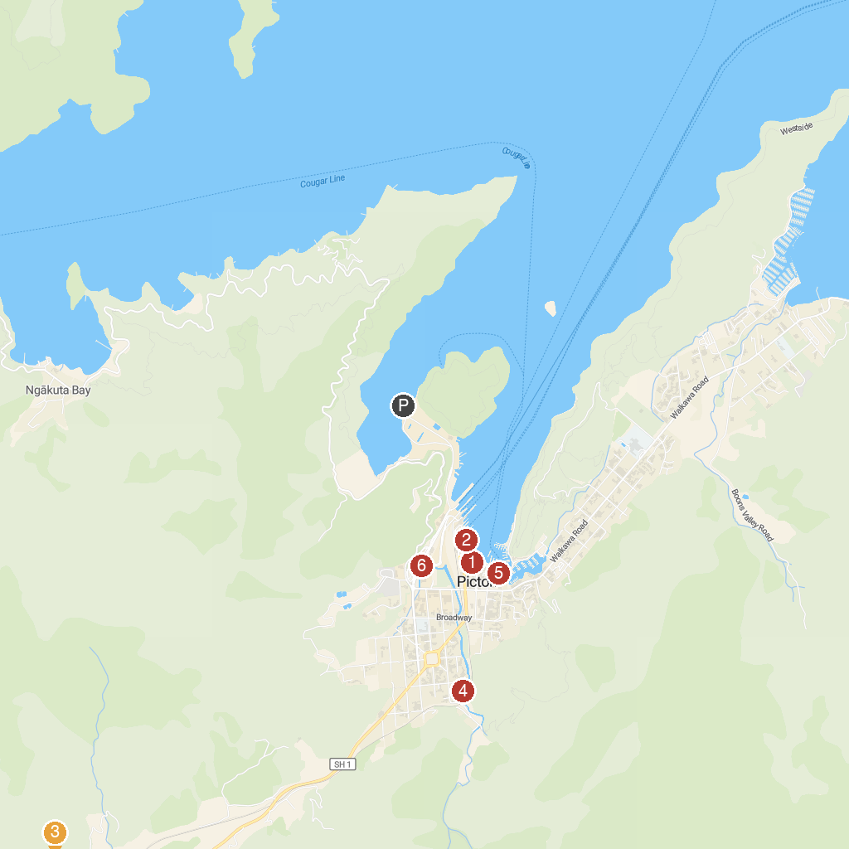
MAP KEY
1. Picton Heritage & Whaling Museum | 4. Alexanders Holiday Park
2. Edwin Fox Maritime Museum | 5. Seafood Odyssea Cruise
3. Collins Memorial Reserve | 6. Picton Interislander Vehicle Check-In
P. Cruise port / terminal
Map © MapTiler © OpenStreetMap contributors · cruiseports.org

