Pigeon Island, Saint Lucia, Caribbean
Once a pirate hideout and British naval stronghold, Pigeon Island packs centuries of Caribbean history into 44 acres of park, peaks, and powder-white beach.
⚓ Tender (anchor in Rodney Bay) or taxi from Castries · 🕒 Typical call: 6–8 hrs · 💵 USD & Eastern Caribbean Dollar · 🗣️ English
✍️ MY DAY IN PORT (FILL IN)
Ship / Date
In port | arrive ______ · all aboard ______
Booked excursion
Notes / meeting point
GETTING ASHORE
- Docking: Most ships dock at Castries (~12 mi away); small/luxury ships tender into Rodney Bay Marina
- Walk to park entrance: 5 min from Rodney Bay Marina; 30–45 min taxi from Castries
- Best For: History buffs, beach seekers, hikers, panoramic views
- Don't Miss: Climb Signal Peak for 360° views — on a clear day you can see Martinique
GETTING AROUND
- 🚕 Taxi: $10–$50 USD — Official taxis (TX plates) wait at the tender landing at Rodney Bay Marina. Fares are government-set: ~$10–20 to Gros Is
- 📱 Rideshare: ✅ Uber, Bolt, Tropicab
TOP THINGS TO DO
- Fort Rodney & the Interpretation Centre — Explore 18th-century British fortifications built by Admiral George Rodney.
- Signal Peak Hike — The island's highest point rewards a steep 30-minute climb with a 360-degree panorama over Rodney Bay, the northern St.
- Pigeon Island Beaches — Two sheltered white-sand beaches on the park's south side face the calm Caribbean Sea, making them ideal for swimming and…
- Sea Trek & SNUBA — Operators inside the park offer underwater helmet walks (Sea Trek) and SNUBA dives off the island's beaches, exploring artificial…
- Jambe de Bois Lunch — Named for pirate François le Clerc ("Jambe de Bois," or "Wooden Leg"), who used the island as a base to raid Spanish galleons in…
BEST WALKS
- Park Loop: Beaches to Fort Rodney: 1.5 km · 30 min · Easy — From the park entrance, follow the paved path to the beaches, then loop up to Fort Rodney's lower…
- Signal Peak Summit: 0.8 km one way · 30–40 min · Strenuous — Continue past Fort Rodney on a steep dirt and rock trail to Signal Peak.
WEATHER · DAYLIGHT · MONEY
Month | High °F | Low °F | Rainy days
May | 85 | 78 | 14
Jul | 85 | 78 | 24
Sep | 86 | 79 | 20
Daylight: May 5:36AM–6:23PM · Jul 5:43AM–6:36PM · Sep 5:52AM–6:05PM
cruiseports.org/pigeon-island · Confirm terminal & all-aboard time with your ship

Pigeon Island, Saint Lucia, Caribbean — Port Map
Red = walkable sights · Amber = excursions farther out · P = cruise terminal
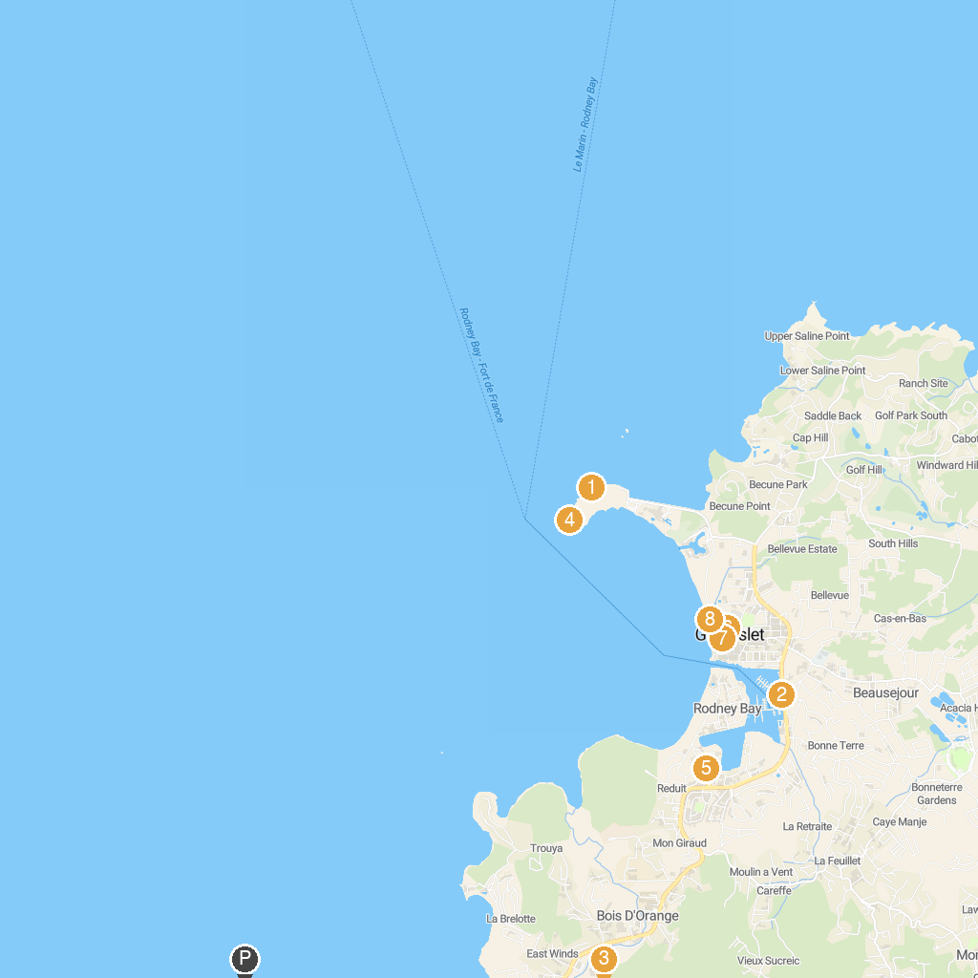
MAP KEY
1. Signal Peak | 5. Treasure Bay Casino
2. Sea Spray Cruises Ltd. | 6. St. Joseph The Worker Catholic Church
3. Lushan Country Life | 7. Friday Night Street Party
4. Fort Rodney | 8. Gros Islet Beach
P. Cruise port / terminal
Map © MapTiler © OpenStreetMap contributors · cruiseports.org

