Plymouth, Devon, England
Plymouth is where the Pilgrims set sail, Drake played bowls while the Armada approached, and the Royal Navy shaped empires. Today it's a walkable, spirited harbour city with free museums, a great aquarium, and one of England's oldest gin distilleries.
⚓ Tender (most ships) or pier at Millbay Docks · 🕒 Typical call: 7-9 hrs · 💷 British Pound (GBP) · 🗣️ English · 🏛️ Rich maritime history
✍️ MY DAY IN PORT (FILL IN)
Ship / Date
In port | arrive ______ · all aboard ______
Booked excursion
Notes / meeting point
GETTING ASHORE
- Docking: Tender to Barbican Landing Stage (most ships); smaller vessels dock at Millbay Docks
- Walk to center: Tender drops you directly at the Barbican; Millbay Docks is 15-20 min walk
- Best For: History, walking, seafood, gin tours, coastal views
- Don't Miss: Plymouth Hoe panorama, Mayflower Steps, The Box museum (free), Plymouth Gin Distillery
GETTING AROUND
- 🚕 Taxi: £13–£16 — Local metered taxis are readily available at the port. A short ride to Plymouth city centre or the train station costs r
- 📱 Rideshare: ✅ Uber
- 🚌 Hop-on hop-off: ✅ Plymouth Citybus — Ocean City Sights (Service 25)
TOP THINGS TO DO
- Barbican & Mayflower Steps Walk — Stroll the cobbled Tudor streets of the Barbican quarter, visit the Mayflower Steps where the Pilgrims departed in 1620, and…
- Plymouth Hoe & Smeaton's Tower — Walk up to Plymouth Hoe for sweeping views across Plymouth Sound, see Drake's famous bowling green, the Naval Memorial, and climb…
- Plymouth Gin Distillery Tour — Tour Black Friars Distillery — England's oldest working gin distillery, in a building dating to the 1400s.
- National Marine Aquarium — The UK's largest aquarium sits right at Sutton Harbour, a short walk from the Barbican.
- Mount Edgcumbe & Cawsand Ferry — Take the Cawsand Ferry from the Barbican across Plymouth Sound into Cornwall.
BEST WALKS
- Barbican to Plymouth Hoe Loop: 2.5 km | ~45 min | Easy-moderate — From the Barbican Landing Stage, walk the Mayflower Steps and Barbican cobbles, head up Hoe Road…
- Barbican to Royal William Yard (Coastal Path): 3 km | ~50 min | Easy — Walk west along the waterfront from the Barbican, past Millbay, to the magnificent Royal William…
WEATHER · DAYLIGHT · MONEY
Month | High °F | Low °F | Rainy days
May | 60 | 49 | 13
Jul | 68 | 58 | 13
Sep | 64 | 55 | 12
Daylight: May 5:29AM–8:57PM · Jul 5:22AM–9:21PM · Sep 6:52AM–7:29PM
cruiseports.org/plymouth-uk · Confirm terminal & all-aboard time with your ship

Plymouth, Devon, England — Port Map
Red = walkable sights · Amber = excursions farther out · P = cruise terminal
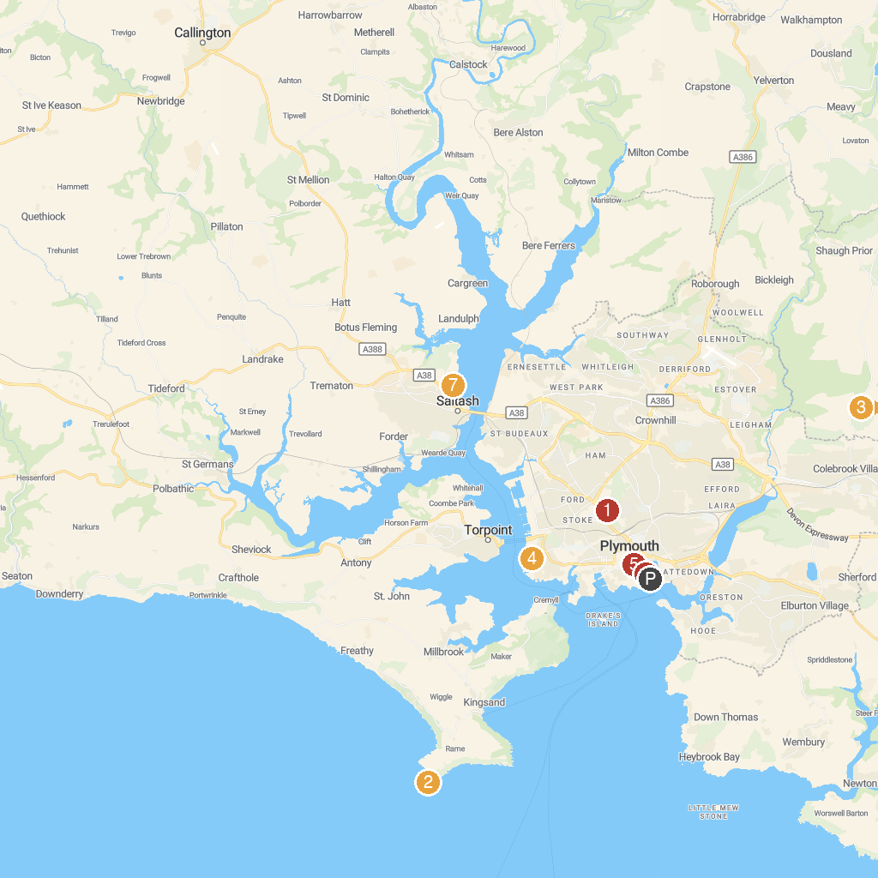
MAP KEY
1. Central Park | 5. Devonport Naval Heritage Centre
2. St Michael's Chapel | 6. Plymouth Synagogue
3. National Trust - Buckland Abbey | 7. Elizabethan Gardens
4. Dartmoor Zoo | 8. Saltmill Park
P. Cruise port / terminal
Map © MapTiler © OpenStreetMap contributors · cruiseports.org

