Pointe-à-Pitre, Guadeloupe, France
Guadeloupe's vibrant capital blends French sophistication with Creole soul — step off your ship straight into colorful spice markets, the landmark Mémorial ACTe, and streets alive with Gwo Ka rhythms.
⚓ Pier (Centre Saint-John Perse) · 🕒 Typical call: 7-9 hrs · 💶 Euro (€) · 🗣️ French / Antillean Creole
✍️ MY DAY IN PORT (FILL IN)
Ship / Date
In port | arrive ______ · all aboard ______
Booked excursion
Notes / meeting point
GETTING ASHORE
- Docking: Pier — Centre Saint-John Perse terminal, Quai Lefèvre
- Walk to centre: 5–10 min to Place de la Victoire; 15 min to MACTe
- Best For: History & culture, Creole food, rum, day trips to beaches
- Don't Miss: Mémorial ACTe museum + a bokit at the Marché de la Darse
GETTING AROUND
- 🚕 Taxi: €8–€15 — Official regulated taxis wait outside the terminal. Government-set metered fares apply (€3 base + ~€1.50/km); agree on f
- 📱 Rideshare: ❌ not available
- 🚌 Hop-on hop-off: ✅ Karumazing
TOP THINGS TO DO
- Mémorial ACTe (MACTe) Museum — One of the Caribbean's most important museums, dedicated to the history of slavery and the African diaspora.
- Beach Day at Le Gosier — Plage de la Datcha offers calm, golden-sand swimming with a view of tiny Îlet du Gosier — take a €5 local boat to the islet.
- Basse-Terre Rainforest & Chutes du Carbet — Guadeloupe's volcanic western wing offers La Soufrière volcano, dramatic waterfalls (Chutes du Carbet), and dense national park…
- Creole Market & Bokit Food Walk — Start at the Marché de la Darse for spices, vanilla, and rum punch, then hunt down a bokit — Guadeloupe's deep-fried street-food…
- Rhum Agricole Distillery Visit — Guadeloupe makes rum from fresh sugarcane juice — the grassy, earthy Rhum Agricole.
BEST WALKS
- Waterfront to Place de la Victoire: ~1 km · 15–20 min · Easy — Walk the quayside from the terminal past the Marché de la Darse and into Pointe-à-Pitre's main…
- Waterfront to Mémorial ACTe: ~1.2 km · 15 min · Easy — Head southwest along the seafront from the terminal to the spectacular MACTe museum, built on the…
WEATHER · DAYLIGHT · MONEY
Month | High °F | Low °F | Rainy days
May | 85 | 77 | 17
Jul | 86 | 78 | 22
Sep | 86 | 78 | 24
Daylight: May 5:36AM–6:29PM · Jul 5:42AM–6:41PM · Sep 5:54AM–6:07PM
cruiseports.org/pointe-a-pitre · Confirm terminal & all-aboard time with your ship

Pointe-à-Pitre, Guadeloupe, France — Port Map
Red = walkable sights · Amber = excursions farther out · P = cruise terminal
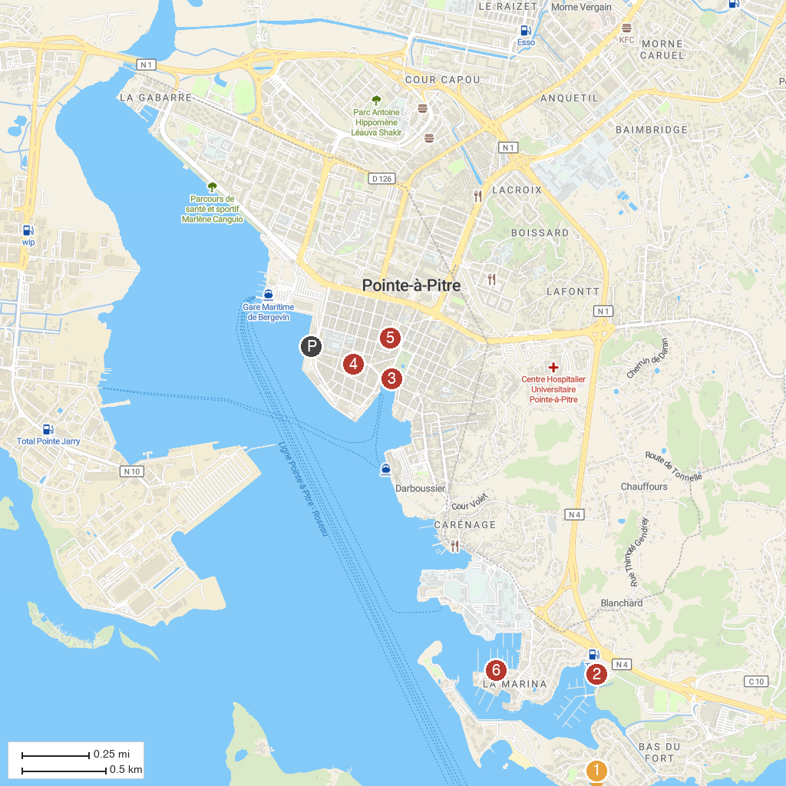
MAP KEY
1. Centre Nautique Bleu Outremer | 4. Spice Market
2. Aquarium of Guadeloupe | 5. Église catholique Saint-Pierre-et-Saint-Paul à Pointe-à-Pitre
3. Victory Square | 6. kiff caraïbes nautique - Location bateau en Guadeloupe -Location de bateaux moteur-gosier
P. Cruise port / terminal
Map © MapTiler © OpenStreetMap contributors · cruiseports.org

