Ponza Island, Lazio, Italy
"Capri without the crowds" — this crescent-shaped volcanic island enchants with pastel houses stacked above a turquoise harbor, Roman sea caves, and coves reachable only by water.
⚓ Tender port · 🕒 Typical call: 6-8 hrs · 💶 Currency: Euro · 🗣️ Language: Italian · 🚤 Best explored by boat
✍️ MY DAY IN PORT (FILL IN)
Ship / Date
In port | arrive ______ · all aboard ______
Booked excursion
Notes / meeting point
GETTING ASHORE
- Docking: Tender — ships anchor in Golfo di Ponza; tenders land at Molo Musco in town
- Walk to center: 2 min flat to Piazza Pisacane from tender pier
- Best For: Boat touring, Roman history, swimming, Italian village atmosphere
- Don't Miss: Grotte di Pilato Roman fish caves and the Frontone Beach water taxi
GETTING AROUND
- 🚕 Taxi: €9–€16 — Local taxis wait near the port. Short rides to beaches and viewpoints cost €9–€16 depending on destination; the port are
- 📱 Rideshare: ❌ not available
TOP THINGS TO DO
- Self-Drive Gozzo Rental — Rent a traditional wooden gozzo or small RIB from harbor vendors.
- Grotte di Pilato Boat Tour — Five Roman-carved tunnels and pools where emperors kept sacred moray eels.
- Frontone Beach Day — Hop a water taxi (barcaiolo) from the port to Frontone Beach — a trendy lido with loungers, a beach bar, and brilliant clear water.
- Natural Pools at Cala Feola — The Piscine Naturali near Cala Feola are shallow, sandy natural pools carved in volcanic rock — perfect for families and calm…
- Ponza Porto Town Walk — Stroll the amphitheater-shaped harbor, Piazza Pisacane, and the winding vicoli behind the waterfront.
BEST WALKS
- Harbor to Chiaia di Luna Overlook: 15-20 min uphill · 1.5 km · Moderate — Walk from the tender pier up the road toward the west side of the island to the overlook above…
- Ponza Porto Town Circuit: 30-45 min · Easy · Flat harbor + steps — From the tender pier, walk Piazza Pisacane, Corso Pisacane, and the narrow vicoli behind the harbor…
WEATHER · DAYLIGHT · MONEY
Month | High °F | Low °F | Rainy days
May | 66 | 63 | 7
Jul | 79 | 76 | 1
Sep | 76 | 73 | 7
Daylight: May 5:50AM–8:18PM · Jul 5:49AM–8:38PM · Sep 6:49AM–7:16PM
cruiseports.org/ponza-island · Confirm terminal & all-aboard time with your ship

Ponza Island, Lazio, Italy — Port Map
Red = walkable sights · Amber = excursions farther out · P = cruise terminal
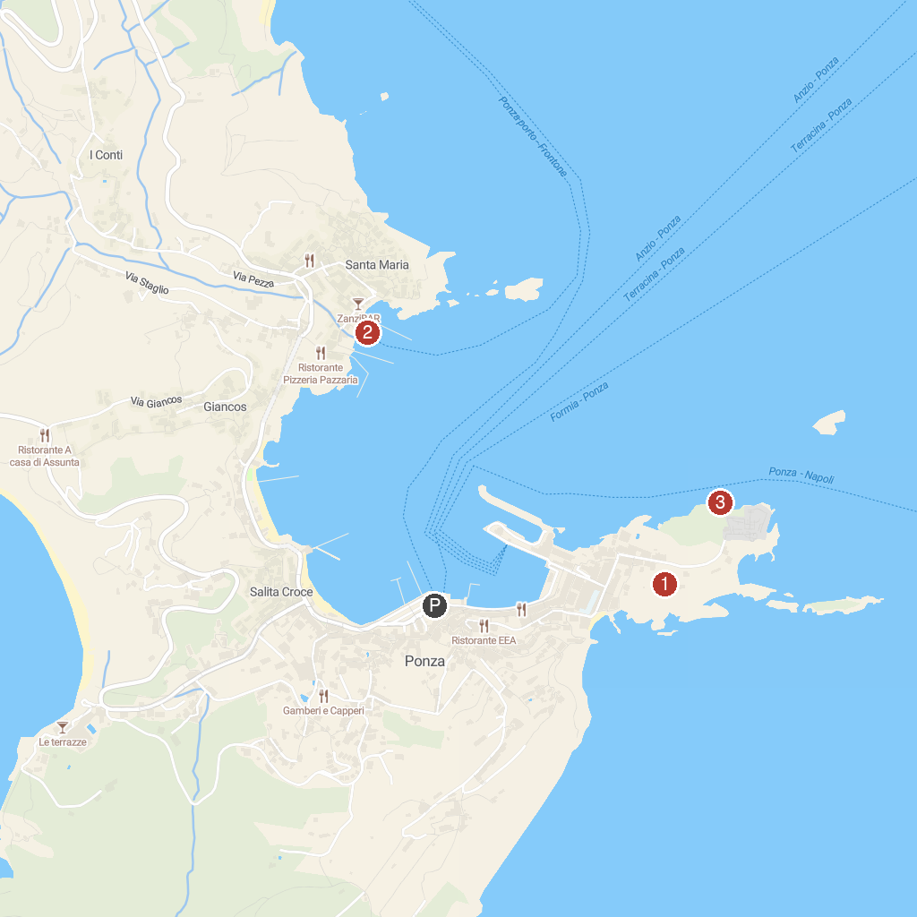
MAP KEY
1. Giardino Botanico Ponziano | 3. Grotte di Pilato
2. Zannone 1954 - Boat Ponza
P. Cruise port / terminal
Map © MapTiler © OpenStreetMap contributors · cruiseports.org

