Port Colborne, Ontario, Canada
A canal town where freighters glide past sidewalk cafés. Port Colborne offers an intimately Canadian Great Lakes experience — and Niagara Falls is just 35 km away.
⚓ Pier (docked) · 🕒 Typical call: 7-9 hrs · 💵 Canadian dollars (CAD) · 🗣️ English
✍️ MY DAY IN PORT (FILL IN)
Ship / Date
In port | arrive ______ · all aboard ______
Booked excursion
Notes / meeting point
GETTING ASHORE
- Docking: Pier — ships dock at Wharf 16 / West Street Wharf, steps from downtown
- Walk to center: 0-5 min to Historic West Street
- Best For: Canal watching, Niagara Falls day-trips, Lake Erie perch
- Don't Miss: Lock 8 Gateway Park — watch a laker being raised or lowered
GETTING AROUND
- 🚕 Taxi: CAD $10–15 (short trips) — Local taxis (e.g. Air Cab) use a metered fare: $4 base + ~$1.90/km. Short hops around town are typically under CAD $15.
- 📱 Rideshare: ✅ Uber, Lyft
TOP THINGS TO DO
- Niagara Falls Day Trip — Just 35 km from the dock, Niagara Falls is the obvious big-ticket excursion.
- Lock 8 Gateway Park & Canal Viewing — Watch massive lakers and salties being raised or lowered at one of the longest locks in the Welland Canal system.
- Port Colborne Historical & Marine Museum — An open-air heritage campus with a blacksmith shop, a one-room schoolhouse, marine artifacts, and a ship's anchor salvaged from…
- Nickel Beach (Lake Erie) — A wide, white-sand Lake Erie beach with paid parking lots a short walk from the shore (on-beach car parking was phased out to…
- Lake Erie Perch & Local Eats — Yellow perch is the regional obsession.
BEST WALKS
- West Street Canal Walk: 1 km · 20 min · Easy · Free — Stroll Historic West Street from the dock to Lock 8 Gateway Park.
- Museum & Waterfront Loop: 2 km · 30 min · Easy · Free — From the dock head east along the canal to the Port Colborne Historical and Marine Museum, then…
WEATHER · DAYLIGHT · MONEY
Month | High °F | Low °F | Rainy days
May | 63 | 49 | 11
Jul | 77 | 66 | 12
Sep | 71 | 60 | 10
Daylight: May 5:53AM–8:33PM · Jul 5:52AM–8:53PM · Sep 6:57AM–7:26PM
cruiseports.org/port-colborne-on · Confirm terminal & all-aboard time with your ship

Port Colborne, Ontario, Canada — Port Map
Red = walkable sights · Amber = excursions farther out · P = cruise terminal
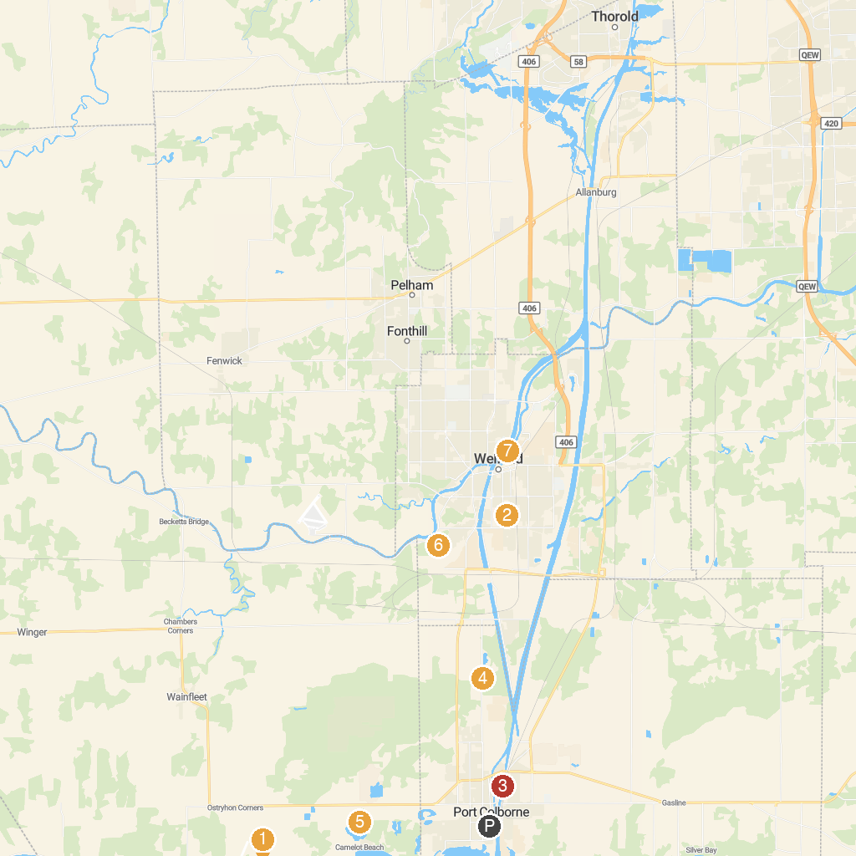
MAP KEY
1. Morgan's Point Conservation Area | 5. Wainfleet Wetlands Conservation Area
2. Plymouth Park | 6. Saint George Park
3. Canal Lock 8 | 7. Merritt Island Park
4. Mud Lake Conservation Area | 8. Stevensville Conservation Area
P. Cruise port / terminal
Map © MapTiler © OpenStreetMap contributors · cruiseports.org

