Port Mahon, Menorca, Spain
Sail into one of Europe's great natural harbors — past hilltop fortresses and colonial villas — and step ashore in a Georgian-era capital shaped by British rule, famous for gin, cheese, and Menorca's wild coastline.
⚓ Pier (Moll de Ponent) · 🕒 Typical call: 7-9 hrs · 💶 Euro · 🗣️ Spanish / Catalan
✍️ MY DAY IN PORT (FILL IN)
Ship / Date
In port | arrive ______ · all aboard ______
Booked excursion
Notes / meeting point
GETTING ASHORE
- Docking: Pier — Moll de Ponent, in the harbor
- Walk to Old Town: 10-15 min; lift or stairs up the cliff
- Best For: History, local gin, harbor views, beaches
- Don't Miss: The sail-in through the fjord-like channel
GETTING AROUND
- 🚕 Taxi: €10–€14 — Official metered taxis are available at the port. Expect a surcharge of ~€2.90 for port pickups plus ~€0.60 per large ba
- 📱 Rideshare: ❌ not available
TOP THINGS TO DO
- Mahon Harbor Boat Tour — One-hour catamaran cruise (with underwater viewing windows on some boats) past King's Island (Isla del Rey), the Lazareto…
- Old Town Mahon Walk — Wander 18th-century streets lined with Georgian sash-window townhouses — an architectural style unique in Spain, a legacy of…
- Xoriguer Gin Distillery — Menorca's signature spirit was born from British sailors' demand for gin in the 18th century.
- Isla del Rey & Hauser & Wirth — A short catamaran hop to King's Island in the middle of the harbor reveals a beautifully restored 18th-century British Naval…
- Es Grau Beach & Nature Reserve — The closest good beach to Mahon — a natural, sandy cove with shallow calm water inside the S'Albufera des Grau Natural Park.
BEST WALKS
- Harbor Front to Old Town: 1.5 km · 20–30 min · Easy — Walk the harbourfront promenade past the Xoriguer Gin Distillery, then ride the glass lift (or take…
- Mirador de Miranda Viewpoint: 0.5 km from Old Town · 10 min · Easy — From the Old Town, walk to the Mirador de Miranda for panoramic views over the entire harbor…
WEATHER · DAYLIGHT · MONEY
Month | High °F | Low °F | Rainy days
May | 72 | 56 | 5
Jul | 84 | 66 | 1
Sep | 80 | 64 | 5
Daylight: May 5:35AM–7:55PM · Jul 5:30AM–8:15PM · Sep 6:30AM–7:05PM
cruiseports.org/port-mahon · Confirm terminal & all-aboard time with your ship

Port Mahon, Menorca, Spain — Port Map
Red = walkable sights · Amber = excursions farther out · P = cruise terminal
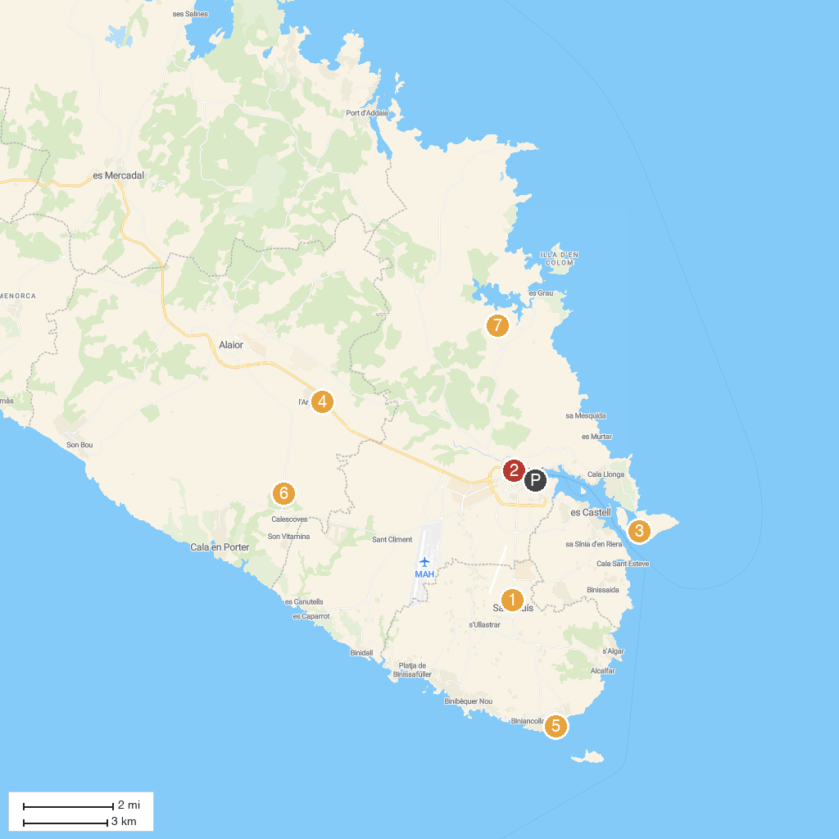
MAP KEY
1. Molí de Dalt de Sant Lluís | 5. Torre d'Alcalfar
2. Menorca en Llaut | 6. So na Caçana
3. Isabel II Fortress / Mola Fortress | 7. Ruta Turística Alaior . Centro de Estudios Locales
4. Centre zoològic | 8. Parc Natural de s'Albufera des Grau
P. Cruise port / terminal
Map © MapTiler © OpenStreetMap contributors · cruiseports.org

