Port of Spain, Trinidad, Trinidad & Tobago
The Caribbean's most cosmopolitan capital — Trinidad's Port of Spain pulses with Carnival energy, world-class street food, and a steelpan soundtrack unlike any other island.
⚓ Pier (King's Wharf) · 🕒 Typical call: 7-10 hrs · 💵 TTD / USD accepted · 🗣️ English · 🎭 Birthplace of Carnival & Steelpan
✍️ MY DAY IN PORT (FILL IN)
Ship / Date
In port | arrive ______ · all aboard ______
Booked excursion
Notes / meeting point
GETTING ASHORE
- Docking: Pier — Cruise Ship Complex, King's Wharf
- Walk to center: 10–15 min flat walk to Brian Lara Promenade
- Best For: Street food, Caroni Bird Sanctuary, culture & history
- Don't Miss: Doubles, Bake & Shark at Maracas Bay, the Magnificent Seven
GETTING AROUND
- 🚕 Taxi: TT$30–60 (~US$4–9) — Licensed "H-plate" taxis queue at the terminal gate. Taxis are unmetered — agree on the fare before you get in. Cash onl
- 📱 Rideshare: ❌ not available
TOP THINGS TO DO
- Caroni Bird Sanctuary — Scarlet Ibis Sunset — Flat-bottomed boat glides through mangrove swamps as thousands of brilliant Scarlet Ibis fly in to roost at dusk.
- Maracas Bay Beach Day — 40–60 minutes over the lush Northern Range mountains and you arrive at Trinidad's most famous beach — a crescent of white sand…
- Fort George Panorama — An 1804-era hilltop fort at 1,100 ft with original cannons and the best panoramic view of Port of Spain and the Gulf of Paria.
- Angostura Distillery & Bitters Tour — The world-famous Angostura Bitters are made here.
- Magnificent Seven & Queen's Park Savannah — Seven spectacular Edwardian mansions line the western edge of the Savannah — Stollmeyer's Castle, Whitehall, and five more.
BEST WALKS
- King's Wharf to Woodford Square: 1.2 km · 15–20 min · Flat · Historic downtown — Walk straight from the terminal along Wrightson Road, cut north on Frederick Street through the…
- Red House to National Museum: 0.6 km · 10 min · Flat · Architecture & culture — From the Red House on Woodford Square, walk north on Frederick Street to the National Museum and…
WEATHER · DAYLIGHT · MONEY
Month | High °F | Low °F | Rainy days
May | 88 | 76 | 12
Jul | 86 | 76 | 23
Sep | 87 | 77 | 23
Daylight: May 5:44AM–6:20PM · Jul 5:51AM–6:32PM · Sep 5:55AM–6:06PM
cruiseports.org/port-of-spain · Confirm terminal & all-aboard time with your ship

Port of Spain, Trinidad, Trinidad & Tobago — Port Map
Red = walkable sights · Amber = excursions farther out · P = cruise terminal
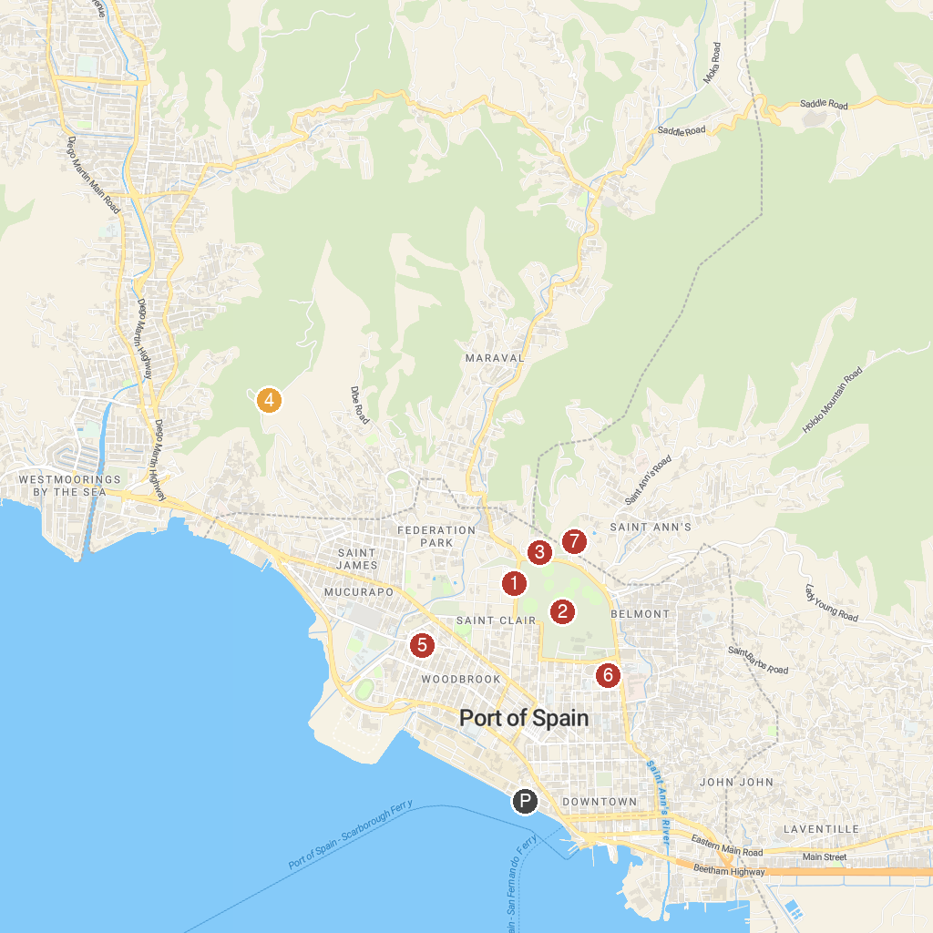
MAP KEY
1. Archbishop’s House | 5. St. Theresa's Roman Catholic Church
2. Queen's Park Savannah | 6. National Museum & Art Gallery
3. Emperor Valley Zoo | 7. Royal Botanic Gardens
4. Fort George
P. Cruise port / terminal
Map © MapTiler © OpenStreetMap contributors · cruiseports.org

