Port-Vendres, Occitanie, France
Where the Pyrenees plunge into the Mediterranean, Port-Vendres remains a genuine working fishing harbour — cruise ships dock right in the heart of town, Collioure is a short bus ride away, and anchovies are the local religion.
⚓ Docked (deep-water pier) · 🕒 Typical call: 7-9 hrs · 💶 Currency: Euro · 🗣️ French & Catalan · 🚌 €1 bus to Collioure
✍️ MY DAY IN PORT (FILL IN)
Ship / Date
In port | arrive ______ · all aboard ______
Booked excursion
Notes / meeting point
GETTING ASHORE
- Docking: Ships dock at Quai de la République or Quai Pierre Forgas — right in town
- Walk to centre: 0–5 min; step off the gangway and you're already there
- Best For: Coastal hikes, Collioure day trip, fresh seafood, Catalan culture
- Don't Miss: The Mackintosh Trail & the €1 bus to Collioure for Matisse country
GETTING AROUND
- 🚕 Taxi: €15–€20 local, ~€40 to Collioure — Local taxis are available at the port. Short trips within town start around €15; neighboring Collioure is roughly €40 ea
- 📱 Rideshare: ✅ Uber
TOP THINGS TO DO
- Collioure & the Matisse Trail — The jewel of the Côte Vermeille is a 10-minute €1 bus ride away.
- Sentier du Littoral Coastal Walk — A spectacular waymarked trail hugs the volcanic red-rock coast.
- Fort Saint-Elme — A star-shaped fortress perched on the hill between Port-Vendres and Collioure.
- Mackintosh Trail — Scottish architect Charles Rennie Mackintosh spent his final years (1923–27) painting Port-Vendres.
- Anchovy & Banyuls Wine Tasting — Collioure anchovies, salted by hand and packed in olive oil, are nothing like tinned supermarket fish.
BEST WALKS
- Harbour & Town Stroll: 30–45 min · Easy · Free — A simple loop around the working port taking in the obelisk, the church, the Mackintosh plaques…
- Coastal Path to Collioure: 45–60 min each way · Moderate · Stunning views — Follow the Sentier du Littoral north along volcanic red cliffs and hidden coves.
cruiseports.org/port-vendres · Confirm terminal & all-aboard time with your ship

Port-Vendres, Occitanie, France — Port Map
Red = walkable sights · Amber = excursions farther out · P = cruise terminal
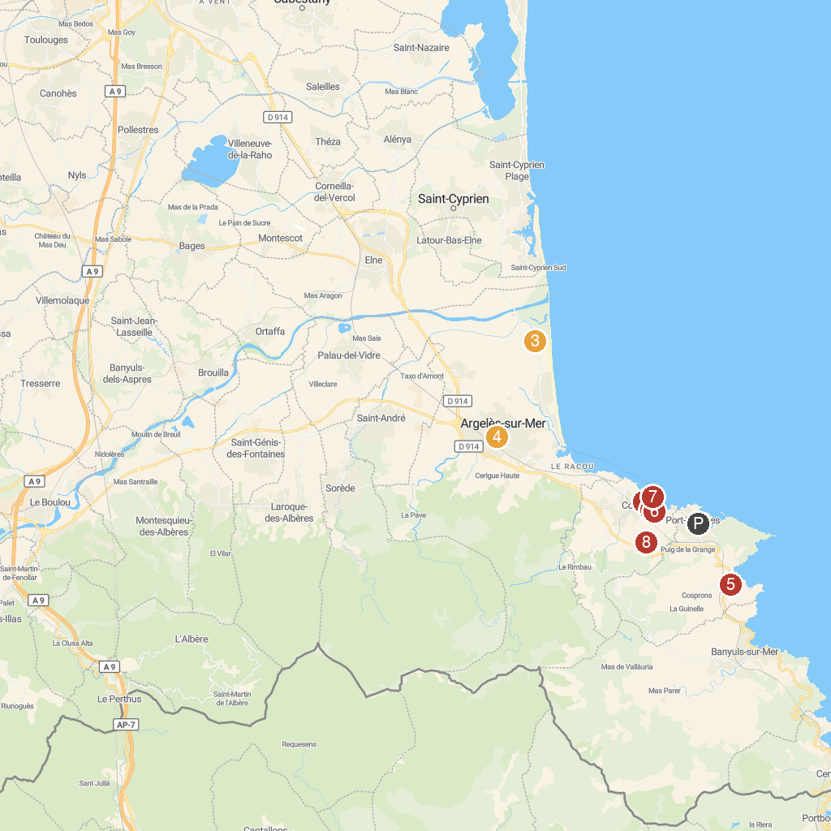
MAP KEY
1. Royal Castle of Collioure | 5. Site House, Museum Of Catalan boats
2. Musée d'art moderne | 6. Moulin de Collioure
3. Canyoning Park | 7. Collioure Lighthouse
4. Église Notre-Dame del Prat d'Argelès-sur-Mer | 8. Fort Dugommier
P. Cruise port / terminal
Map © MapTiler © OpenStreetMap contributors · cruiseports.org

