Port Vila, Efate, Vanuatu
The vibrant capital of Vanuatu blends Melanesian culture with tropical beaches, electric-blue lagoons, and a walkable waterfront market — all within easy reach of the main wharf.
⚓ Docked (commercial wharf) · 🕒 Typical call: 7-9 hrs · 💵 Vanuatu Vatu (VUV) / AUD widely accepted · 🗣️ Bislama, English, French
✍️ MY DAY IN PORT (FILL IN)
Ship / Date
In port | arrive ______ · all aboard ______
Booked excursion
Notes / meeting point
GETTING ASHORE
- Docking: Main Wharf on Wharf Rd; ~3 km southwest of town center. Occasional tender for largest ships.
- Walk to center: 30–40 min on foot; taxis, shuttle vans, and water taxis available
- Best For: Blue Lagoon swims, cultural villages, waterfall hikes, duty-free shopping
- Don't Miss: Blue Lagoon, Mele Cascades, Ekasup Cultural Village, Port Vila Market
GETTING AROUND
- 🚕 Taxi: 2,500–4,000 VUV (~$21–33 USD) — Taxis do not use meters — always agree on the fare before getting in. Short city trips run ~2,500 VUV; resorts on the Pa
- 📱 Rideshare: ❌ not available
TOP THINGS TO DO
- Blue Lagoon & Eden on the River — Vanuatu's star attraction: a vivid turquoise swimming hole where fresh and salt water meet.
- Mele Cascades Waterfall — Tiered freshwater pools and a 35-metre waterfall set in lush tropical jungle.
- Ekasup Cultural Village — Step into traditional Melanesian life at this authentic cultural village.
- Hideaway Island Snorkel & Underwater Post Office — A short boat ride to a marine reserve with calm, shallow snorkeling.
- Lelepa Island Day Trip — Boat to Lelepa Island for a bush-trail walk through native flora, snorkeling over giant clams, kayaking, and a BBQ lunch on the…
BEST WALKS
- Wharf to Port Vila Market & Waterfront: 2.5 km · 30 min · Easy — Follow Wharf Road northeast along the bay, past the Independence Park, into the heart of downtown.
- Waterfront Promenade & Duty-Free Strip: 1 km · 15 min · Flat — Stroll the palm-lined waterfront promenade past duty-free stores, café terraces, and the colourful…
WEATHER · DAYLIGHT · MONEY
Month | High °F | Low °F | Rainy days
May | 80 | 74 | 13
Jul | 77 | 72 | 10
Sep | 78 | 72 | 11
Daylight: May 6:04AM–5:21PM · Jul 6:18AM–5:27PM · Sep 5:42AM–5:41PM
cruiseports.org/port-vila · Confirm terminal & all-aboard time with your ship

Port Vila, Efate, Vanuatu — Port Map
Red = walkable sights · Amber = excursions farther out · P = cruise terminal
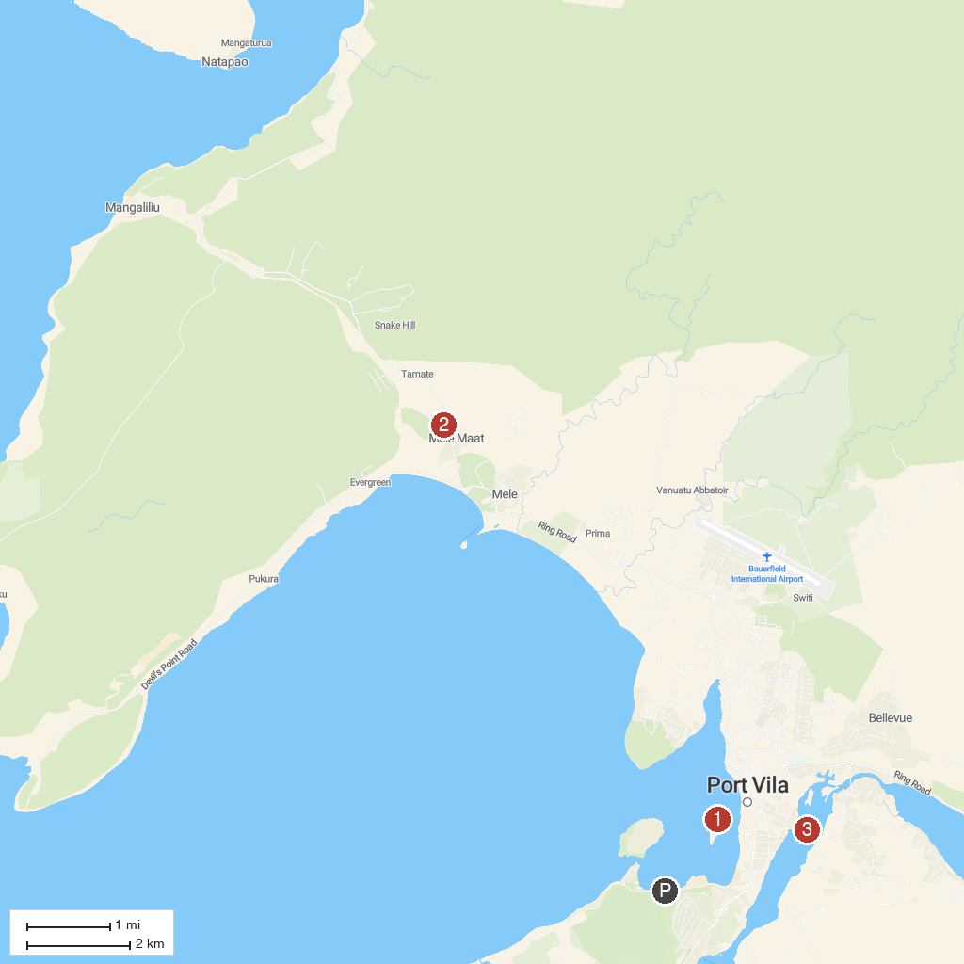
MAP KEY
1. Iririki Island | 3. Erakor Lagoon
2. Mele Cascades | 4. Chief Roi Mata's Domain
P. Cruise port / terminal
Map © MapTiler © OpenStreetMap contributors · cruiseports.org

