Portimão, Algarve, Portugal
Portugal's sardine capital sits at the mouth of the Arade River, flanked by world-famous golden-cliff beaches and a picture-perfect fishing village just a ferry ride away.
⚓ Pier (small ships) / Tender (large ships) · 🕒 Typical call: 7-9 hrs · 💶 Euro (€) — cards widely accepted · 🗣️ Portuguese / English widely spoken · ☀️ Best: May–Oct
✍️ MY DAY IN PORT (FILL IN)
Ship / Date
In port | arrive ______ · all aboard ______
Booked excursion
Notes / meeting point
GETTING ASHORE
- Docking: Pier for ships ≤215 m; tender for larger vessels
- Walk to center: 15-20 min to downtown; ~30 min to Praia da Rocha
- Best For: Beaches, Benagil cave tours, seafood dining
- Don't Miss: Water taxi to Ferragudo village across the river
GETTING AROUND
- 🚕 Taxi: €5–€12 — Taxis queue at the terminal; the short ride to the city center costs roughly €5–€8. Longer trips (e.g. Lagos or Silves)
- 📱 Rideshare: ✅ Bolt, Uber
TOP THINGS TO DO
- Benagil Sea Cave RIB Tour — The famous cathedral cave at Benagil is one of the most photographed spots in Europe.
- Praia da Rocha Beach Day — About 2.5 km from the pier (a 30-minute walk or a short taxi/bus ride) lies one of Portugal's finest beaches: wide golden sand…
- Ferragudo Village Water-Taxi Excursion — Hop a water taxi (€3–5, 5 minutes) from the marina to Ferragudo — a whitewashed fishing village that feels untouched by tourism.
- Silves Moorish Castle — Twenty minutes inland, the red sandstone castle of Silves is the best-preserved Moorish fortification in Portugal.
- Sardine Lunch on the Riverfront — Portimão is the sardine capital of the Algarve.
BEST WALKS
- Pier to Praia da Rocha & Fort of Santa Catarina: 2.5 km · 30 min · Flat · Free — Follow the paved riverside path south from the cruise terminal toward the beach.
- Riverfront Stroll to the Old Town: 2.5 km · 30 min · Flat · Free — Head north along the Ribeirinha promenade — a palm-lined riverside walkway with benches and cafes.
WEATHER · DAYLIGHT · MONEY
Month | High °F | Low °F | Rainy days
May | 75 | 59 | 4
Jul | 86 | 66 | 0
Sep | 80 | 65 | 4
Daylight: May 6:25AM–8:35PM · Jul 6:26AM–8:53PM · Sep 7:16AM–7:41PM
cruiseports.org/portimao · Confirm terminal & all-aboard time with your ship

Portimão, Algarve, Portugal — Port Map
Red = walkable sights · Amber = excursions farther out · P = cruise terminal
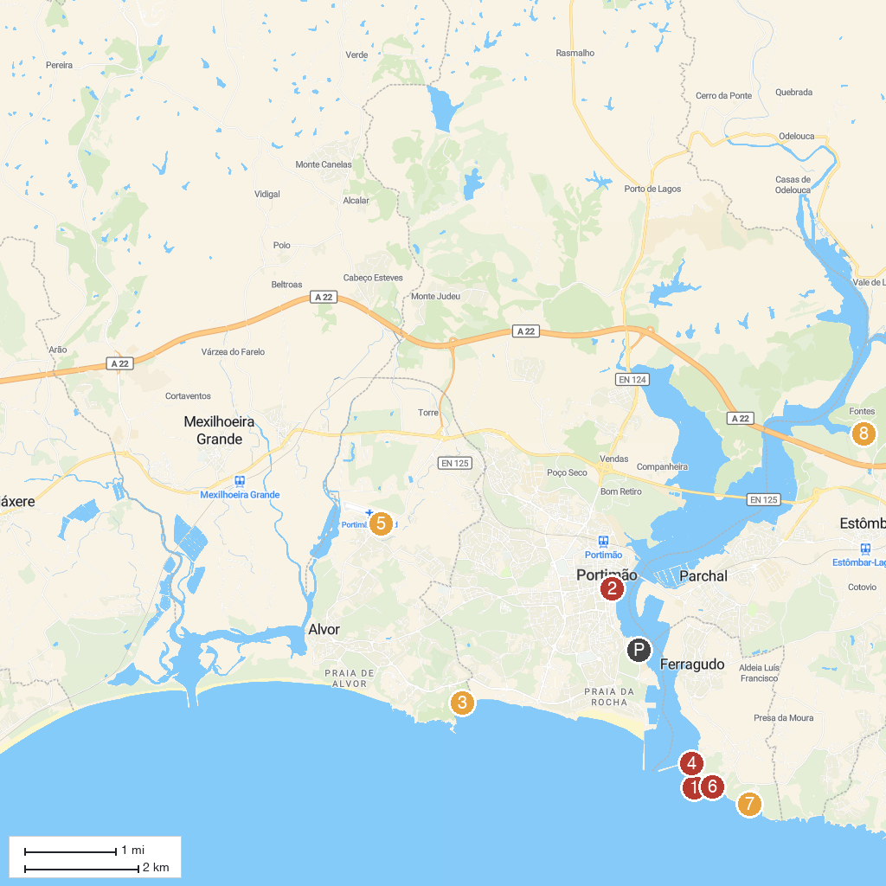
MAP KEY
1. Farol da Ponta do Altar | 5. Skydive Seven Algarve
2. Casa Manuel Teixeira Gomes | 6. Praia do Torrado
3. Praia de Boião | 7. Praia da Afurada
4. Praia do Molhe | 8. Parque Municipal do Sítio das Fontes
P. Cruise port / terminal
Map © MapTiler © OpenStreetMap contributors · cruiseports.org

