Portland, Oregon, USA
Terminal 2 sits on the Willamette River in NW Portland, a short ride from the compact, walkable downtown core — where craft-beer culture, world-class bookstores, and the dramatic Columbia River Gorge are all within easy reach.
⚓ Docked at Terminal 2 · 🕒 Typical call: 8-10 hrs · 💵 USD · 🗣️ English · 🌧️ Layer up — Portland is famously drizzly
✍️ MY DAY IN PORT (FILL IN)
Ship / Date
In port | arrive ______ · all aboard ______
Booked excursion
Notes / meeting point
GETTING ASHORE
- Docking: Terminal 2, Willamette River — downtown Portland, docked alongside
- Getting to center: ~2.5 mi to downtown — about a 10 min rideshare; ~2 mi to the Pearl District
- Best For: Foodies, book lovers, craft-beer fans, Columbia Gorge day-trippers
- Don't Miss: Powell's City of Books — a full city block of half a million titles
GETTING AROUND
- 🚕 Taxi: $10–$15 — Taxis are readily available at Terminal 2. The cruise port is only ~2.5 miles from the city center, making for a quick 1
- 📱 Rideshare: ✅ Uber, Lyft
- 🚌 Hop-on hop-off: ✅ Gray Line Pink Trolley
TOP THINGS TO DO
- Columbia River Gorge & Multnomah Falls — Head 30 miles east on the Historic Columbia River Highway to reach Multnomah Falls, Oregon's tallest waterfall at 620 feet.
- Powell's City of Books — One of the world's largest independent bookstores occupies an entire city block on W Burnside St at 1005 W Burnside, on the edge…
- Portland Food Cart Pods — Portland invented the food cart pod culture.
- International Rose Test Garden — Portland is the 'City of Roses' for good reason.
- Willamette River Jet Boat Tour — High-speed jet boats depart from downtown Portland on the Willamette and Columbia Rivers, reaching speeds of 45 mph while passing…
BEST WALKS
- Tom McCall Waterfront Park Stroll: 2 miles · Flat · 45 min — Start downtown along the Willamette and follow the paved riverside path through Tom McCall…
- Pearl District & Powell's Loop: 2.5 miles · Flat · 1 hr — From downtown, walk into the Pearl District — Portland's upscale arts neighborhood filled with…
WEATHER · DAYLIGHT · MONEY
Month | High °F | Low °F | Rainy days
May | 68 | 49 | 10
Jul | 83 | 58 | 2
Sep | 75 | 55 | 8
Daylight: May 5:39AM–8:35PM · Jul 5:37AM–8:55PM · Sep 6:49AM–7:20PM
cruiseports.org/portland-or · Confirm terminal & all-aboard time with your ship

Portland, Oregon, USA — Port Map
Red = walkable sights · Amber = excursions farther out · P = cruise terminal
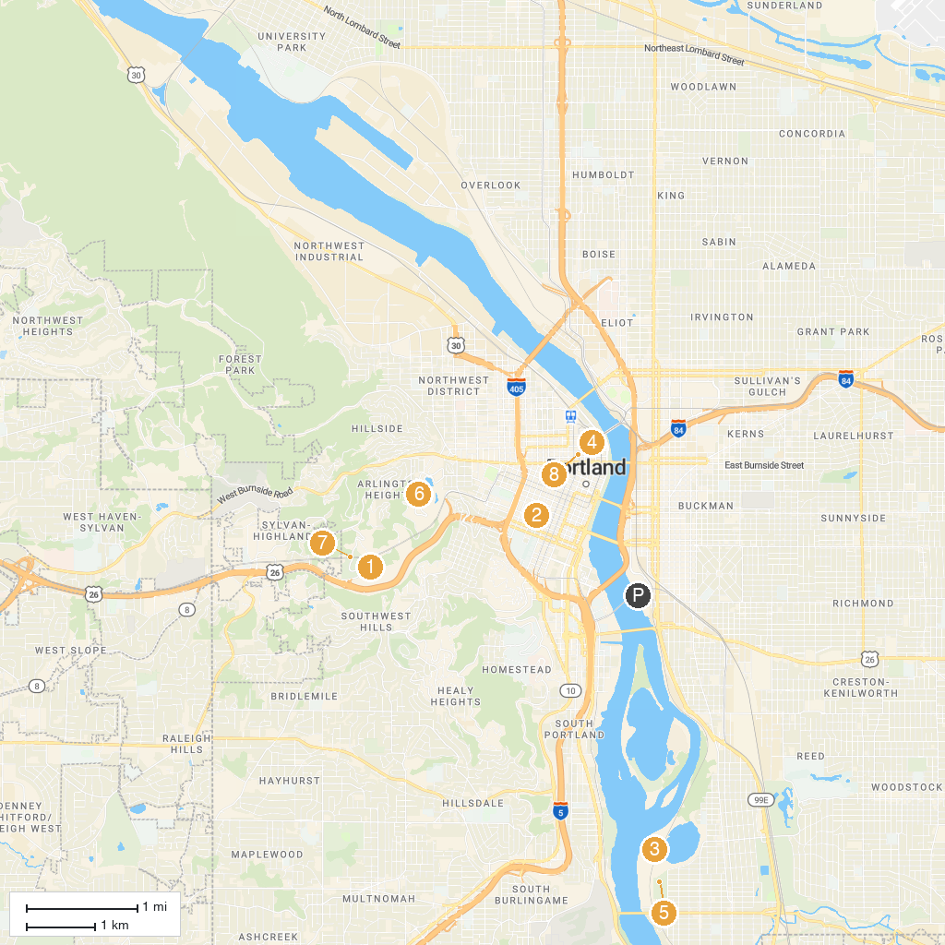
MAP KEY
1. Oregon Zoo | 5. Sellwood Park
2. Portland Art Museum | 6. International Rose Test Garden
3. Oaks Amusement Park | 7. World Forestry Center
4. Lan Su Chinese Garden | 8. Ground Kontrol Classic Arcade and Bar
P. Cruise port / terminal
Map © MapTiler © OpenStreetMap contributors · cruiseports.org

