Porto Cervo, Sardinia, Italy
Sardinia's playground of the ultra-wealthy, Porto Cervo delivers crystalline turquoise coves, a glamorous superyacht marina, and some of the Mediterranean's most beautiful beaches — all arriving by tender into the heart of the action.
⚓ Tender port · 🕒 Typical call: 6-8 hrs · 💶 Currency: Euro (€) · 🗣️ Language: Italian · 🌡️ Best season: June–September
✍️ MY DAY IN PORT (FILL IN)
Ship / Date
In port | arrive ______ · all aboard ______
Booked excursion
Notes / meeting point
GETTING ASHORE
- Docking: Tender — ships anchor offshore; boats drop at marina pontoon
- Walk to center: Immediate — tender drops in downtown Porto Cervo
- Best For: Beaches, boat tours to La Maddalena, luxury people-watching
- Don't Miss: Cala del Faro beach, Stella Maris Church views, marina promenade
GETTING AROUND
- 🚕 Taxi: €10–€20 within Porto Cervo; €70–€90 to/from Olbia — Local taxis are available near the harbor. Fixed-rate private transfers to Olbia (the nearest cruise hub) run €70–90 and
- 📱 Rideshare: ✅ Uber Taxi
TOP THINGS TO DO
- La Maddalena Archipelago Boat Tour — The highlight excursion from Porto Cervo.
- Costa Smeralda Beach Day — Hire a taxi or join a tour to Spiaggia del Principe, Liscia Ruja, or the iconic Capriccioli coves.
- Nuragic Ruins at Nuraghe La Prisgiona — Sardinia's mysterious Bronze Age towers are among the most impressive prehistoric monuments in Europe.
- San Pantaleo Village & Local Market — A charming granite hilltop village in the Gallura hinterland, just 15 minutes by taxi.
- Kayaking & Snorkeling the Coves — Rent a kayak from the beach or join a guided sea-kayak tour to explore the granite-fringed coves around Porto Cervo that are…
BEST WALKS
- Old Port to Stella Maris & New Marina: 1.5 km · 30–40 min · Easy — From the tender pontoon, wind up through Porto Vecchio past designer boutiques to Piazza Azzurra…
- Cala Granu Short Beach Walk: 1 km each way · 15 min · Easy — An easy footpath from the marina area leads to Cala Granu, the closest beach to the port — calm…
WEATHER · DAYLIGHT · MONEY
Month | High °F | Low °F | Rainy days
May | 70 | 59 | 7
Jul | 86 | 73 | 1
Sep | 79 | 68 | 5
Daylight: May 6:03AM–8:33PM · Jul 6:02AM–8:52PM · Sep 7:02AM–7:30PM
cruiseports.org/porto-cervo · Confirm terminal & all-aboard time with your ship

Porto Cervo, Sardinia, Italy — Port Map
Red = walkable sights · Amber = excursions farther out · P = cruise terminal
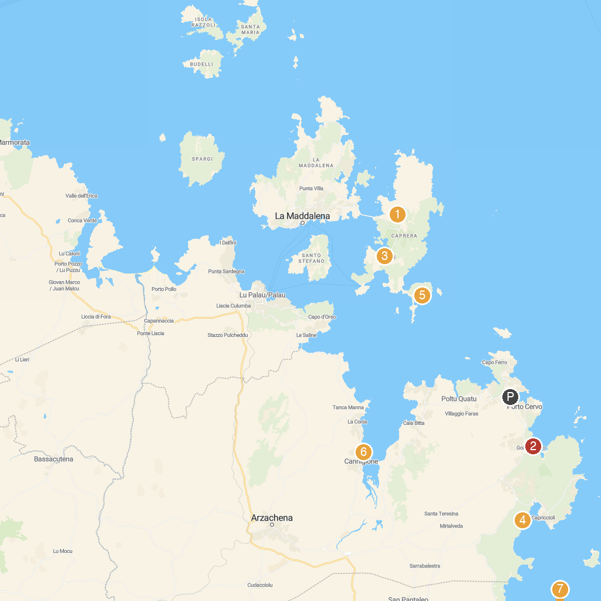
MAP KEY
1. Casa e Tomba di Garibaldi | 5. Beach Li Itriceddi
2. Parco Nazionale dell'Arcipelago di La Maddalena | 6. Cala Andreani
3. Spiaggia Del Piccolo Pevero Beach | 7. Spiaggia di Cannigione
4. Museo geo-mineralogico naturalistico di La Maddalena-Caprera | 8. Spiaggia Hruska
P. Cruise port / terminal
Map © MapTiler © OpenStreetMap contributors · cruiseports.org

