Porto Empedocle, Sicily, Italy
Gateway to one of the ancient world's greatest temple complexes, Porto Empedocle is a workaday Sicilian port town that also claims fame as the real-life inspiration for Andrea Camilleri's beloved Inspector Montalbano stories.
⚓ Pier (Banchina Todaro) · 🕒 Typical call: 8-10 hrs · 💶 Euro (€) · 🗣️ Italian · 🏛️ UNESCO World Heritage nearby
✍️ MY DAY IN PORT (FILL IN)
Ship / Date
In port | arrive ______ · all aboard ______
Booked excursion
Notes / meeting point
GETTING ASHORE
- Docking: Pier — Banchina Todaro (T1/T2), no tender required
- Walk to center: ~10 min (1–1.5 km along the seafront)
- Best For: Valley of the Temples, Greek history, Sicilian food
- Don't Miss: Temple of Concordia at the Valley of the Temples
GETTING AROUND
- 🚕 Taxi: €20–€25 one way — Taxis wait outside the port and reach Agrigento Centrale (~9 km) in about 12 minutes. Agree on the fare before departure
- 📱 Rideshare: ✅ Uber Black
TOP THINGS TO DO
- Valley of the Temples — A UNESCO World Heritage Site and one of the best-preserved Greek temple complexes outside Greece.
- Scala dei Turchi — A stunning white marl cliff sculpted by wind and sea into natural staircases, about 11 km west of Porto Empedocle near Realmonte.
- Agrigento Old Town & Montalbano Trail — Agrigento's medieval hilltop centro storico has a striking Norman cathedral, the Via Atenea market street, and several plaques…
- Sicilian Food & Market Walk — Porto Empedocle's waterfront trattorias serve fresh-caught fish, pasta con le sarde, and Sicilian cannoli at local prices.
- Full-Day Combo: Temples + Scala dei Turchi — Hire a driver or join a combo tour that hits the Valley of the Temples in the morning, then heads to Scala dei Turchi cliff for…
BEST WALKS
- Seafront Promenade to Town Center: 1.2 km · 15 min · Easy · Flat — From the cruise pier, follow the waterfront promenade west into the heart of Porto Empedocle.
- Vigàta Trail: Montalbano Landmarks: 2 km · 30 min · Easy · Flat — Follow the self-guided trail through town spotting locations from Camilleri's Montalbano novels and…
WEATHER · DAYLIGHT · MONEY
Month | High °F | Low °F | Rainy days
May | 74 | 58 | 6
Jul | 90 | 70 | 0
Sep | 83 | 67 | 5
Daylight: May 5:57AM–8:07PM · Jul 5:57AM–8:25PM · Sep 6:48AM–7:13PM
cruiseports.org/porto-empedocle · Confirm terminal & all-aboard time with your ship

Porto Empedocle, Sicily, Italy — Port Map
Red = walkable sights · Amber = excursions farther out · P = cruise terminal
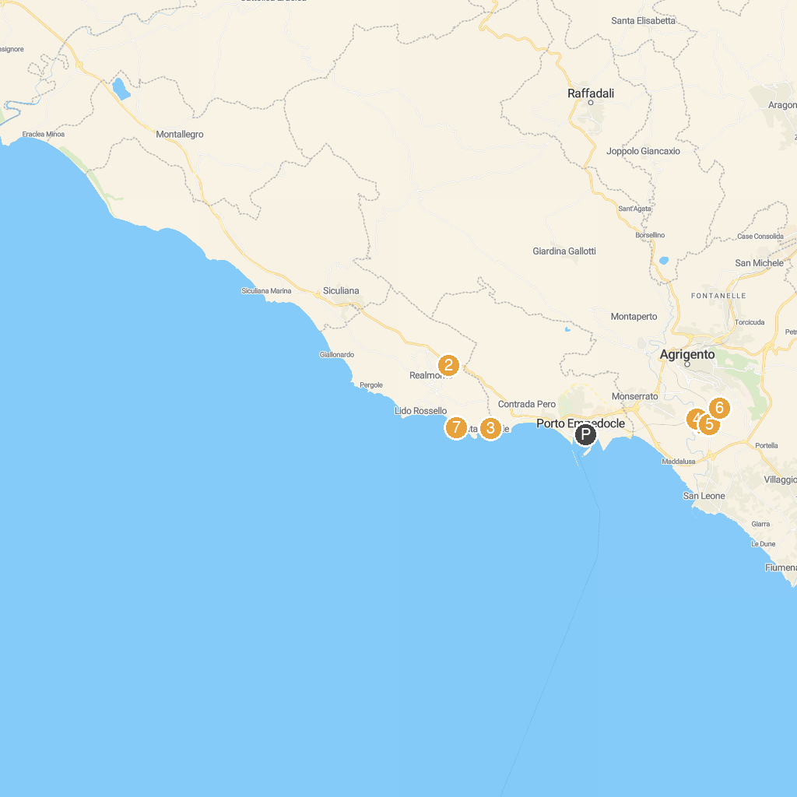
MAP KEY
1. Temple of the Dioscuri | 5. Temple of Olympian Zeus
2. B&B Zu Tanu e Za Carmela | 6. Archaeological Museum "Pietro Griffo" of Agrigento
3. Villa Romana | 7. Scala dei Turchi
4. Temple of Vulcano (Hefestos)
P. Cruise port / terminal
Map © MapTiler © OpenStreetMap contributors · cruiseports.org

