Porto Ercole, Tuscany, Italy
A sun-gilded Tuscan resort tucked between Spanish fortresses and sapphire coves, Porto Ercole rewards cruise visitors with old-town charm, the Caravaggio legend, and some of Italy's most pristine beaches.
⚓ Tender port · 🕒 Typical call: 6–8 hrs · 💶 Euro (€) · 🗣️ Italian
✍️ MY DAY IN PORT (FILL IN)
Ship / Date
In port | arrive ______ · all aboard ______
Booked excursion
Notes / meeting point
GETTING ASHORE
- Docking: Tender — ships anchor in the bay; short boat ride to the marina
- Walk to center: You land at the marina; Old Town 5–10 min on foot
- Best For: History, beaches, hiking, upscale Italian atmosphere
- Don't Miss: Forte Stella panorama and Feniglia Beach nature reserve
GETTING AROUND
- 🚕 Taxi: €10–€15 — Licensed taxis are available near the harbor. A ride to nearby Orbetello (~8 km) costs approximately €10–€13. Pre-book f
TOP THINGS TO DO
- Spanish Fortresses of Porto Ercole — Explore Forte Stella and Forte Filippo, 16th-century Spanish fortifications that once guarded the State of the Presidi.
- In Caravaggio's Footsteps — The Baroque master died here in 1610, fleeing a murder charge and hoping for a papal pardon.
- Feniglia Beach Nature Reserve — A 7 km stretch of golden sand sheltered by a pine forest reserve on the Tombolo di Feniglia.
- Coastal Boat Tour to Giannutri Island — Charter or join a boat tour from Porto Ercole to Giannutri Island, the southernmost isle of the Tuscan Archipelago, famed for…
- Orbetello Lagoon & Town — A short drive away, the Orbetello Lagoon is a protected reserve where flamingos wade in brackish water.
BEST WALKS
- Old Town & Borgo Antico Loop: 1–2 hrs | Easy to moderate | Free — From the marina quay, follow the lungomare north, pass through the Spanish gate into the Borgo…
- Feniglia Beach Walk: 1.5–3 hrs | Easy | Free — Head south from the tender quay along the flat path to the Tombolo di Feniglia nature reserve.
WEATHER · DAYLIGHT · MONEY
Month | High °F | Low °F | Rainy days
May | 70 | 58 | 10
Jul | 85 | 71 | 3
Sep | 78 | 65 | 7
Daylight: May 5:53AM–8:29PM · Jul 5:51AM–8:50PM · Sep 6:55AM–7:24PM
cruiseports.org/porto-ercole · Confirm terminal & all-aboard time with your ship

Porto Ercole, Tuscany, Italy — Port Map
Red = walkable sights · Amber = excursions farther out · P = cruise terminal
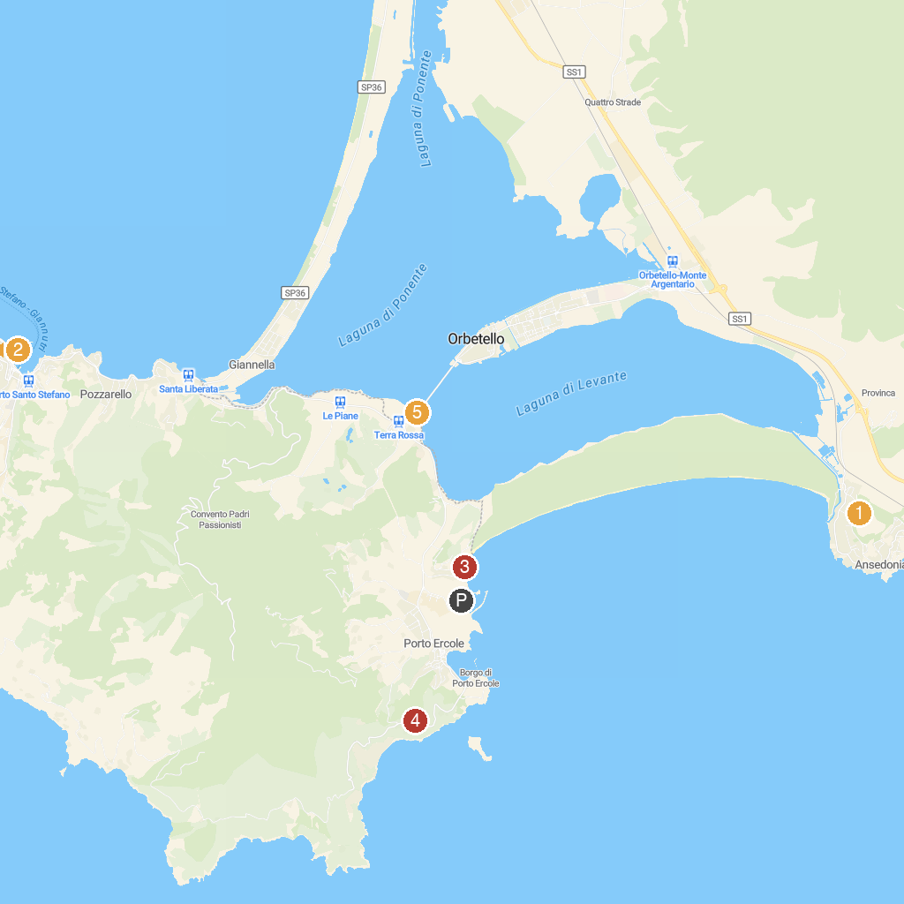
MAP KEY
1. Roman Town of Cosa | 4. Fort Stella
2. Argentario Aquarium | 5. Pista Ciclabile di Orbetello
3. Spiaggia libera
P. Cruise port / terminal
Map © MapTiler © OpenStreetMap contributors · cruiseports.org

