Porto Levante, Vulcano, Aeolian Islands, Italy
The island that gave the world the word 'volcano.' Vulcano greets you with a sulfur tang in the air, fumaroles hissing at the waterfront, and one of the most dramatic crater hikes in the Mediterranean — all reachable on foot from the tender pier.
⚓ Tender port · 🕒 Typical call: 6-8 hrs · 💶 Currency: Euro · 🗣️ Language: Italian
✍️ MY DAY IN PORT (FILL IN)
Ship / Date
In port | arrive ______ · all aboard ______
Booked excursion
Notes / meeting point
GETTING ASHORE
- Docking: Tender — ships anchor in the bay; tenders land at the Porto Levante pier
- Walk to center: 2 min to village; 3 min to mud baths; 10 min to black sand beach
- Best For: Volcanic crater hike, thermal mud baths, Aeolian food & wine
- Don't Miss: Gran Cratere hike for 360° Aeolian archipelago views
GETTING AROUND
- 🚕 Taxi: €10–€20 — Licensed taxis and NCC (Noleggio Con Conducente) private car services operate in the area around Porto Levante and nearb
TOP THINGS TO DO
- Gran Cratere Crater Hike — A 45–60 min climb to the rim of Vulcano's active Fossa crater rewards you with 360° views across the whole Aeolian archipelago…
- Thermal Mud Baths (Laghetto di Fanghi) — Lather yourself in warm mineral mud just 3 minutes from the pier, then rinse off in the sea where underwater geothermal vents…
- Black Sand Beach (Sabbie Nere) — A dramatic crescent of jet-black volcanic sand on the Porto Ponente side, 10 minutes' walk from the pier.
- Valle dei Mostri (Valley of Monsters) — On the Vulcanello peninsula, wind and lava have carved black basalt into shapes that look like mythical beasts.
- Boat Tour to Venus Pool & Horse Cave — Local boatmen at the pier run 1-2 hour trips around the west coast to the Venus Pool (Piscina di Venere) — a turquoise natural…
BEST WALKS
- Port to Crater Trailhead & Back: 2.5 km | 2-3 hrs with climb | Moderate — Walk straight from the pier through the village, past the fumaroles, and up to the Gran Cratere…
- Isthmus Walk: Levante to Sabbie Nere Beach: 1 km | 10 min | Easy — Cross the flat sandy isthmus from the east-side mud baths and hot-spring beach over to the…
WEATHER · DAYLIGHT · MONEY
Month | High °F | Low °F | Rainy days
May | 69 | 59 | 12
Jul | 83 | 71 | 8
Sep | 75 | 64 | 9
Daylight: May 5:41AM–8:32PM · Jul 5:38AM–8:54PM · Sep 6:49AM–7:21PM
cruiseports.org/porto-levante · Confirm terminal & all-aboard time with your ship

Porto Levante, Vulcano, Aeolian Islands, Italy — Port Map
Red = walkable sights · Amber = excursions farther out · P = cruise terminal
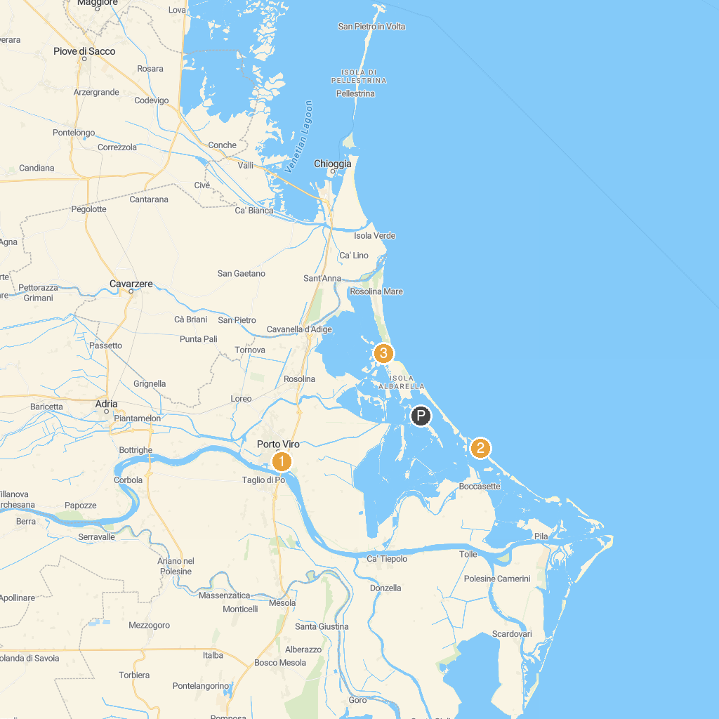
MAP KEY
1. Parco Regionale Veneto del Delta del Po | 3. Panoramic Point
2. Bagno azzurra boccasette
P. Cruise port / terminal
Map © MapTiler © OpenStreetMap contributors · cruiseports.org

