Portobelo, Colón, Panama
A UNESCO-listed colonial stronghold on Panama's Caribbean coast, Portobelo guards its Spanish forts, Black Christ legend, and turquoise bay with quiet pride — bring cash and an umbrella.
⚓ Tender (no pier) · 🕒 Typical call: 5–7 hrs · 💵 USD (cash essential) · 🗣️ Spanish · 🏛️ UNESCO World Heritage
✍️ MY DAY IN PORT (FILL IN)
Ship / Date
In port | arrive ______ · all aboard ______
Booked excursion
Notes / meeting point
GETTING ASHORE
- Docking: Tender — ships anchor in the bay; water taxis to shore
- Walk to center: ~5 min from tender dock to Fuerte San Jerónimo
- Best For: Colonial history, snorkeling, Afro-Panamanian culture
- Don't Miss: Iglesia de San Felipe (Black Christ church) and Fuerte San Jerónimo cannons
GETTING AROUND
- 🚕 Taxi: $40–$45 one-way — Local taxis near the waterfront can take you to Colón (~50 km away). Negotiate the fare before departing; asking the dri
TOP THINGS TO DO
- Spanish Forts & UNESCO Ruins — Wander three Spanish colonial fortifications — Fuerte San Jerónimo, Fuerte San Fernando, and Fuerte Santiago — that once guarded…
- Black Christ Church (Iglesia de San Felipe) — Visit the 1814 church housing the venerated Nazareno of Portobelo — the Black Christ.
- Snorkeling & Catamaran Day — Catamaran tours from Portobelo explore Caribbean cays, coral reefs, and starfish-filled shallows.
- Isla Grande Boat Trip — Isla Grande is a relaxed Caribbean island with beaches, a small restaurant strip, and a lighthouse.
- Portobelo National Park & Kayaking — The national park surrounding the town includes mangrove forests, jungle trails, coral reefs, and nesting turtle beaches.
BEST WALKS
- Fort & Church Walking Loop: ~1.5 km · 45–60 min · easy — From the tender dock, walk along the waterfront to Fuerte San Jerónimo, then continue to Fuerte San…
- Customs House & Waterfront Stroll: ~0.5 km · 20 min · easy — Short stroll from the dock past the restored Real Aduana (Royal Customs House) — once the counting…
WEATHER · DAYLIGHT · MONEY
Month | High °F | Low °F | Rainy days
May | 78 | 67 | 30
Jul | 79 | 64 | 22
Sep | 79 | 64 | 24
Daylight: May 6:16AM–6:13PM · Jul 6:26AM–6:22PM · Sep 6:11AM–6:15PM
cruiseports.org/portobelo · Confirm terminal & all-aboard time with your ship

Portobelo, Colón, Panama — Port Map
Red = walkable sights · Amber = excursions farther out · P = cruise terminal
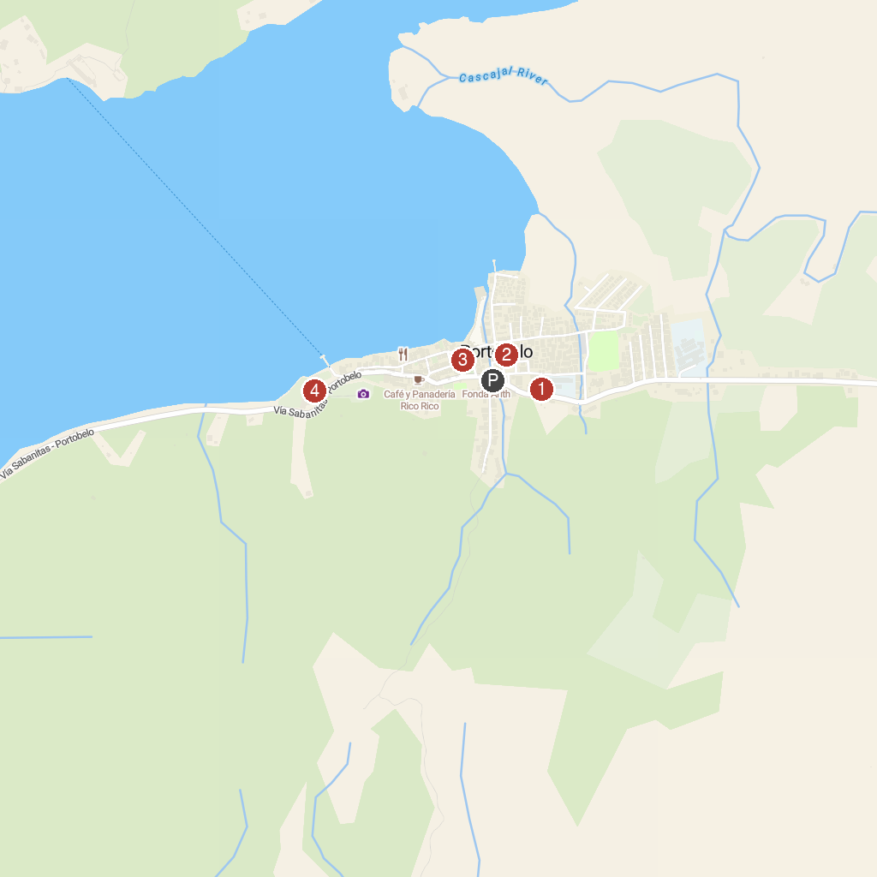
MAP KEY
1. Parque Nacional Portobelo | 3. Royal Customs House of Portobelo
2. Iglesia de San Felipe | 4. Santiago Battery
P. Cruise port / terminal
Map © MapTiler © OpenStreetMap contributors · cruiseports.org

