Portofino, Liguria, Italy
A crescent of pastel facades, luxury yachts, and lush Ligurian hillsides — Portofino is tiny, traffic-free, and unforgettable. Every cruise ship anchors offshore and tenders in, dropping you steps from the famous Piazzetta.
⚓ Tender only (no pier) · 🕒 Typical call: 6–8 hrs · 💶 Euro (€) · 🗣️ Italian · 🌊 Weather can cancel tender
✍️ MY DAY IN PORT (FILL IN)
Ship / Date
In port | arrive ______ · all aboard ______
Booked excursion
Notes / meeting point
GETTING ASHORE
- Docking: Tender only — ships anchor in the bay, ~10–15 min ride to Molo Umberto I
- Walk to center: 0 min — tender drops you directly at the Piazzetta
- Best For: Scenic strolling, seafood & pesto, Castello Brown views, light hiking
- Don't Miss: Castello Brown panorama, focaccia al formaggio, the lighthouse walk
GETTING AROUND
- 🚕 Taxi: €12–€13 to Santa Margherita Ligure — Taxis are available in Portofino for rides to nearby towns. The 15-minute trip to Santa Margherita Ligure runs roughly €
TOP THINGS TO DO
- Castello Brown & Harbor Views — Climb the steep path above the Piazzetta to this 16th-century fortress-turned-house-museum.
- Lighthouse Walk (Al Faro) — A shaded, mostly paved 30–40-minute path threads along the clifftop peninsula from the Piazzetta to the historic lighthouse.
- Abbey of San Fruttuoso by Ferry — A roughly 25–30-minute public ferry ride delivers you to a medieval Benedictine abbey set directly on a pebble cove — reachable…
- Paraggi Beach — The nearest sandy beach, a 20-minute walk or 5-minute bus ride from the Piazzetta.
- Ligurian Pesto & Focaccia Tasting — Liguria invented pesto Genovese and focaccia.
BEST WALKS
- Harbor to Lighthouse Loop: 2.5–3 km · 1–1.5 hrs · Moderate (uphill sections) — Start at Molo Umberto I on the Piazzetta, wind up the paved path to the Church of San Giorgio…
- Piazzetta to Paraggi Beach: 2 km one-way · 20–25 min · Easy (shaded path) — Take the signed pedestrian passeggiata that runs parallel to the coastal road to reach Paraggi's…
WEATHER · DAYLIGHT · MONEY
Month | High °F | Low °F | Rainy days
May | 68 | 58 | 14
Jul | 81 | 70 | 6
Sep | 76 | 65 | 10
Daylight: May 5:56AM–8:43PM · Jul 5:53AM–9:04PM · Sep 7:02AM–7:33PM
cruiseports.org/portofino · Confirm terminal & all-aboard time with your ship

Portofino, Liguria, Italy — Port Map
Red = walkable sights · Amber = excursions farther out · P = cruise terminal
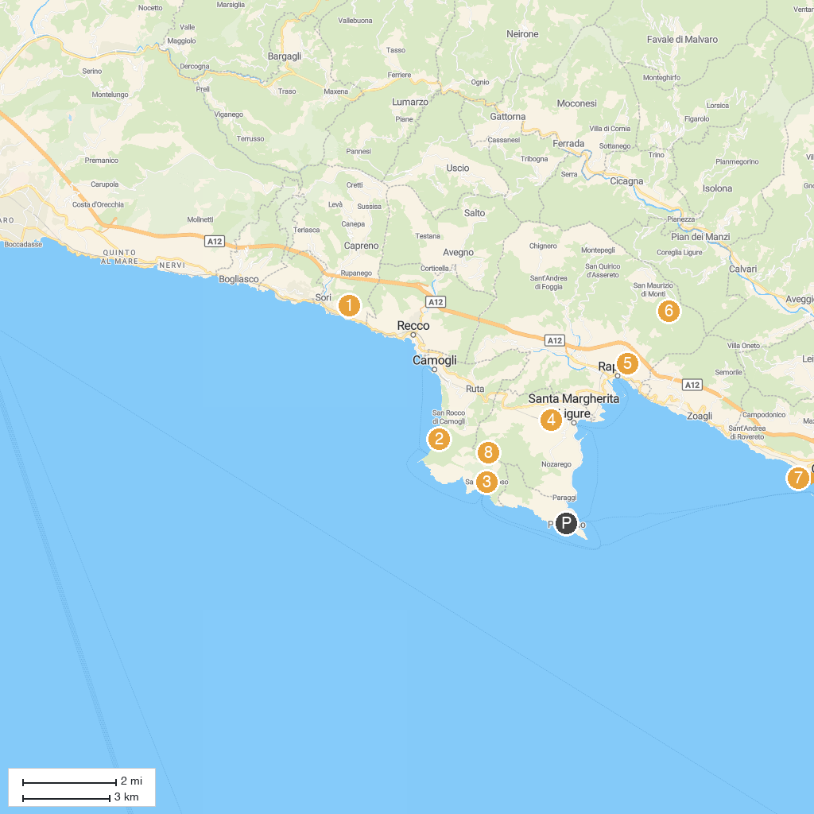
MAP KEY
1. Chiesa di Sant'Apollinare | 5. Funivia Rapallo Montallegro Stazione a Valle
2. San Nicolò di Capodimonte | 6. Funivia Rapallo - Montallegro / Stazione a monte
3. Abbazia di San Fruttuoso | 7. Parco di Villa Rocca
4. Chiesa di San Siro | 8. Pietre Strette
P. Cruise port / terminal
Map © MapTiler © OpenStreetMap contributors · cruiseports.org

