Portsmouth, Saint John, Dominica
Dominica's second city sits where a 18th-century British fort guards a sweep of tropical bay. Tender ashore at Cabrits Pier and you're steps from wild rivers, volcanic hikes, and one of the Caribbean's most unspoiled coastlines.
⚓ Tender port (Prince Rupert Bay) · 🕒 Typical call: 7-9 hrs · 💵 Eastern Caribbean Dollar / USD accepted · 🗣️ English (official)
✍️ MY DAY IN PORT (FILL IN)
Ship / Date
In port | arrive ______ · all aboard ______
Booked excursion
Notes / meeting point
GETTING ASHORE
- Docking: Tender to Cabrits Pier, Cabrits National Park
- Walk to center: ~1 mile (20 min) south to Portsmouth town
- Best For: Nature, history, river tours, whale watching
- Don't Miss: Indian River boat tour & Fort Shirley
GETTING AROUND
- 🚕 Taxi: $5–10 USD (local); $15–19 USD (to Roseau) — Taxis wait at the pier. Fares are not metered — negotiate before you get in. USD and Eastern Caribbean dollars both acce
TOP THINGS TO DO
- Indian River Boat Tour — Glide through a serene mangrove corridor on a hand-oared wooden boat guided by local boatmen.
- Fort Shirley & Cabrits National Park — Walk straight from the pier into this restored 18th-century British garrison perched on volcanic headlands.
- Whale & Dolphin Watching — Dominica is one of the world's best year-round spots for sperm whale encounters.
- Champagne Reef Snorkel — Drive south to this volcanic snorkel site where underwater hot springs bubble through the reef like carbonation, creating a…
- Trafalgar Falls Day Trip — Twin waterfalls — Father and Mother — cascade into pools surrounded by lush Morne Trois Pitons National Park vegetation.
BEST WALKS
- Cabrits Peninsula Loop: 1.5 miles | Easy-moderate | 45-60 min — From Cabrits Pier, follow signs into Cabrits National Park.
- Pier to Portsmouth Waterfront Walk: 1 mile | Easy | 20 min — A flat, pleasant walk south along Prince Rupert Bay's shoreline from Cabrits Pier into Portsmouth…
WEATHER · DAYLIGHT · MONEY
Month | High °F | Low °F | Rainy days
May | 88 | 75 | 11
Jul | 88 | 77 | 15
Sep | 88 | 75 | 16
Daylight: May 5:36AM–6:27PM · Jul 5:43AM–6:40PM · Sep 5:54AM–6:07PM
Representative sunrise/sunset — 2025, 15th of each month; local civil time including DST (America/Dominica). Source: Astral; not a forecast or climate average.
cruiseports.org/portsmouth-dominica · Confirm terminal & all-aboard time with your ship

Portsmouth, Saint John, Dominica — Port Map
Red = walkable sights · Amber = excursions farther out · P = cruise terminal
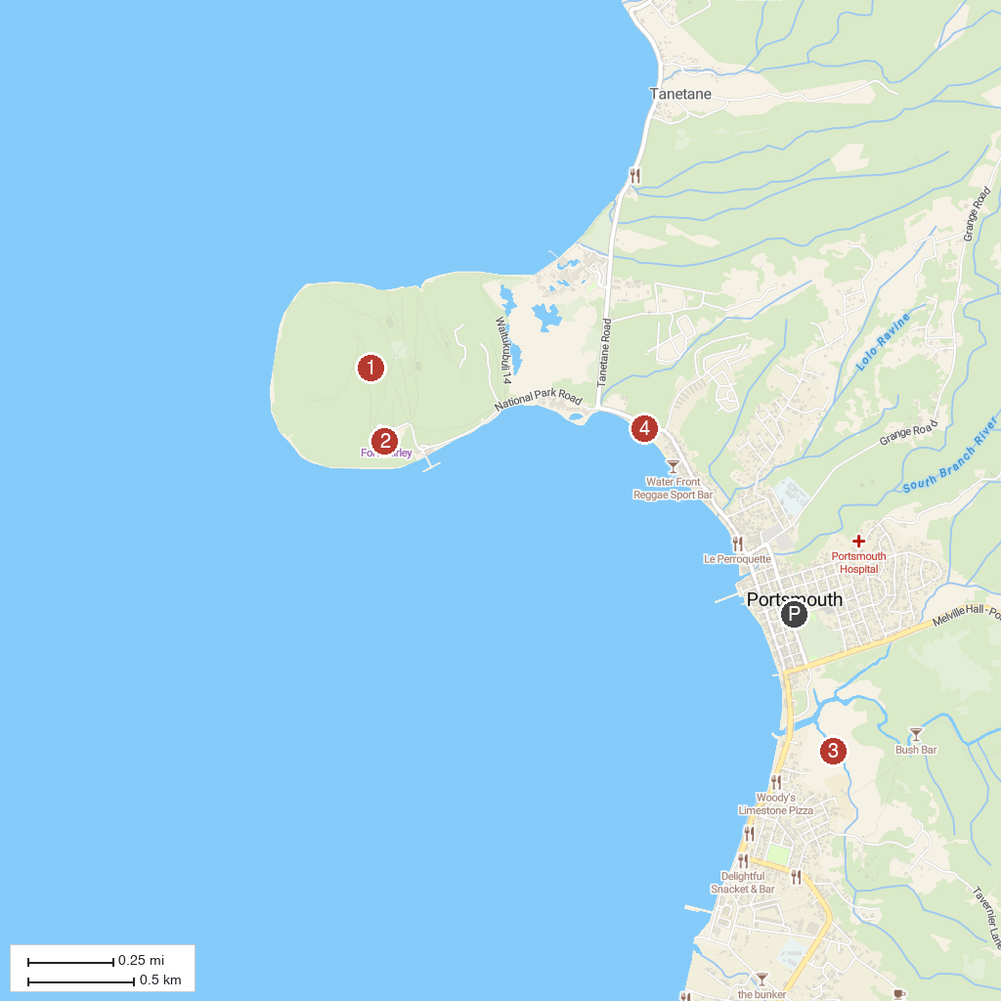
MAP KEY
1. Cabrits National Park | 3. Indian River
2. Fort Shirley | 4. Purple Turtle Beach
P. Cruise port / terminal
Map © MapTiler © OpenStreetMap contributors · cruiseports.org

