Portsmouth, England, United Kingdom
The UK's only island city and birthplace of the Royal Navy, Portsmouth packs 800 years of maritime history into one walkable waterfront — with world-class warships, a dramatic harbour, and a modern outlet marina just steps apart.
⚓ Docked (pier) · 🕒 Typical call: 8-10 hrs · 💷 British Pound (GBP) · 🗣️ English · 🚢 Portsmouth International Port
✍️ MY DAY IN PORT (FILL IN)
Ship / Date
In port | arrive ______ · all aboard ______
Booked excursion
Notes / meeting point
GETTING ASHORE
- Docking: Docked at Portsmouth International Port — no tendering
- Walk to center: ~2 miles (40 min) to Historic Dockyard; flat terrain
- Best For: Naval history, warships, waterfront dining, outlet shopping
- Don't Miss: HMS Victory & the Mary Rose Museum at the Historic Dockyard
GETTING AROUND
- 🚕 Taxi: £6–£8 — The cruise terminal is less than a mile from Portsmouth city centre; a taxi takes 3–5 minutes. Licensed taxis queue outs
- 📱 Rideshare: ✅ Uber, Bolt
TOP THINGS TO DO
- Portsmouth Historic Dockyard — The centrepiece of any Portsmouth day.
- Spinnaker Tower & Gunwharf Quays — Ride the lift up the 170m sail-shaped Spinnaker Tower for 360° views of the harbour, Solent, and Isle of Wight — including the…
- Old Portsmouth & The Hotwalls — Wander cobblestone lanes past the Round Tower, Square Tower, and Royal Garrison Church — defences that have guarded the harbour…
- The D-Day Story Museum — The UK's only museum dedicated entirely to the Normandy landings, housing the 83m Overlord Embroidery (a 20th-century Bayeux…
- Southsea Seafront & Hovercraft — Stroll the wide promenade along Southsea Common (100+ acres) to shingle Southsea Beach.
BEST WALKS
- Historic Harbour Loop: 2.5 miles · 60-75 min · Easy · Flat — Start at Gunwharf Quays, walk past the Spinnaker Tower base and along the waterfront toward the…
- Southsea Promenade Walk: 2 miles · 45-60 min · Easy · Flat seafront — From Old Portsmouth's Hotwalls, walk east along the seafront promenade past the D-Day memorial and…
WEATHER · DAYLIGHT · MONEY
Month | High °F | Low °F | Rainy days
May | 61 | 49 | 11
Jul | 70 | 59 | 10
Sep | 66 | 55 | 10
Daylight: May 5:15AM–8:46PM · Jul 5:08AM–9:11PM · Sep 6:40AM–7:17PM
cruiseports.org/portsmouth-uk · Confirm terminal & all-aboard time with your ship

Portsmouth, England, United Kingdom — Port Map
Red = walkable sights · Amber = excursions farther out · P = cruise terminal
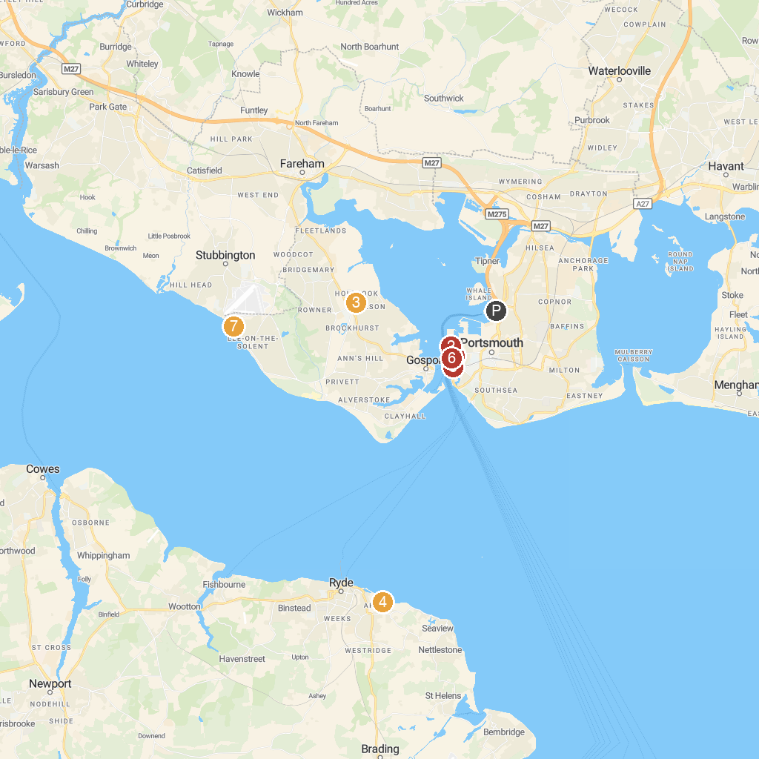
MAP KEY
1. Portsmouth Historic Dockyard | 5. Spinnaker Tower
2. Royal Navy Museums: HMS Victory | 6. Royal Navy Museums: HMS Warrior
3. Fort Brockhurst | 7. The Hovercraft Museum
4. Appley Park
P. Cruise port / terminal
Map © MapTiler © OpenStreetMap contributors · cruiseports.org

