Positano, Amalfi Coast, Italy
Pastel houses cascade down sheer cliffs to a dark-pebble beach — Positano is the Amalfi Coast at its most dramatic. Expect steep staircases, chic boutiques, fresh seafood, and views that belong on a postcard.
⚓ Tender port (boutique/expedition ships only) · 🕒 Typical call: 6–8 hrs · 💶 Currency: Euro (€) · 🗣️ Language: Italian · 🏔️ Strenuous walking — lots of stairs
✍️ MY DAY IN PORT (FILL IN)
Ship / Date
In port | arrive ______ · all aboard ______
Booked excursion
Notes / meeting point
GETTING ASHORE
- Docking: Tender — ship anchors in bay; tender to Molo di Positano pier
- Walk to center: 1 min flat to Spiaggia Grande; 5–10 min uphill to town
- Best For: Scenic wandering, beaches, handmade sandals, Amalfi Coast views
- Don't Miss: Church of Santa Maria Assunta dome; Fornillo Beach; custom leather sandals
GETTING AROUND
- 🚕 Taxi: €10–15 in town; €120–150 to Sorrento/Amalfi — Licensed taxis operate from ranks near the beach and upper road. Fares within Positano are fixed but steep; longer trans
- 📱 Rideshare: ❌ not available
TOP THINGS TO DO
- Amalfi Coast Boat Tour — Board a traditional wooden gozzo for a private or shared tour along the coast — sea caves, the Li Galli islands (said to be the…
- Path of the Gods Hike — The Sentiero degli Dei trails across the cliffs 630 m above sea level with breathtaking views of the entire Amalfi Coast.
- Roman Villa Under the Church (MAR Museum) — Descend beneath the Church of Santa Maria Assunta into a remarkably preserved 1st-century Roman villa buried by Vesuvius in 79 AD.
- Fornillo Beach Day — Escape Spiaggia Grande's crowds via the scenic Via Positanesi d'America path — a mostly flat 10-minute coastal walk ending at…
- Day Trip to Capri by Ferry — Regular high-speed ferries run from Positano's pier to Capri in about 50 minutes.
BEST WALKS
- Pier to Piazza dei Mulini (Town Center): 20 min round-trip | Moderate uphill | Paved paths — From the tender pier, follow the pedestrian alley uphill past boutique shops, ceramic stalls, and…
- Coastal Path to Fornillo Beach: 20–25 min round-trip | Easy-flat | Scenic coastal walk — From the main pier, follow the Via Positanesi d'America coastal walkway — it hugs the cliff face…
WEATHER · DAYLIGHT · MONEY
Month | High °F | Low °F | Rainy days
May | 69 | 58 | 11
Jul | 83 | 71 | 4
Sep | 77 | 66 | 8
Daylight: May 5:45AM–8:12PM · Jul 5:44AM–8:31PM · Sep 6:43AM–7:10PM
cruiseports.org/positano · Confirm terminal & all-aboard time with your ship

Positano, Amalfi Coast, Italy — Port Map
Red = walkable sights · Amber = excursions farther out · P = cruise terminal
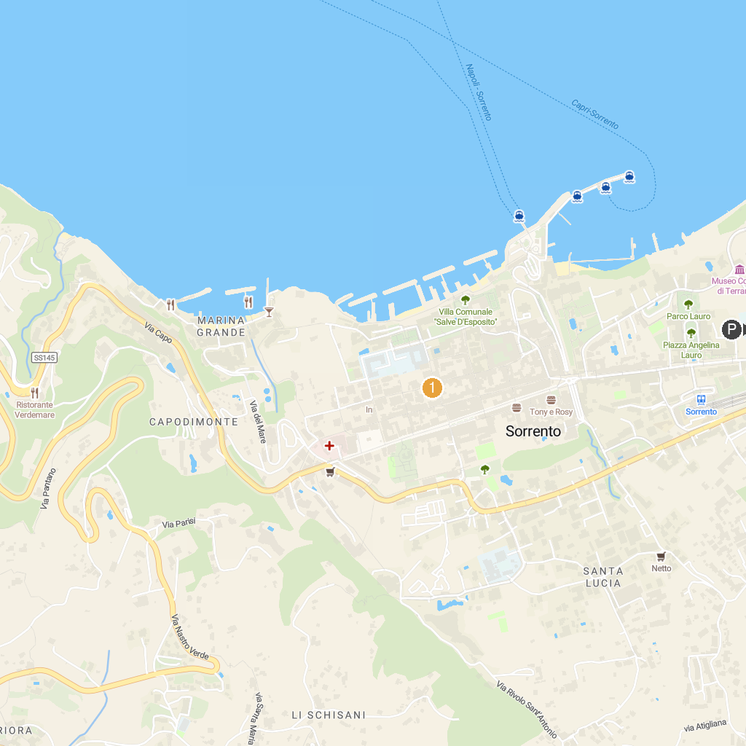
MAP KEY
1. House of Meleager | 5. Macellum
2. Amphitheatre of Pompeii | 6. Temple of Isis
3. The brothel of Pompeii | 7. Temple of Venus in Pompeii
4. Church of Santi Felice and Baccolo
P. Cruise port / terminal
Map © MapTiler © OpenStreetMap contributors · cruiseports.org

