Praia da Vitória, Terceira, Azores, Portugal
Terceira's east-coast port town opens onto the Azores' best sandy beach — and an island packed with volcanic caves, patchwork hillsides, and a UNESCO Renaissance city just 20 minutes away.
⚓ Pier (Porto Comercial) · 🕒 Typical call: 8-10 hrs · 💶 Euro (€) · 🗣️ Portuguese (English widely spoken)
✍️ MY DAY IN PORT (FILL IN)
Ship / Date
In port | arrive ______ · all aboard ______
Booked excursion
Notes / meeting point
GETTING ASHORE
- Docking: Pier — Porto Comercial da Praia da Vitória; no tendering
- Walk to center: ~1.5–2 km flat walk along the marina; shuttle often available
- Best For: Volcanic landscapes, UNESCO city, patchwork viewpoints, beach day
- Don't Miss: Algar do Carvão volcanic chimney and a plate of Alcatra beef
GETTING AROUND
- 🚕 Taxi: €10–15 — Taxis wait at the pier and can reach the town center in minutes. Fares are metered; expect €10–15 for the short ride wit
- 📱 Rideshare: ✅ Bolt
TOP THINGS TO DO
- Algar do Carvão — Volcanic Chimney — Descend into one of the world's only accessible volcanic chimneys — a moss-draped cavern ending in a crystal-clear rainwater lake.
- Angra do Heroísmo — UNESCO Old City — Terceira's capital is a beautifully preserved Renaissance city with 16th-century fortresses, cobblestone streets, and the lush…
- Serra do Cume Viewpoint — Terceira's most photographed panorama: an emerald patchwork of green fields divided by black volcanic stone walls.
- Biscoitos Natural Pools — Atlantic rock pools on Terceira's north coast formed from volcanic basalt — calm enough to swim while surf breaks just outside.
- Impérios & Holy Spirit Chapels — Terceira's brightly painted Holy Spirit chapels — called Impérios — are unique to this island.
BEST WALKS
- Town & Beach Stroll: 1.5 km · 20 min · Flat · Easy — Walk the marina promenade to Praia Grande beach, then cut through the pedestrianized Rua de Jesus…
- Facho Viewpoint Hike: 2 km round-trip · 30-40 min · Strenuous climb · Rewarding views — From the town center, follow the staircase path up to Miradouro do Facho for a panoramic sweep of…
WEATHER · DAYLIGHT · MONEY
Month | High °F | Low °F | Rainy days
May | 65 | 59 | 14
Jul | 74 | 67 | 12
Sep | 73 | 68 | 16
Daylight: May 6:36AM–8:53PM · Jul 6:36AM–9:12PM · Sep 7:30AM–7:55PM
cruiseports.org/praia-da-vitoria · Confirm terminal & all-aboard time with your ship

Praia da Vitória, Terceira, Azores, Portugal — Port Map
Red = walkable sights · Amber = excursions farther out · P = cruise terminal
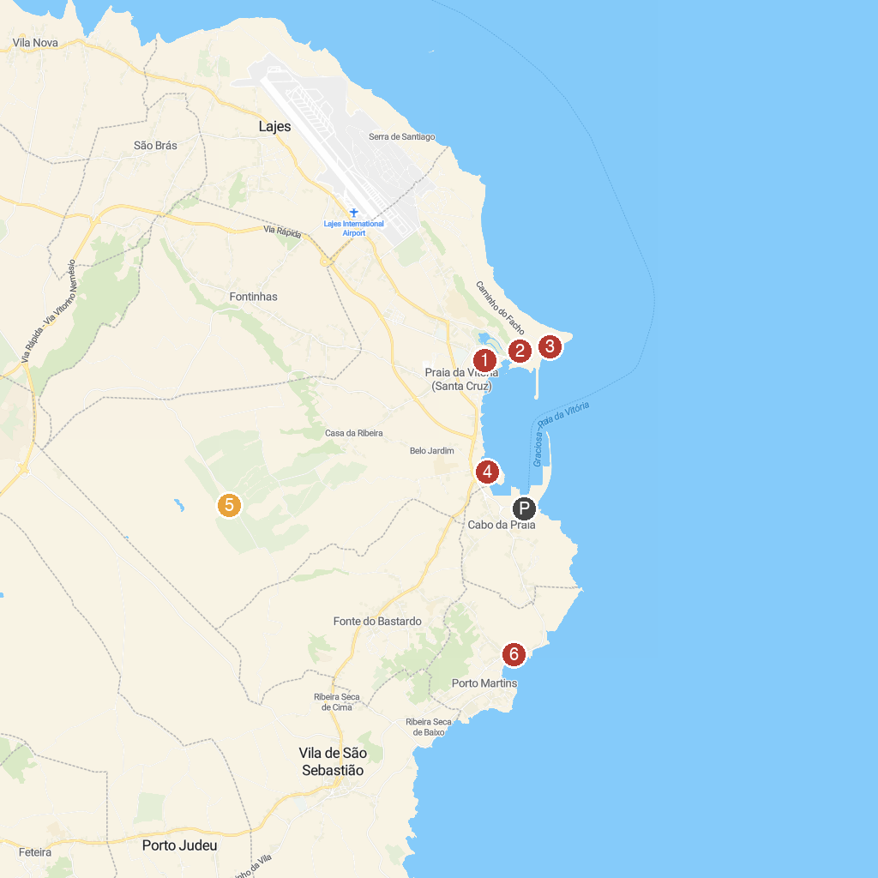
MAP KEY
1. Algar do Carvão | 5. Praia da Riviera
2. Casa de Vitorino Nemésio | 6. Miradouro da Serra do Cume
3. Facho Viewpoint | 7. Baía das Canas
4. Miradouro da Ponta da Má Merenda
P. Cruise port / terminal
Map © MapTiler © OpenStreetMap contributors · cruiseports.org

