Praia, Cape Verde
For an authentic experience, explore the Plateau (Platô) district for colonial history and the vibrant markets of the city.
🏙️ Capital City · 🏛️ Colonial Architecture · 🏖️ Atlantic Coast · 🎶 Carnival Spirit
✍️ MY DAY IN PORT (FILL IN)
Ship / Date
In port | arrive ______ · all aboard ______
Booked excursion
Notes / meeting point
GETTING ASHORE
- Docking: Dock or tender — confirm with your line
- Port: Praia Port (Porto de Praia)
- Currency: Cape Verdean Escudo (CVE)
- Language: Portuguese and Kriolu
GETTING AROUND
- 🚕 Taxi: 500–1,000 CVE (~€5–10) — Taxis wait at the port and are the most convenient option to reach the Plateau (city center), about 2–3 km away. Agree o
- 📱 Rideshare: ❌ not available
TOP THINGS TO DO
- The Plateau (Platô) District — Walk through the historic center, visiting the Presidential Palace and colonial squares.
- Sucupira Market — Immerse yourself in the bustling open-air market filled with fresh produce, spices, textiles, and local crafts.
- Quebra Canela Beach — Relax on the crescent-shaped golden sands with calm waters, beach bars, and fresh seafood.
- Cidade Velha & São Filipe Fort — Visit the UNESCO-listed first European colonial town in the tropics and explore the hilltop Fortaleza Real de São Filipe.
BEST WALKS
- The Plateau Loop: Historic Center — A loop around the historic Plateau district, visiting the Presidential Palace and colonial-era…
- Coastal Promenade: Ocean View — A walk along the waterfront, offering views of the Atlantic and the ships in the harbor.
- Market Wander: Shopping — A stroll through Sucupira Market, exploring the local trade and culture.
WEATHER · DAYLIGHT · MONEY
Month | High °F | Low °F | Rainy days
May | 80 | 69 | 0
Jul | 83 | 72 | 1
Sep | 84 | 76 | 10
Daylight: May 6:05AM–6:55PM · Jul 6:12AM–7:07PM · Sep 6:22AM–6:35PM
cruiseports.org/praia · Confirm terminal & all-aboard time with your ship

Praia, Cape Verde — Port Map
Red = walkable sights · Amber = excursions farther out · P = cruise terminal
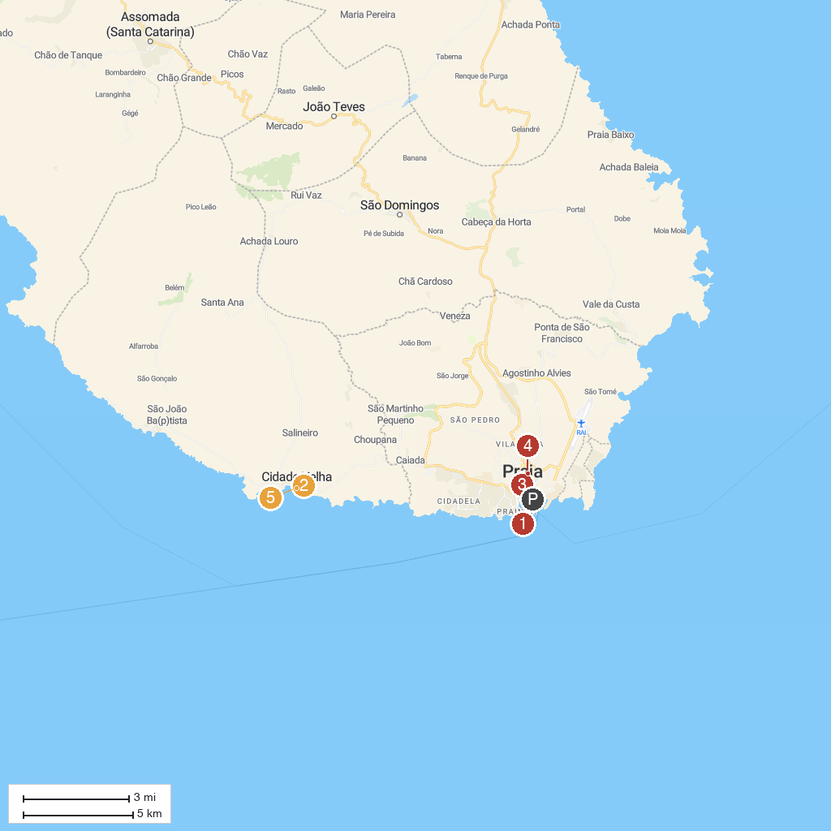
MAP KEY
1. Lighthouse Dona Maria Pia | 4. Museu Etnográfico da Praia
2. São Filipe Royal Fortress | 5. Pelourinho
3. Presidential Palace
P. Cruise port / terminal
Map © MapTiler © OpenStreetMap contributors · cruiseports.org

