Primošten, Dalmatia, Croatia
A medieval fishing peninsula with narrow stone alleys, sun-warmed pebble beaches, and vineyards so unique they hang in the United Nations — Primošten is the Adriatic at its most authentic.
⚓ Tender (no pier) · 🕒 Typical call: 4–7 hrs · 💶 Euro (€) · 🗣️ Croatian
✍️ MY DAY IN PORT (FILL IN)
Ship / Date
In port | arrive ______ · all aboard ______
Booked excursion
Notes / meeting point
GETTING ASHORE
- Docking: Tender — ships anchor in the bay, tenders land on the Riva waterfront
- Walk to centre: 2 min from tender pier to Old Town gate
- Best For: Beaches, wine, wandering medieval alleys, photography
- Don't Miss: Church of St. George panorama & the UNESCO-listed Babić vineyards
GETTING AROUND
- 🚕 Taxi: €9–11 — If your ship docks at nearby Marina Kremik (~3 km south), a taxi to the town center costs roughly €9–11 per vehicle. Loc
- 📱 Rideshare: ✅ Uber
TOP THINGS TO DO
- Old Town & Church of St. George — Wind through the medieval stone alleys of Stari Grad up to the 15th-century Church of St.
- Mala & Velika Raduča Beaches — Two pebble beaches flank the Old Town — Mala Raduča is 5 minutes from the tender pier; Velika Raduča offers pine shade, sunbeds…
- Babić Wine Tasting at Local Vineyards — The stone-lace Bucavac vineyards outside town — tentative UNESCO World Heritage — produce the region's prized full-bodied Babić…
- Krka National Park Day Trip — Just 35 minutes by road, Krka's spectacular travertine waterfalls and emerald river pools are among Croatia's top natural sites.
- Šibenik UNESCO Old Town — A 30-minute drive brings you to Šibenik's Cathedral of St.
BEST WALKS
- Old Town Loop & St. George Viewpoint: 1.5 km · 30–45 min · Easy (some cobblestone inclines) — From the tender landing on the Riva, pass through the historic town gate and wind uphill through…
- Raduča Peninsula Promenade: 2 km loop · 30 min · Easy — A shaded paved path encircles the forested Raduča peninsula just west of the Old Town, linking Mala…
WEATHER · DAYLIGHT · MONEY
Month | High °F | Low °F | Rainy days
May | 74 | 58 | 1
Jul | 89 | 71 | 0
Sep | 80 | 64 | 1
Daylight: May 5:31AM–8:14PM · Jul 5:29AM–8:34PM · Sep 6:36AM–7:06PM
cruiseports.org/primosten · Confirm terminal & all-aboard time with your ship

Primošten, Dalmatia, Croatia — Port Map
Red = walkable sights · Amber = excursions farther out · P = cruise terminal
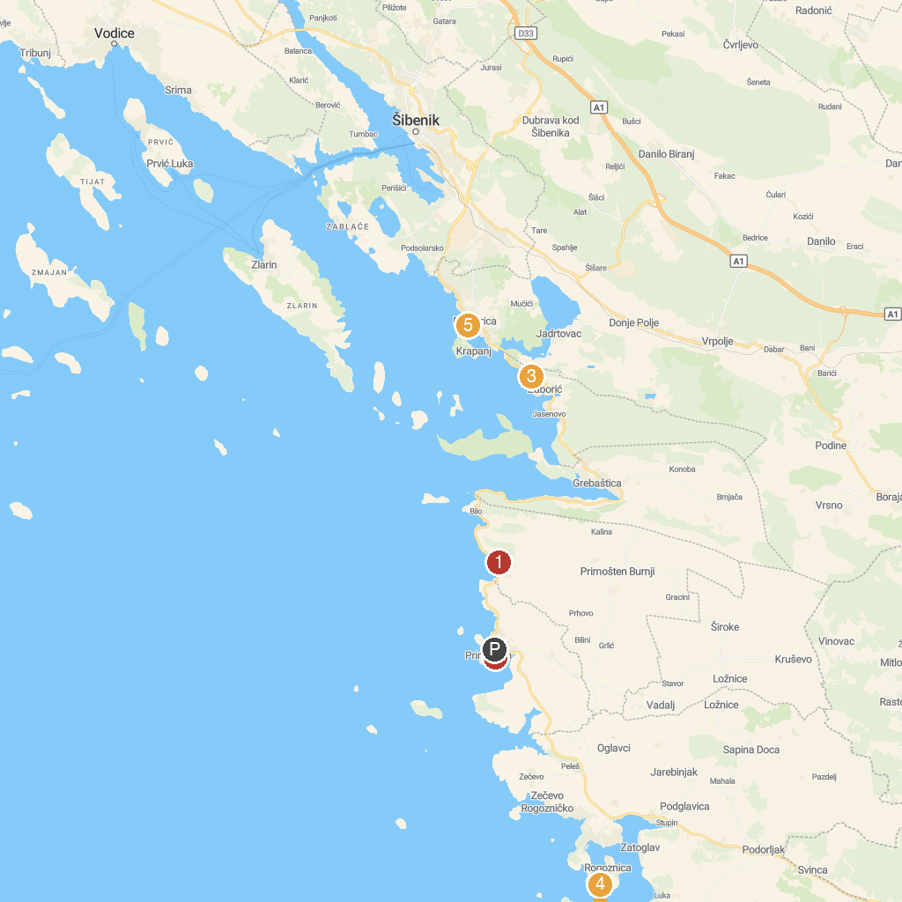
MAP KEY
1. Dolac | 5. Пляж "Бродарица"
2. Plaža Luka | 6. Beach Solina
3. Plaża Žaborić | 7. Beach Zablaće
4. Movar | 8. Uvala Stari Trogir
P. Cruise port / terminal
Map © MapTiler © OpenStreetMap contributors · cruiseports.org

