Prince Rupert, British Columbia, Canada
Gateway to the Great Bear Rainforest, Prince Rupert punches well above its size — totem poles, grizzly sanctuaries, and reversing rapids all within reach of a charming waterfront you can walk to straight off the ship.
⚓ Docked — Northland Cruise Terminal · 🕒 Typical call: 7-9 hrs · 💵 Canadian dollar (CAD) · 🗣️ English
✍️ MY DAY IN PORT (FILL IN)
Ship / Date
In port | arrive ______ · all aboard ______
Booked excursion
Notes / meeting point
GETTING ASHORE
- Docking: Alongside at Northland Cruise Terminal; no tender needed
- Walk to centre: 5–10 min to Cow Bay district
- Best For: Wildlife watching, First Nations culture, rainforest hiking
- Don't Miss: Khutzeymateen Grizzly Sanctuary or the Museum of Northern BC
GETTING AROUND
- 🚕 Taxi: CAD $15–40 — Local taxis (Skeena Taxi 250-624-2185, Papa Taxi 250-622-7272) serve further destinations. Fare to the North Pacific Can
- 📱 Rideshare: ✅ Uber
TOP THINGS TO DO
- Khutzeymateen Grizzly Bear Sanctuary — Canada's first protected grizzly habitat, accessible only by floatplane or boat.
- Great Bear Rainforest by Rail & Road — A scenic rail journey inland through old-growth rainforest combined with a road segment showcasing glacial valleys and salmon…
- Whale Watching & Marine Wildlife — The nutrient-rich waters off Prince Rupert support humpback whales, orcas, Steller sea lions, and bald eagles.
- North Pacific Cannery National Historic Site — A remarkably intact 19th-century salmon cannery at Port Edward (~20 min south) that once employed 800 seasonal workers.
- Museum of Northern BC & Totem Poles — Housed in a longhouse-style building, this museum tells the story of the Ts'msyen (Tsimshian) Nation and Northwest Coast peoples…
BEST WALKS
- Cow Bay Waterfront Stroll: 1 km · Easy · 20–30 min — Follow the Atlin Promenade from the cruise terminal along the waterfront into Cow Bay.
- Downtown Totem Pole & Museum Walk: 2–3 km · Easy · 45–60 min — From Cow Bay, head inland to the Museum of Northern BC on First Avenue, then walk through downtown…
WEATHER · DAYLIGHT · MONEY
Month | High °F | Low °F | Rainy days
May | 57 | 43 | 14
Jul | 64 | 53 | 15
Sep | 60 | 49 | 18
Daylight: May 5:36AM–9:39PM · Jul 5:27AM–10:06PM · Sep 7:15AM–7:56PM
cruiseports.org/prince-rupert-bc · Confirm terminal & all-aboard time with your ship

Prince Rupert, British Columbia, Canada — Port Map
Red = walkable sights · Amber = excursions farther out · P = cruise terminal
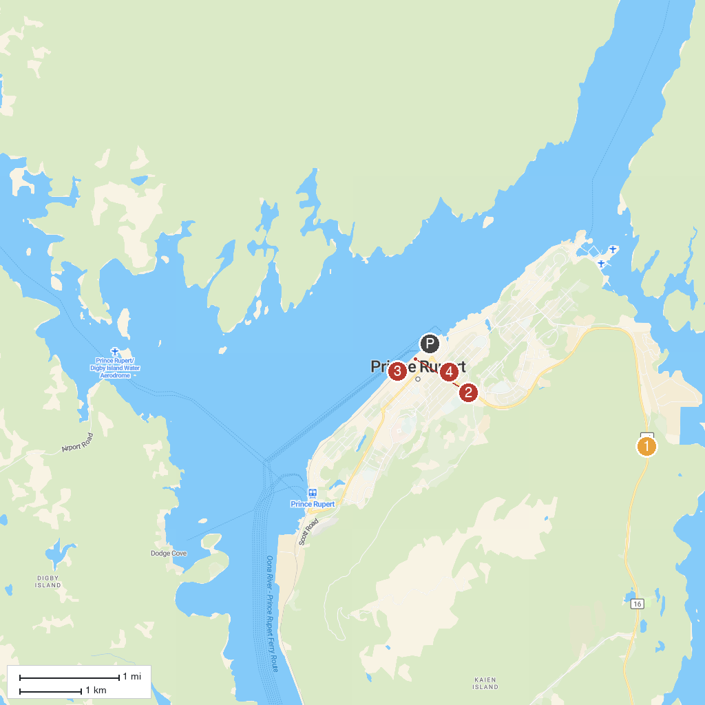
MAP KEY
1. Tall Trees Trail | 4. Chances Prince Rupert Casino
2. Diana Lake Provincial Park | 5. Rotary Waterfront Park
3. Prudhomme Lake Provincial Park | 6. Moose Tot Park
P. Cruise port / terminal
Map © MapTiler © OpenStreetMap contributors · cruiseports.org

