Princess Cays, Eleuthera, Bahamas
Half a mile of white-sand beach on the southern tip of Eleuthera — a private slice of the Bahamas served up exclusively for cruise guests, with a living coral reef just steps from shore.
⚓ Tender port (no pier) · 🕒 Typical call: 7-9 hrs · 💵 USD / cruise card (vendors: cash only) · 🗣️ English · 🏖️ Private beach resort
✍️ MY DAY IN PORT (FILL IN)
Ship / Date
In port | arrive ______ · all aboard ______
Booked excursion
Notes / meeting point
GETTING ASHORE
- Docking: Tender — ship anchors offshore; 10–20 min tender ride to marina
- Best For: Beach day, snorkeling, bungalow rentals, family relaxation
- Don't Miss: Coral reef snorkeling just off the beach; Bahamian straw market
- Watch Out For: Rocky shoreline entry — water shoes are essential
GETTING AROUND
- 📱 Rideshare: ❌ not available
TOP THINGS TO DO
- Snorkel the Natural Reef — A thriving coral reef sits just offshore, accessible from the beach with minimal swimming.
- Dune Buggy Heritage Adventure — Cruise off the resort property and explore Eleuthera's dramatic scenery and local heritage on an open dune buggy.
- Stingray Encounter — Wade into a sheltered lagoon on-site and interact with southern stingrays in a guided, shallow-water experience — a big hit with…
- Private Bungalow or Clamshell — Reserve a shaded clamshell (two loungers, canvas canopy) or an air-conditioned bungalow for the day.
- Clear-Bottom Kayaking — Paddle a transparent kayak over Eleuthera's brilliant shallow flats and spot sea life below without getting wet.
BEST WALKS
- Marina to Observation Tower & South Beach: ~1.5 km one-way | Easy | 15–20 min — From the tender marina, stroll south past the main beach bars and grill toward quieter South Beach.
- Bahamian Straw Market Stroll: ~5 min from marina | Easy — Just beyond the marina, a designated area hosts local Bahamian artisans selling straw hats, bags…
cruiseports.org/princess-cays · Confirm terminal & all-aboard time with your ship

Princess Cays, Eleuthera, Bahamas — Port Map
Red = walkable sights · Amber = excursions farther out · P = cruise terminal
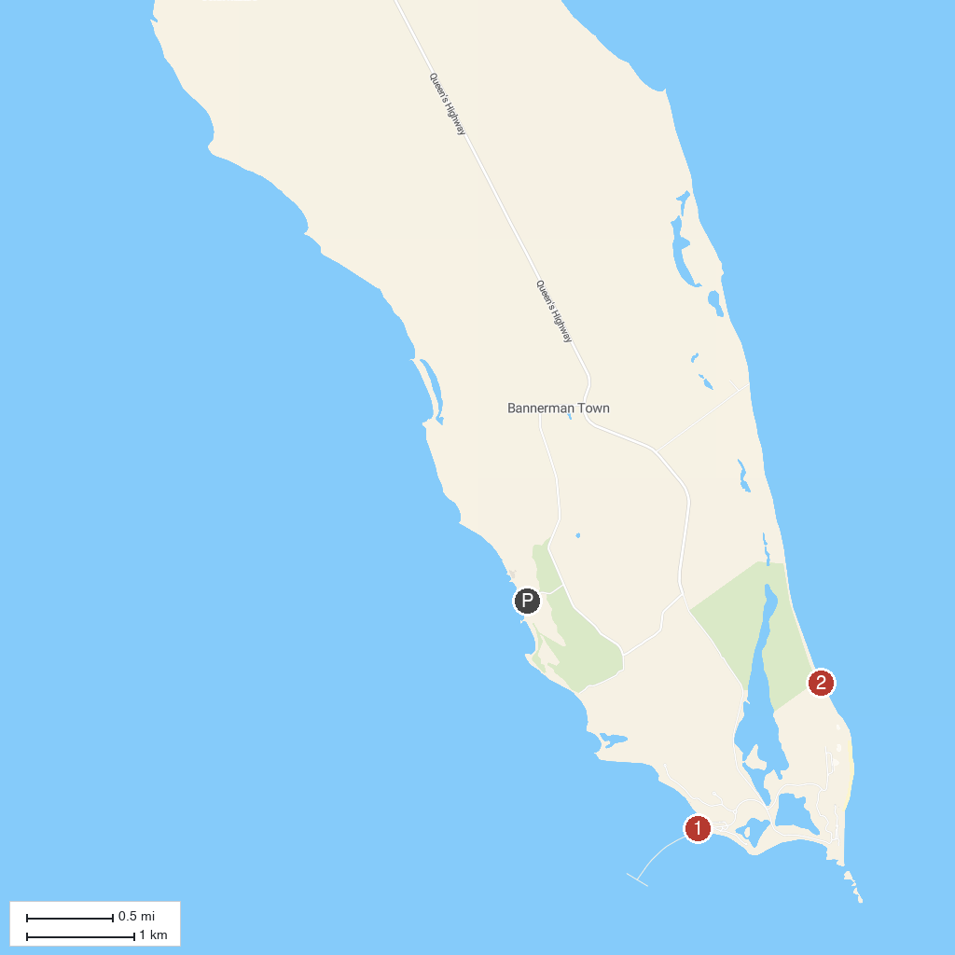
MAP KEY
1. Disney Lighthouse Point Marina | 2. Disney’s Lookout Cay at Lighthouse Point
P. Cruise port / terminal
Map © MapTiler © OpenStreetMap contributors · cruiseports.org

