Propriano, Corsica, France
One of Corsica's most authentic harbor towns, Propriano puts turquoise beaches, the Bronze Age statue-menhirs of Filitosa, and the maquis-scented alleys of Sartène all within easy reach of the pier.
⚓ Pier (small ships) / Tender (large ships) · 🕒 Typical call: 6-8 hrs · 💵 Euro (€) · 🗣️ French / Corsican
✍️ MY DAY IN PORT (FILL IN)
Ship / Date
In port | arrive ______ · all aboard ______
Booked excursion
Notes / meeting point
GETTING ASHORE
- Docking: Small-to-mid ships dock at Quai de l'Herminier; larger ships anchor in the Gulf of Valinco and tender to the marina
- Walk to center: 2–5 min flat walk to shops and restaurants; beach in 10 min
- Best for: Beaches, prehistory (Filitosa), Corsican food and wine
- Don't miss: Filitosa megalithic site — Bronze Age carved statue-menhirs (c. 1500 BC), 20 min from port
GETTING AROUND
- 🚕 Taxi: €20–€35 to Sartène; €15–€25 to Filitosa — Taxis are available near the port but limited in number — book in advance if possible. Agree on the fare before departur
TOP THINGS TO DO
- Filitosa Megalithic Site — One of the Mediterranean's most important prehistoric sites: carved statue-menhirs with human faces, weapons, and armor (erected…
- Sartène: Most Corsican of Towns — Perched on a granite ridge 15 minutes south, Sartène is a medieval labyrinth of tall stone houses, narrow cobblestone alleys, and…
- Beach Day at Campomoro or Portigliolo — The sheltered bay at Belvédère-Campomoro offers incredibly calm, shallow turquoise water perfect for swimming and paddleboarding.
- Campomoro Genoese Tower Hike — The largest Genoese watchtower on Corsica sits on a dramatic headland above the village of Campomoro.
- Corsican Food & Market Tasting — Stroll Rue du Général de Gaulle for charcuterie (prisuttu, lonzu, coppa), brocciu cheese fritters, Pietra chestnut beer, and…
BEST WALKS
- Marina & Town Centre Stroll: 30–45 min • Flat • Free — From the cruise pier, walk along the waterfront to the Port de Plaisance marina, lined with yachts…
- Plage de Mancinu Beach Walk: 10 min each way • Flat • Free — Head west from the marina along the seafront to Plage de Mancinu (also called Plage du Faro).
WEATHER · DAYLIGHT · MONEY
Month | High °F | Low °F | Rainy days
May | 74 | 52 | 1
Jul | 89 | 65 | 0
Sep | 83 | 59 | 1
Daylight: May 6:04AM–8:37PM · Jul 6:03AM–8:56PM · Sep 7:04AM–7:33PM
cruiseports.org/propriano · Confirm terminal & all-aboard time with your ship

Propriano, Corsica, France — Port Map
Red = walkable sights · Amber = excursions farther out · P = cruise terminal
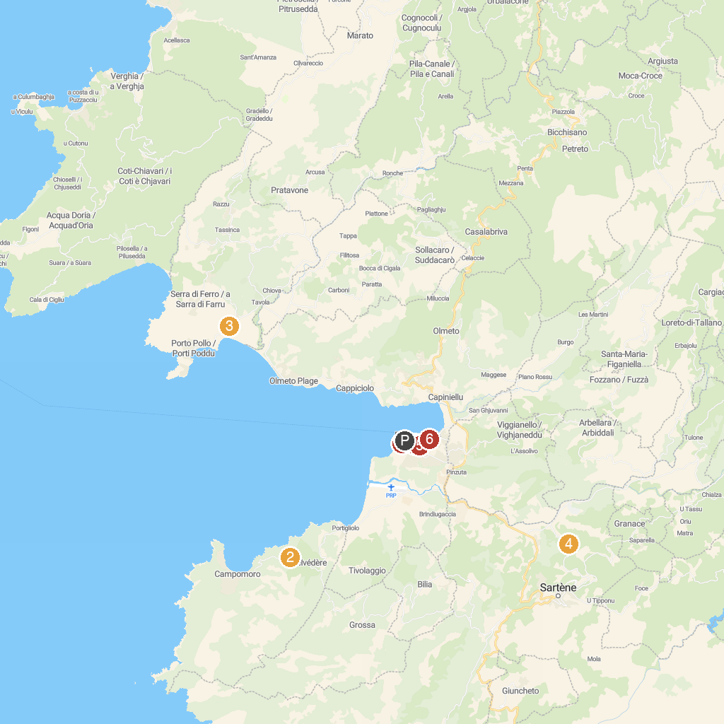
MAP KEY
1. CMPV Promenades en mer Propriano | 5. Eglise Notre Dame de Miséricorde
2. Belvedere Campomoro | 6. Plage de Propriano
3. Étang de Tanchiccia | 7. Plage du Lido
4. The Nature Park On olva
P. Cruise port / terminal
Map © MapTiler © OpenStreetMap contributors · cruiseports.org

