Puerto Banús–Marbella, Andalusia, Spain
Spain's answer to Saint-Tropez: a glittering yacht marina backed by a whitewashed Moorish Old Town, designer boutiques, and ten Salvador Dalí sculptures on the way to the beach. Small luxury ships tender directly in; guests from larger vessels make the 45-minute drive from Málaga.
⚓ Tender port (small ships dock in marina) · 🕒 Typical call: 6–9 hrs · 💶 Euro (€) · 🗣️ Spanish (English widely spoken)
✍️ MY DAY IN PORT (FILL IN)
Ship / Date
In port | arrive ______ · all aboard ______
Booked excursion
Notes / meeting point
GETTING ASHORE
- Docking: Small luxury ships tender into Puerto Banús marina; mega-ships dock at Málaga (~45 min away)
- Walk to center: 0–5 min from tender pier to marina; 10–15 min walk to Marbella Old Town from its marina
- Best For: Upscale people-watching, luxury shopping, Andalusian Old Town, beaches
- Don't Miss: Plaza de los Naranjos, Dalí sculptures on Avenida del Mar, espeto de sardinas on the beach
GETTING AROUND
- 🚕 Taxi: €15–22 — Taxis wait at the marina exit and can reach Marbella Old Town in 7–8 minutes. Fares may be higher at night, on holidays,
- 📱 Rideshare: ✅ Uber, Bolt
TOP THINGS TO DO
- Marbella Old Town & Orange Square — Wander the Casco Antiguo's cobbled lanes to Plaza de los Naranjos — the 1485 Orange Square flanked by a Renaissance town hall and…
- Puerto Banús Marina & Luxury Shopping — Stroll Calle Ribera along the front-line marina to gawk at mega-yachts and supercars, then browse 40+ designer boutiques (Gucci…
- Costa del Sol Beach Day — Playa de Levante (east of marina, calm water, family-friendly) and Playa del Duque (west, upscale beach clubs like Ocean Club)…
- Roman Villa of Río Verde — Roughly halfway between Puerto Banús and Marbella, these late-1st/2nd-century AD ruins are best known for black-and-white mosaic…
- Dolphin Watching & Boat Charter — Dolphins are common in the Alborán Sea off the Costa del Sol; short catamaran or private boat charters depart from Puerto Banús…
BEST WALKS
- Paseo Marítimo — Marina to Old Town: 6.5 km one-way | ~1.5 hrs | Flat — Walk the full beachfront boardwalk from Puerto Banús marina east to Marbella's Old Town.
- Marbella Old Town Loop: 1.5 km | ~45 min | Easy — From Marbella marina, walk up to Plaza de los Naranjos, thread through the narrow lanes of the…
WEATHER · DAYLIGHT · MONEY
Month | High °F | Low °F | Rainy days
May | 73 | 61 | 4
Jul | 85 | 72 | 0
Sep | 80 | 69 | 4
Daylight: May 7:12AM–9:19PM · Jul 7:13AM–9:37PM · Sep 8:02AM–8:26PM
cruiseports.org/puerto-banus-marbella · Confirm terminal & all-aboard time with your ship

Puerto Banús–Marbella, Andalusia, Spain — Port Map
Red = walkable sights · Amber = excursions farther out · P = cruise terminal
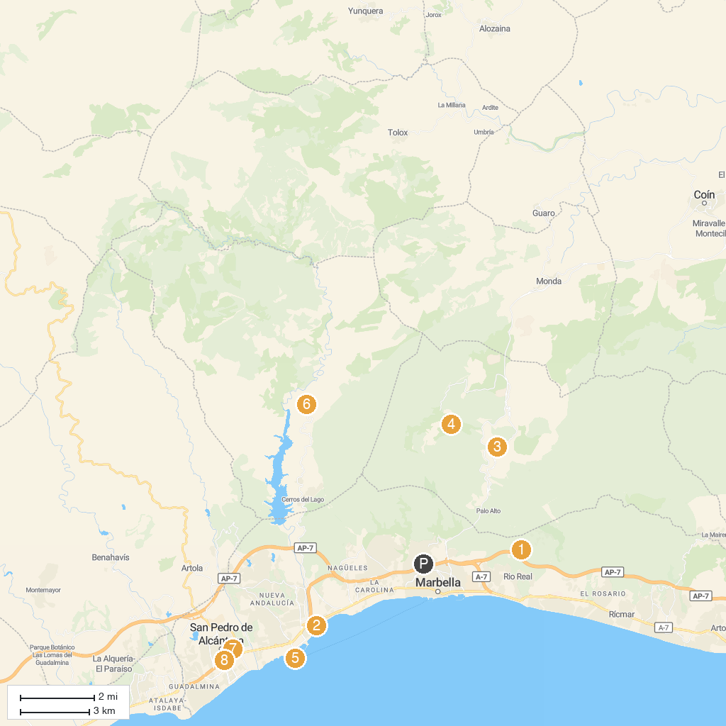
MAP KEY
1. Los Monteros | 5. Faro Puerto Banús
2. Villa romana de Río Verde | 6. Fuente y Lavadero El Chorro
3. Cueva de las Columnas | 7. Trapiche Guadaiza
4. Corzo Viewpoint | 8. Bulevar San Pedro Alcántara (WEB)
P. Cruise port / terminal
Map © MapTiler © OpenStreetMap contributors · cruiseports.org

