Puerto Limón, Costa Rica
Costa Rica's Caribbean gateway — your launchpad into steaming rainforest, sloth-filled canopies, and jungle canals teeming with wildlife, all within reach of the pier.
⚓ Docked (city pier) · 🕒 Typical call: 8–10 hrs · 💵 Costa Rican Colón (CRC) · USD ok · 🗣️ Spanish · English in tourism
✍️ MY DAY IN PORT (FILL IN)
Ship / Date
In port | arrive ______ · all aboard ______
Booked excursion
Notes / meeting point
GETTING ASHORE
- Docking: Pier in town
- Walk to center: 5–10 min
- Best For: Rainforest · Wildlife
- Don't Miss: Sloths & canals
GETTING AROUND
- 🚕 Taxi: $10–$15 USD — Official red taxis with a yellow triangle are available outside the terminal. Taxis do not always use meters so agree on
- 📱 Rideshare: ✅ Uber
TOP THINGS TO DO
- Tortuguero Canals Boat Safari — Glide through jungle waterways spotting caimans, monkeys, toucans, and sloths from a small boat.
- Rainforest Aerial Tram & Zip Line — Ride a gondola through the canopy of a private rainforest reserve, with optional zip lines and guided nature walks among…
- Sloth Sanctuary Visit — Meet rescued two- and three-toed sloths up close at a working sanctuary along the Estrella River, with a gentle canoe ride…
- Cahuita National Park & Beach — A coastal rainforest park where jungle trails meet white-sand Caribbean beaches — easy wildlife spotting (howler monkeys, sloths)…
BEST WALKS
- Parque Vargas & seafront: ~1.5 km · 1 hr · easy — The town's leafy central park, famous for the sloths that sometimes hang in its trees, leading…
- Mercado Central: ~1 km · 45 min · easy — Limón's bustling covered market — tropical fruit, spices, and local Caribbean food.
- Playa Bonita: ~4 km / short taxi · 1–2 hrs · easy — A pretty palm-fringed beach just west of town, popular with locals — best reached by a quick taxi…
WEATHER · DAYLIGHT · MONEY
Month | High °F | Low °F | Rainy days
May | 83 | 74 | 29
Jul | 82 | 73 | 30
Sep | 84 | 74 | 28
Daylight: May 5:11AM–5:45PM · Jul 5:18AM–5:57PM · Sep 5:22AM–5:32PM
cruiseports.org/puerto-limon · Confirm terminal & all-aboard time with your ship

Puerto Limón, Costa Rica — Port Map
Red = walkable sights · Amber = excursions farther out · P = cruise terminal
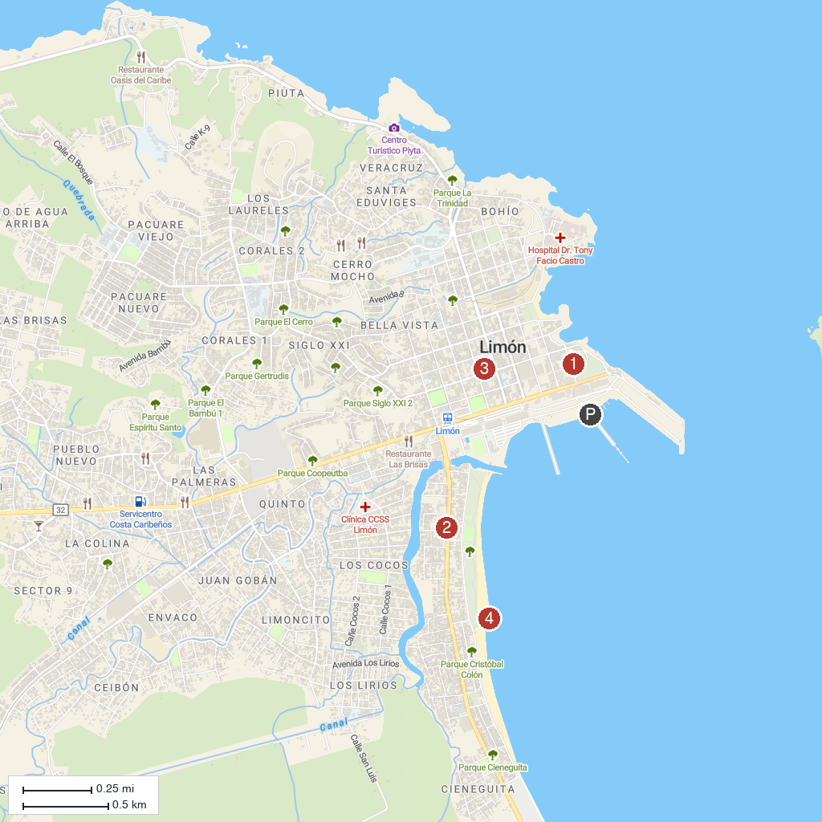
MAP KEY
1. Columbus Platinum | 4. Sacred Heart Cathedral
2. INTERBUS, PUERTO VIEJO | 5. Rompeolas Cieneguita
3. Brisas de La Jungla
P. Cruise port / terminal
Map © MapTiler © OpenStreetMap contributors · cruiseports.org

