Puerto Montt, Chile
Gateway to Chile's Lake District and the Patagonian fjords
🚢 Port City · 🐟 Seafood Hub · 🏔️ Lake District Gateway · 🏔️ Patagonia Entry
✍️ MY DAY IN PORT (FILL IN)
Ship / Date
In port | arrive ______ · all aboard ______
Booked excursion
Notes / meeting point
GETTING ASHORE
- Docking: Tender
- Currency: Chilean Peso (CLP)
- Language: Spanish
- Time Zone: GMT-4
GETTING AROUND
- 🚕 Taxi: ~$6–15 USD — Metered taxis queue near the terminal; the short hop to the city center typically runs 5,500–14,000 CLP (~$6–15 USD). Co
- 📱 Rideshare: ✅ Uber
- 🚌 Hop-on hop-off: ✅
TOP THINGS TO DO
- Osorno Volcano & Lake Todos los Santos — A full-day excursion visiting the majestic Osorno Volcano and the turquoise waters of Lake Todos los Santos.
- Pueblo Caleta and Angelmó Market — Visit the traditional fishing village of Caleta and the Angelmó Market, where you can sample fresh seafood and buy local…
- Huatron and the Reloncaví Sound — A boat trip through the Reloncaví Sound, offering views of the surrounding mountains and a chance to spot dolphins and seals.
- City Center and Plaza de Armas — A walking tour of the city center, visiting the Plaza de Armas and the local cathedral, exploring the urban layout of this…
BEST WALKS
- Angelmó Waterfront Walk: Easy — Walk from the terminal to the Angelmó Market.
- City Center Loop: Moderate — A loop from the terminal to the Plaza de Armas and the local cathedral, providing a glimpse into…
- Reloncaví Sound Promenade: Easy — A stroll along the waterfront promenade, offering panoramic views of the surrounding hills and the…
WEATHER · DAYLIGHT · MONEY
Month | High °F | Low °F | Rainy days
May | 55 | 46 | 19
Jul | 50 | 41 | 21
Sep | 53 | 42 | 19
Daylight: May 7:54AM–5:41PM · Jul 8:14AM–5:41PM · Sep 7:52AM–7:41PM
cruiseports.org/puerto-montt · Confirm terminal & all-aboard time with your ship

Puerto Montt, Chile — Port Map
Red = walkable sights · Amber = excursions farther out · P = cruise terminal
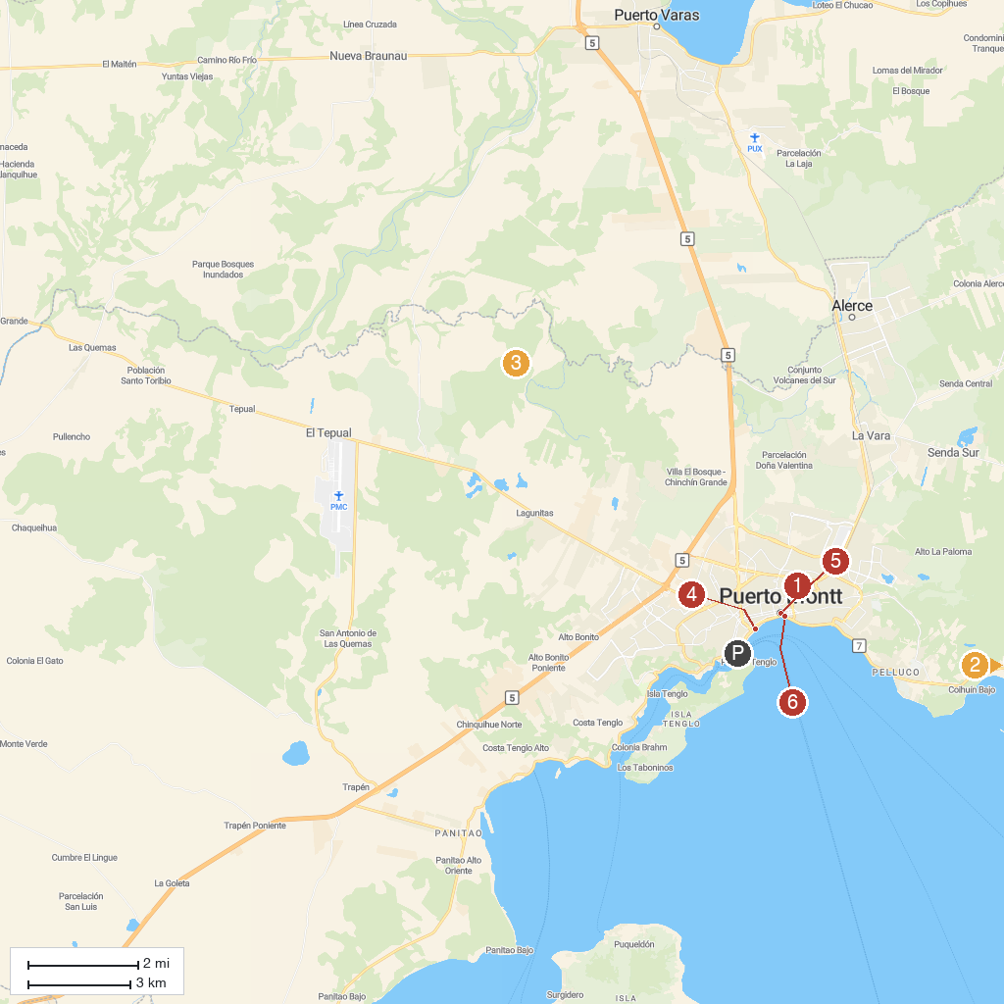
MAP KEY
1. Mirador Manuel Montt | 4. Puerto Montt Historical Museum Juan Pablo II
2. Kupange Aventura | 5. Plaza de Armas de Puerto Montt
3. Lahuen Ñadi Natural Monument | 6. Km 0 Carretera Austral
P. Cruise port / terminal
Map © MapTiler © OpenStreetMap contributors · cruiseports.org

