Puerto Natales, Magallanes, Chile
At the edge of the known world, Puerto Natales is the launching pad for Torres del Paine's granite spires, ancient glaciers, and some of the most dramatic scenery on Earth. Wind-scoured and wonderfully remote.
⚓ Pier (expedition ships) / Tender (large ships) · 🕒 Typical call: 6-8 hrs · 💵 Chilean Peso (CLP) · 🗣️ Spanish
✍️ MY DAY IN PORT (FILL IN)
Ship / Date
In port | arrive ______ · all aboard ______
Booked excursion
Notes / meeting point
GETTING ASHORE
- Docking: Expedition ships dock at Puerto Bories (~5 km); large ships tender to the Puerto Natales Marine Terminal
- Walk to Centre: 10–15 min flat walk from tender pier to Plaza de Armas
- Best For: Torres del Paine day trips, glacier cruises, Patagonian cuisine
- Don't Miss: Milodon Cave and a Calafate Sour at the Plaza
GETTING AROUND
- 🚕 Taxi: CLP 1,000–2,000 (~USD 1–2) in-town — Local taxis have no meters; agree on a fare before boarding. Very affordable for short city hops; slightly higher when c
- 📱 Rideshare: ✅ Uber
TOP THINGS TO DO
- Torres del Paine National Park — One of the world's great natural wonders: turquoise lakes, condors overhead, and the iconic granite towers rising roughly 2,500 m.
- Balmaceda & Serrano Glaciers Boat Tour — Cruise the Última Esperanza Fjord past cormorant colonies and sea lions to two dramatic hanging glaciers.
- Cueva del Milodón Natural Monument — A massive cave where remains of a prehistoric giant ground sloth were found in 1895.
- Estancia Experience & Traditional Asado — Visit a working Patagonian sheep ranch by boat.
- Kayaking the Fjords — Paddle the calm channels of the Última Esperanza Sound with a guide, passing steep cliffs and watching for black-necked swans…
BEST WALKS
- Waterfront Costanera Stroll: 1.5 km · 20 min · Easy · Free — Follow the Costanera promenade from the Marine Terminal past the old wooden Muelle Histórico (a…
- Plaza de Armas & Artisan Market: 0.5 km · 15 min browsing · Easy · Free — Wander the leafy plaza with its church and municipal building, then duck into the Pueblo Artesanal…
WEATHER · DAYLIGHT · MONEY
Month | High °F | Low °F | Rainy days
May | 44 | 34 | 15
Jul | 36 | 26 | 15
Sep | 45 | 33 | 15
Daylight: May 9:23AM–6:08PM · Jul 9:49AM–6:03PM · Sep 7:54AM–7:36PM
cruiseports.org/puerto-natales · Confirm terminal & all-aboard time with your ship

Puerto Natales, Magallanes, Chile — Port Map
Red = walkable sights · Amber = excursions farther out · P = cruise terminal
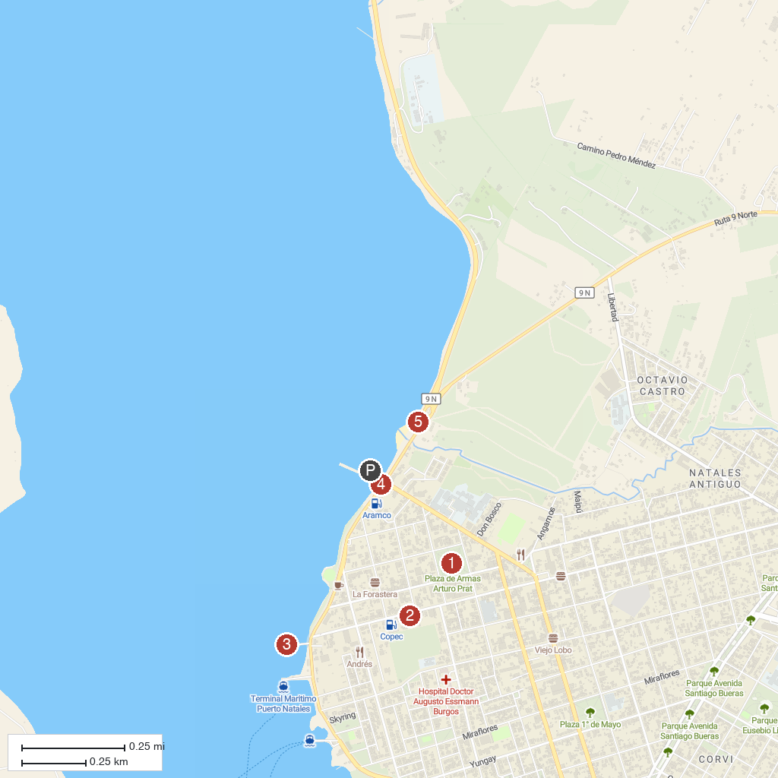
MAP KEY
1. Plaza de Armas Arturo Prat | 4. National Tourism Service
2. Municipal Historical Museum | 5. La Mano
3. Muelle Viejo
P. Cruise port / terminal
Map © MapTiler © OpenStreetMap contributors · cruiseports.org

