Puerto Plata (Amber Cove), Dominican Republic
A purpose-built resort pier where the pool and water slides are free, blue amber glows under UV light, and the 27 Charcos waterfall canyon awaits 30 minutes inland.
⚓ Pier (docked) · 🕒 Typical call: 7–9 hrs · 💵 USD widely accepted / DOP · 🗣️ Spanish (English at port) · 🏖️ No beach at pier — excursion required
✍️ MY DAY IN PORT (FILL IN)
Ship / Date
In port | arrive ______ · all aboard ______
Booked excursion
Notes / meeting point
GETTING ASHORE
- Docking: Deep-water pier — no tender. Long walk (~400 m) to terminal; free rickshaws available.
- Walk to center: Puerto Plata city is 20 min by taxi (~$80 RT for up to 5); not walkable from pier.
- Best For: Waterfall adventures, resort pool days, cable car, Dominican amber shopping.
- Don't Miss: 27 Charcos de Damajagua — slide and jump down natural limestone waterfalls.
GETTING AROUND
- 🚕 Taxi: $15–$40 one-way — Official taxis line up just outside Amber Cove with posted rates — roughly $15–$20/group for up to 4 passengers to Puert
- 📱 Rideshare: ✅ Uber
TOP THINGS TO DO
- 27 Charcos de Damajagua — Hike into a jungle canyon and slide, jump, and swim through 27 natural limestone waterfalls — the Dominican Republic's signature…
- Teleférico Cable Car & Mount Isabel de Torres — The only cable car in the Caribbean rises to 2,600 ft.
- Playa Dorada Beach Day — The best sand beach near port — golden, calm, and lined with all-inclusive resorts offering day passes.
- Puerto Plata City & Fortaleza San Felipe — Explore a charming Victorian colonial town — visit the 16th-century Spanish fort, colorful Umbrella Street, and the atmospheric…
- Playa Sosúa Snorkel & Beach — A crescent bay with calm turquoise water and good snorkeling.
BEST WALKS
- Amber Cove Hilltop Lookout: 20 min round trip · Easy · Free — A paved path climbs from the pool area to a hilltop bar with 360° views over the cove, the docked…
- Puerto Plata Malecón & Colonial Zone Stroll: 1–2 hrs · Easy · Taxi to start · ~$80 RT — After a taxi to Puerto Plata, walk the seafront Malecón, cut up to colorful Umbrella Street (Calle…
WEATHER · DAYLIGHT · MONEY
Month | High °F | Low °F | Rainy days
May | 84 | 74 | 16
Jul | 86 | 77 | 12
Sep | 86 | 77 | 17
Daylight: May 6:07AM–7:11PM · Jul 6:12AM–7:24PM · Sep 6:30AM–6:44PM
cruiseports.org/puerto-plata-amber-cove · Confirm terminal & all-aboard time with your ship

Puerto Plata (Amber Cove), Dominican Republic — Port Map
Red = walkable sights · Amber = excursions farther out · P = cruise terminal
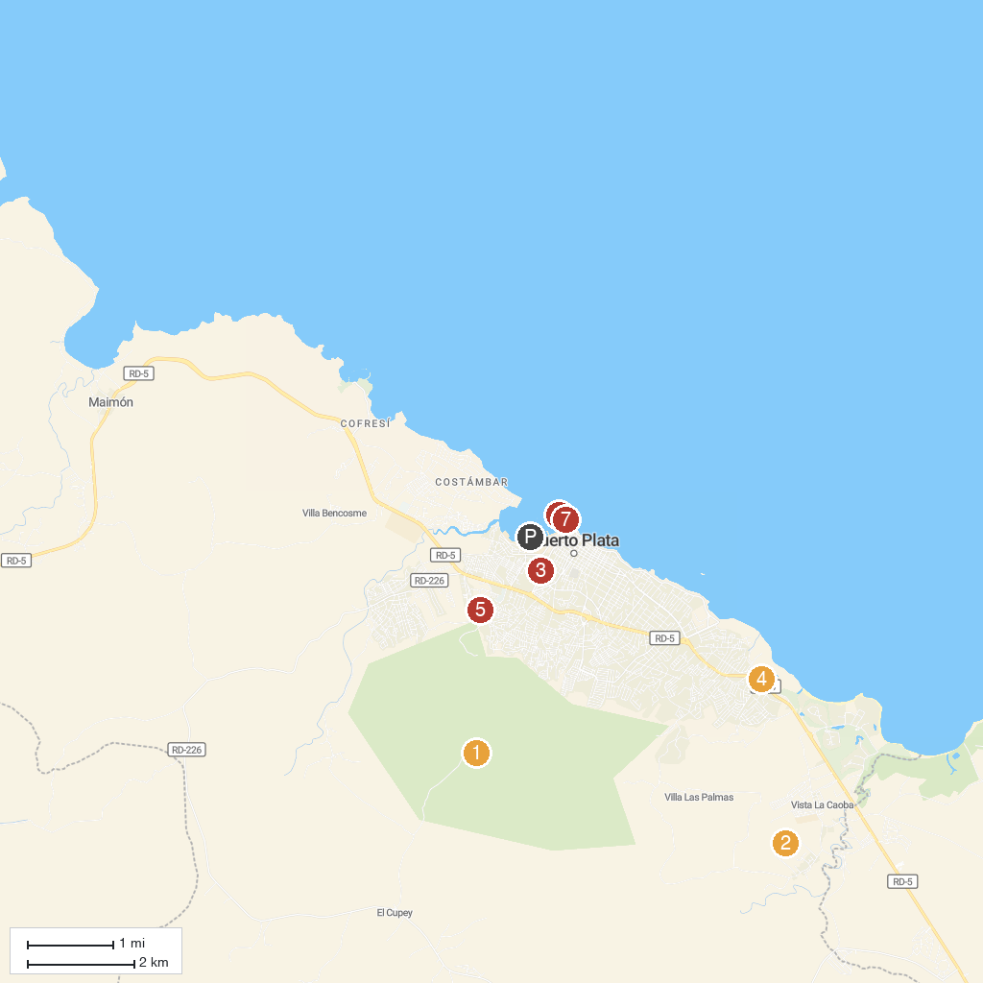
MAP KEY
1. Pico Isabel de Torres | 5. Country World Adventure Park
2. Rancho Lorilar | 6. Puerto Plata Cable Car
3. Macorix House of Rum | 7. Fortaleza de San Felipe
4. Kviar Show Disco & Casino Puerto Plata | 8. La Puntilla Park
P. Cruise port / terminal
Map © MapTiler © OpenStreetMap contributors · cruiseports.org

