Puerto Quetzal, Escuintla, Guatemala
Guatemala's main Pacific cruise port puts colonial Antigua, an active volcano, and ancient Mayan ruins all within striking distance. A compact terminal gets you on the road fast.
⚓ Pier (docked) · 🕒 Typical call: 8-10 hrs · 💵 GTQ / USD accepted · 🗣️ Spanish
✍️ MY DAY IN PORT (FILL IN)
Ship / Date
In port | arrive ______ · all aboard ______
Booked excursion
Notes / meeting point
GETTING ASHORE
- Docking: Pier — ships dock directly at cruise terminal, no tender
- Walk to Center: Terminal only; no walkable town — taxis/tours needed
- Best For: Colonial Antigua, volcano hikes, Mayan archaeology
- Don't Miss: Antigua Guatemala — UNESCO World Heritage colonial city
GETTING AROUND
- 🚕 Taxi: $50-$70/person (shared minivan) or $140-$180 private — Antigua is the main destination, ~90 min away. Negotiate fares before departing; shared minivans with a guide run ~$50/p
TOP THINGS TO DO
- Antigua Guatemala — Guatemala's showpiece colonial city is a UNESCO World Heritage site packed with cobblestone streets, crumbling convents, colorful…
- Pacaya Volcano Hike — One of Central America's most accessible active volcanoes, Pacaya lets you walk to within meters of lava flows.
- Iximché Mayan Ruins — The former capital of the Kaqchikel Maya kingdom, Iximché is less visited than Tikal but equally atmospheric — ancient plazas…
- Antigua + Coffee Plantation — Combine a walk through Antigua with a visit to a working coffee finca in the highlands, learning how Guatemala's famous…
- Mangrove Kayaking — Paddle through coastal mangrove channels near the port, spotting birds, crocodiles, and marine life.
BEST WALKS
- Terminal Market Stroll: 30 min · Flat · Free — Within the cruise terminal complex you'll find a covered handicrafts market with Guatemalan…
WEATHER · DAYLIGHT · MONEY
Month | High °F | Low °F | Rainy days
May | 86 | 71 | 28
Jul | 85 | 70 | 26
Sep | 83 | 70 | 29
Daylight: May 5:35AM–6:23PM · Jul 5:42AM–6:35PM · Sep 5:52AM–6:04PM
cruiseports.org/puerto-quetzal · Confirm terminal & all-aboard time with your ship

Puerto Quetzal, Escuintla, Guatemala — Port Map
Red = walkable sights · Amber = excursions farther out · P = cruise terminal
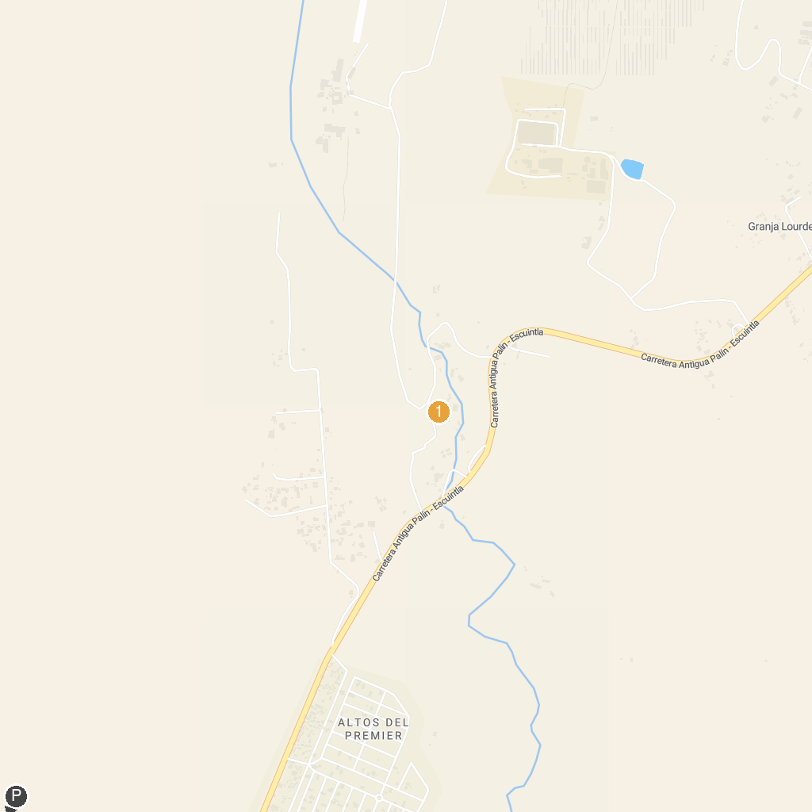
MAP KEY
1. Parque Guateque | 2. Aqua Park Guatemala
P. Cruise port / terminal
Map © MapTiler © OpenStreetMap contributors · cruiseports.org

