Puerto Vallarta, Jalisco, Mexico
A Pacific paradise where jungle mountains tumble into Banderas Bay — Puerto Vallarta blends cobblestone old-town charm with world-class beaches, adventure, and one of Mexico's most walkable seafronts.
⚓ Docked (pier) · 🕒 Typical call: 8-10 hrs · 💵 Mexican Peso (USD accepted in tourist areas) · 🗣️ Spanish
✍️ MY DAY IN PORT (FILL IN)
Ship / Date
In port | arrive ______ · all aboard ______
Booked excursion
Notes / meeting point
GETTING ASHORE
- Docking: Ships dock at Puerto Mágico Terminal, Hotel Zone — no tendering
- Walk to center: 5 km to downtown; take bus ("Centro", ~$1) or taxi (~$8-12)
- Best For: Beach days, adventure tours, Old Town culture, whale watching (Dec–Mar)
- Don't Miss: Malecón boardwalk sculptures, Church of Our Lady of Guadalupe, Los Arcos snorkeling
GETTING AROUND
- 🚕 Taxi: USD 16–20/car — White federally authorized taxis at the pier with posted rates. To the Malecón runs about $16/car; to the Cathedral arou
- 📱 Rideshare: ✅ Uber, DiDi, inDrive
- 🚌 Hop-on hop-off: ✅
TOP THINGS TO DO
- Los Arcos National Marine Park Snorkeling — Boat out to the iconic granite arch islands of Los Arcos, a protected marine park teeming with tropical fish, rays, and coral.
- Sierra Madre Zipline & Canopy Tour — Fly through the jungle canopy above the Sierra Madre foothills on a multi-line zipline course.
- Marietas Islands & Hidden Beach — Cruise to the remote Marietas Islands — a UNESCO-protected biosphere — and swim into the famous Hidden Beach (Playa del Amor), a…
- Old Town Walking & Food Tour — Explore Centro Histórico's cobblestone streets, sample birria tacos and fresh ceviche at the Mercado Municipal, and visit the…
- Whale Watching (December–March) — Banderas Bay hosts one of the highest concentrations of humpback whales on Earth during winter months.
BEST WALKS
- Malecón to Old Town: 3 km one-way | Easy | 1-2 hrs — Start at the northern end of the Malecón boardwalk and stroll south past bronze sculpture…
- Playa Los Muertos Beach Walk: Easy | 30-45 min stroll — From the Malecón, head south past the Cuale River to Playa Los Muertos — PV's most popular beach.
WEATHER · DAYLIGHT · MONEY
Month | High °F | Low °F | Rainy days
May | 85 | 70 | 3
Jul | 88 | 77 | 24
Sep | 86 | 76 | 26
Daylight: May 6:23AM–7:30PM · Jul 6:29AM–7:44PM · Sep 6:48AM–7:03PM
cruiseports.org/puerto-vallarta · Confirm terminal & all-aboard time with your ship

Puerto Vallarta, Jalisco, Mexico — Port Map
Red = walkable sights · Amber = excursions farther out · P = cruise terminal
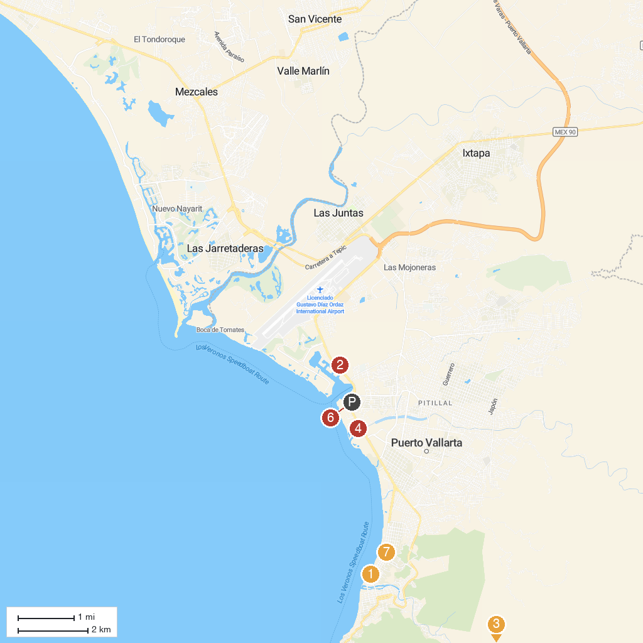
MAP KEY
1. The Boy on the Seahorse | 5. Puerto Magico
2. Área Natural Protegida Estero El Salado | 6. Pirate Ship Vallarta
3. River Park | 7. Parroquia Nuestra Señora del Refugio
4. Skydive Vallarta
P. Cruise port / terminal
Map © MapTiler © OpenStreetMap contributors · cruiseports.org

