Puerto Williams, Isla Navarino, Chile
The world's southernmost city sits on Isla Navarino, across the Beagle Channel from Argentina — a wind-scoured frontier town of 3,000 souls, fresh king crab, and the last stop before Cape Horn and Antarctica.
⚓ Pier (new dock, small-ship focus) · 🕒 Typical call: 6-8 hrs · 💵 Chilean Peso (CLP) — one ATM, carry cash · 🗣️ Spanish (little English outside museum) · 🧊 Sub-Antarctic: cold and windy year-round
✍️ MY DAY IN PORT (FILL IN)
Ship / Date
In port | arrive ______ · all aboard ______
Booked excursion
Notes / meeting point
GETTING ASHORE
- Docking: New multipurpose pier — 150m access bridge + 130m berthing head (Phase 1 complete); large ships may still anchor and tender
- Walk to Centre: 10-15 min flat walk from pier to Plaza de Armas (~1 km)
- Best For: Expedition cruisers, history buffs, Yahgan culture, Antarctica homeport
- Don't Miss: Centolla (king crab), Martin Gusinde Museum, Micalvi yacht club bar
GETTING AROUND
- 🚕 Taxi: ~5,000 CLP (~5–6 USD) — No formal taxi company operates on Isla Navarino, but informal local transfers are available. Short rides to/from the ae
- 📱 Rideshare: ❌ not available
TOP THINGS TO DO
- Martin Gusinde Anthropological Museum — One of South America's finest small museums, detailing the Yahgan people who survived sub-Antarctic conditions with only seal…
- Cerro Bandera Hike — A strenuous 3-4 hour round-trip climb above town leads to a Chilean flag and sweeping views of the Beagle Channel, Navarino's…
- Omora Ethnobotanical Park — About 4 km west of town, Omora is famous for 'tourism with a hand lens' — visitors explore miniature forests of mosses, lichens…
- Yelcho Monument & Micalvi Yacht Club — See the replica bow of the Chilean Navy tug Yelcho that rescued Shackleton's crew from Elephant Island in 1916 (the original bow…
- Centolla (Southern King Crab) Lunch — Puerto Williams is one of the best places on Earth to eat fresh centolla pulled from the Beagle Channel.
BEST WALKS
- Waterfront & Town Loop: 1.5 km · 25-30 min · Easy · Flat — From the pier, walk the Costanera (waterfront road) west past the Yelcho monument and Micalvi to…
- Villa Ukika Walk: 2 km one-way · Easy · Flat gravel road — A short walk east of town leads to Villa Ukika, a small settlement where descendants of the Yahgan…
WEATHER · DAYLIGHT · MONEY
Month | High °F | Low °F | Rainy days
May | 43 | 34 | 15
Jul | 37 | 28 | 14
Sep | 42 | 32 | 14
Daylight: May 9:17AM–5:35PM · Jul 9:45AM–5:27PM · Sep 7:36AM–7:15PM
cruiseports.org/puerto-williams · Confirm terminal & all-aboard time with your ship

Puerto Williams, Isla Navarino, Chile — Port Map
Red = walkable sights · Amber = excursions farther out · P = cruise terminal
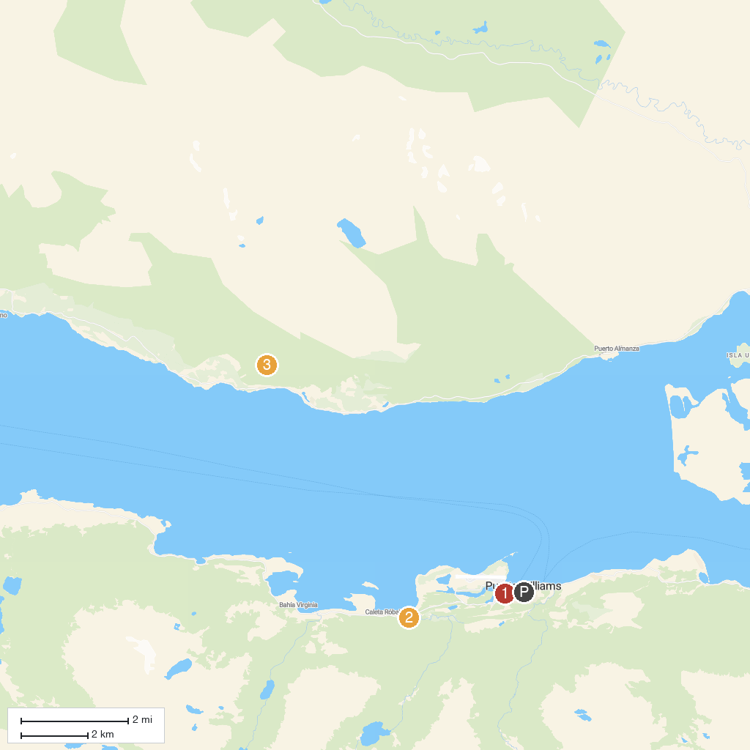
MAP KEY
1. Martin Gusinde Anthropological Museum | 3. Cascada del Duende
2. Etnobotánico Omora Park
P. Cruise port / terminal
Map © MapTiler © OpenStreetMap contributors · cruiseports.org

