Pula, Istria, Croatia
Few ports deliver Roman grandeur this quickly — Pula's 1st-century amphitheater is a 10-minute walk from the gangway. Add truffles, Adriatic seafood, and turquoise beaches and you have one of the Adriatic's most rewarding short calls.
⚓ Pier (Quay Rijeka, most ships) · 🕒 Typical call: 7–10 hrs · 💶 Currency: Euro (€) · 🗣️ Croatian (Italian widely spoken)
✍️ MY DAY IN PORT (FILL IN)
Ship / Date
In port | arrive ______ · all aboard ______
Booked excursion
Notes / meeting point
GETTING ASHORE
- Docking: Pier at Quay Rijeka; very large ships may tender
- Walk to center: 10 min flat to the Arena; 15 min to Forum Square
- Best For: Roman ruins, Istrian cuisine, beaches, walkability
- Don't Miss: Pula Arena underground galleries & truffle products at the market
GETTING AROUND
- 🚕 Taxi: €8–€11 — Metered taxis are readily available at the port. Daytime rate is approx. €1.80/km with a ~€5 minimum fare; night/holiday
- 📱 Rideshare: ✅ Uber, Bolt
- 🚌 Hop-on hop-off: ✅
TOP THINGS TO DO
- Pula Arena & Roman Monuments Walk — Enter one of the world's best-preserved Roman amphitheaters, explore its underground gladiator galleries, then follow the old…
- Istrian Truffle & Wine Experience — Head into the Istrian hills to taste black and white truffles paired with local Malvazija white wine and Teran red.
- Verudela Peninsula Beaches — Hop a city bus or taxi to the Verudela Peninsula for Ambrela Beach (pine shade, sunbeds, cafes) and the photogenic Hawaii Cove…
- Rovinj & Istrian Coastal Towns — If your call is long enough, a guided trip to the beautifully preserved fishing town of Rovinj — with its colorful harbourfront…
- Coastal Cycling & Kayaking — Rent e-bikes near the port and ride the flat Lungomare coastal path to quiet coves, or book a sea kayaking tour around the…
BEST WALKS
- Roman Monuments Loop: 1.5 km · 45–60 min · Easy — Walk from the Riva waterfront to the Arena, then wind up through the old town past the Arch of the…
- Market & Hidden Mosaic Stroll: 1 km · 30 min · Easy — From Forum Square, detour to the 1903 iron-and-glass Pula Green Market for local olive oil, truffle…
WEATHER · DAYLIGHT · MONEY
Month | High °F | Low °F | Rainy days
May | 69 | 59 | 12
Jul | 84 | 72 | 7
Sep | 75 | 65 | 10
Daylight: May 5:35AM–8:27PM · Jul 5:33AM–8:48PM · Sep 6:44AM–7:14PM
cruiseports.org/pula · Confirm terminal & all-aboard time with your ship

Pula, Istria, Croatia — Port Map
Red = walkable sights · Amber = excursions farther out · P = cruise terminal
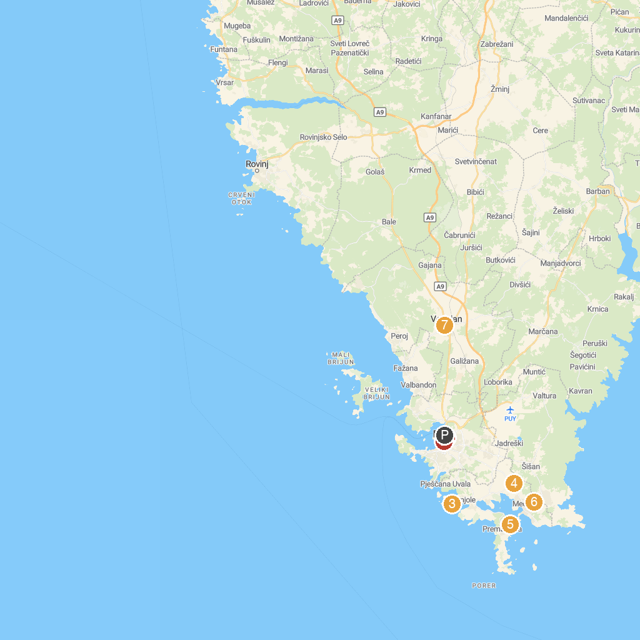
MAP KEY
1. Pula Arena | 5. Beach Guvnina
2. The small Roman theater in Pula | 6. Samy's Ranch
3. Beach Centinera | 7. Church of St. Blaise
4. Adrenalin Park Medulin
P. Cruise port / terminal
Map © MapTiler © OpenStreetMap contributors · cruiseports.org

