Punta Arenas, Chile
Chile's windswept gateway to Patagonia and the Strait of Magellan — a frontier city of grand wool-era mansions, penguin islands, and the raw end of the Americas.
⚓ Tender or dock · 🕒 Typical call: 8–10 hrs · 💵 Chilean Peso (CLP) · 🗣️ Spanish · some English
✍️ MY DAY IN PORT (FILL IN)
Ship / Date
In port | arrive ______ · all aboard ______
Booked excursion
Notes / meeting point
GETTING ASHORE
- Docking: Tender or Mardones pier
- To center: Short tender/walk
- Best For: History · Penguins
- Don't Miss: Magdalena Island
GETTING AROUND
- 🚕 Taxi: CLP 6,000–9,000 (~$6–10 USD) — Fixed-rate taxis are plentiful near the pier. Confirm the fare before boarding; rides within city limits typically stay
- 📱 Rideshare: ✅ Uber
TOP THINGS TO DO
- Magdalena Island Penguin Colony — A boat trip across the Strait to an island home to ~120,000 Magellanic penguins, where a marked path winds right through the…
- Otway Sound Penguin Reserve — A land-based alternative penguin colony reached by road, with boardwalks and hides — a good option when sea conditions rule out…
- City & Wool-Era Mansions — Punta Arenas grew rich on sheep and shipping.
- Fort Bulnes & Strait of Magellan — Drive south to the reconstructed fort at the spot where Chile claimed the Strait, with sweeping views over the waterway Magellan…
BEST WALKS
- Plaza de Armas & mansions loop: ~2 km · 1.5 hrs · easy — From the pier to the Plaza Muñoz Gamero with its Magellan monument (rub the toe for luck), past the…
- Cerro de la Cruz viewpoint: ~2 km · 1 hr · moderate — A short uphill walk to the hilltop cross for a colorful panorama over the city's tin roofs and the…
- Municipal Cemetery: ~1.5 km · 1 hr · easy — One of South America's most striking cemeteries — manicured cypress avenues and elaborate…
WEATHER · DAYLIGHT · MONEY
Month | High °F | Low °F | Rainy days
May | 44 | 37 | 12
Jul | 39 | 32 | 13
Sep | 45 | 36 | 11
Daylight: May 9:23AM–5:56PM · Jul 9:49AM–5:50PM · Sep 7:48AM–7:29PM
cruiseports.org/punta-arenas · Confirm terminal & all-aboard time with your ship

Punta Arenas, Chile — Port Map
Red = walkable sights · Amber = excursions farther out · P = cruise terminal
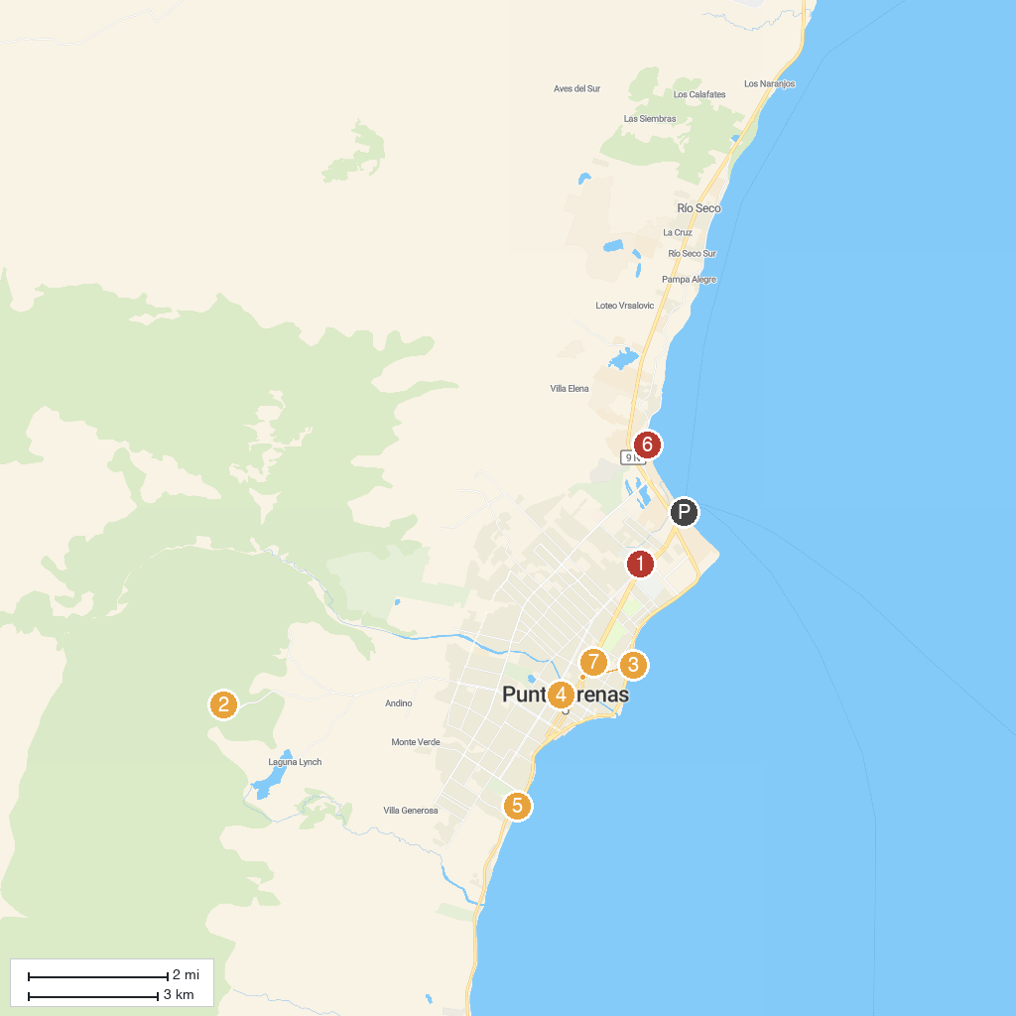
MAP KEY
1. Remembrance Museum | 5. Lord Lonsdale
2. Club Andino punta arenas | 6. Museo Nao Victoria
3. Museo Maggiorino Borgatello | 7. Cemetery of Punta Arenas
4. La Galería, tienda de arte y diseño
P. Cruise port / terminal
Map © MapTiler © OpenStreetMap contributors · cruiseports.org

