Puntarenas, Puntarenas Province, Costa Rica
A slender sandy peninsula jutting into the Gulf of Nicoya, Puntarenas puts you minutes from scarlet macaws, massive crocodiles, and the best shaved ice you'll ever eat.
⚓ Pier (docked) · 🕒 Typical call: 7-9 hrs · 💵 USD & CRC accepted · 🗣️ Spanish (English widely spoken near pier)
✍️ MY DAY IN PORT (FILL IN)
Ship / Date
In port | arrive ______ · all aboard ______
Booked excursion
Notes / meeting point
GETTING ASHORE
- Docking: Pier (docked) — either the Muelle de Cruceros in Puntarenas town or Puerto Caldera (~20 km/12 mi away); no tendering either way
- Walk to center: ~10 min walk to the Paseo de los Turistas if docked at the town pier; from Puerto Caldera you'll need a shuttle, taxi, or tour
- Best For: Wildlife lovers, rainforest excursions, families, foodies
- Don't Miss: A Churchill (shaved ice dessert) from a kiosk on the Paseo de los Turistas
GETTING AROUND
- 🚕 Taxi: $2–$5 — Official red taxis are available at the pier for short rides within the city center. Meters (la maria) should be used; c
- 📱 Rideshare: ✅ Uber
TOP THINGS TO DO
- Tarcoles River Crocodile Safari — Boat down the Tarcoles River to see enormous American crocodiles (some over 15 ft) basking on the banks, plus scarlet macaws…
- Carara National Park — A rare transition zone between dry and humid rainforest — one of the best places in Costa Rica to spot wild scarlet macaws in the…
- Isla Tortuga Catamaran Day — Sail 45-60 minutes to a stunning uninhabited island with white-sand beaches and turquoise water — the best beach day option from…
- Rainforest Canopy & Zipline — Fly through the rainforest canopy on ziplines or cross hanging bridges for a bird's-eye view of the jungle.
- Parque Marino del Pacífico — A small marine rescue center just 5 minutes' walk from the pier — sea turtles, crocodiles, seahorses, and tropical fish.
BEST WALKS
- Paseo de los Turistas Stroll: 1.5 km | Flat | 20-30 min each way — Walk the full length of the tourist promenade from the pier terminal east along the oceanfront.
- Pier to El Faro (Lighthouse): 0.8 km | Flat | 10-15 min — Short walk from the cruise terminal to the lighthouse at the tip of the peninsula — great photo…
WEATHER · DAYLIGHT · MONEY
Month | High °F | Low °F | Rainy days
May | 85 | 76 | 28
Jul | 84 | 75 | 29
Sep | 83 | 75 | 29
Daylight: May 5:18AM–5:53PM · Jul 5:26AM–6:04PM · Sep 5:29AM–5:39PM
cruiseports.org/puntarenas · Confirm terminal & all-aboard time with your ship

Puntarenas, Puntarenas Province, Costa Rica — Port Map
Red = walkable sights · Amber = excursions farther out · P = cruise terminal
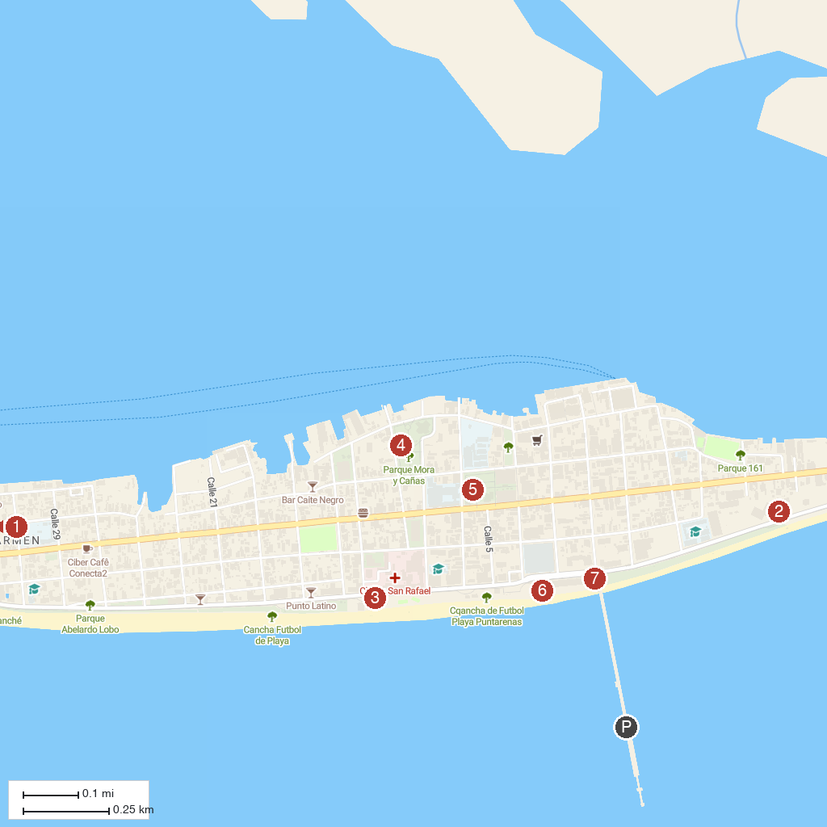
MAP KEY
1. Faro de "Puntarenas" | 5. Catedral de Puntarenas. Sagrado Corazón de Jesús
2. Parque Marino del Pacifico | 6. Parador Fotográfico Puntarenas
3. Paseo de los Turistas | 7. Antigua Capitanía de Puntarenas
4. Parque Mora y Cañas
P. Cruise port / terminal
Map © MapTiler © OpenStreetMap contributors · cruiseports.org

