Pylos, Peloponnese, Greece
A charming harbour town on the Bay of Navarino, Pylos punches well above its size — Mycenaean ruins, a perfectly preserved Ottoman fortress, and the iconic horseshoe of Voidokilia Beach all within a short drive.
⚓ Tender or small pier (ship-dependent) · 🕒 Typical call: 6–8 hrs · 💶 Euro (€) · 🗣️ Greek / English widely spoken
✍️ MY DAY IN PORT (FILL IN)
Ship / Date
In port | arrive ______ · all aboard ______
Booked excursion
Notes / meeting point
GETTING ASHORE
- Docking: Larger ships anchor in Navarino Bay and tender ashore; smaller vessels may dock at the town quay
- Walk to centre: Tender landing is right in town — Platia Trion Navarchon (Three Admirals' Square) is 5 min on foot
- Best For: History, archaeology, beaches, authentic Greek harbour life
- Don't Miss: Neokastro fortress above the harbour and the Palace of Nestor (17 km; taxi or rental car needed)
GETTING AROUND
- 🚕 Taxi: €8–€15 (short trips) — Taxis are available at a stand near the main square. Short in-town rides run €8–€15; longer trips to Nestor's Palace or
TOP THINGS TO DO
- Neokastro Ottoman Fortress — Towering above the harbour, this 1573 fortress is one of the best-preserved in Greece.
- Palace of Nestor — One of the best-preserved Mycenaean Bronze Age palaces in Greece (c.
- Voidokilia Beach — A near-perfect horseshoe of white sand framed by Natura 2000 dunes and crystal-clear turquoise water — consistently rated among…
- Three Admirals' Square & Harbour Stroll — Pylos's main square is shaded by ancient plane trees and anchored by a monument to the British, French, and Russian admirals who…
- Navarino Bay Boat Tour — Local boat tours depart from the harbour to explore the sunken Ottoman fleet from the 1827 battle, circumnavigate Sfakteria…
BEST WALKS
- Waterfront to Neokastro Fortress: 1.5 km round-trip | 30–40 min | moderate (uphill) — From the tender quay, follow the waterfront north, then take the signed path uphill to the castle…
- Three Admirals' Square Stroll: 0.5 km | 20–30 min | easy — A leisurely loop from the quay through the main square and back along the harbour promenade.
WEATHER · DAYLIGHT · MONEY
Month | High °F | Low °F | Rainy days
May | 74 | 61 | 6
Jul | 87 | 73 | 1
Sep | 82 | 70 | 5
Daylight: May 6:25AM–8:34PM · Jul 6:25AM–8:52PM · Sep 7:15AM–7:40PM
cruiseports.org/pylos · Confirm terminal & all-aboard time with your ship

Pylos, Peloponnese, Greece — Port Map
Red = walkable sights · Amber = excursions farther out · P = cruise terminal
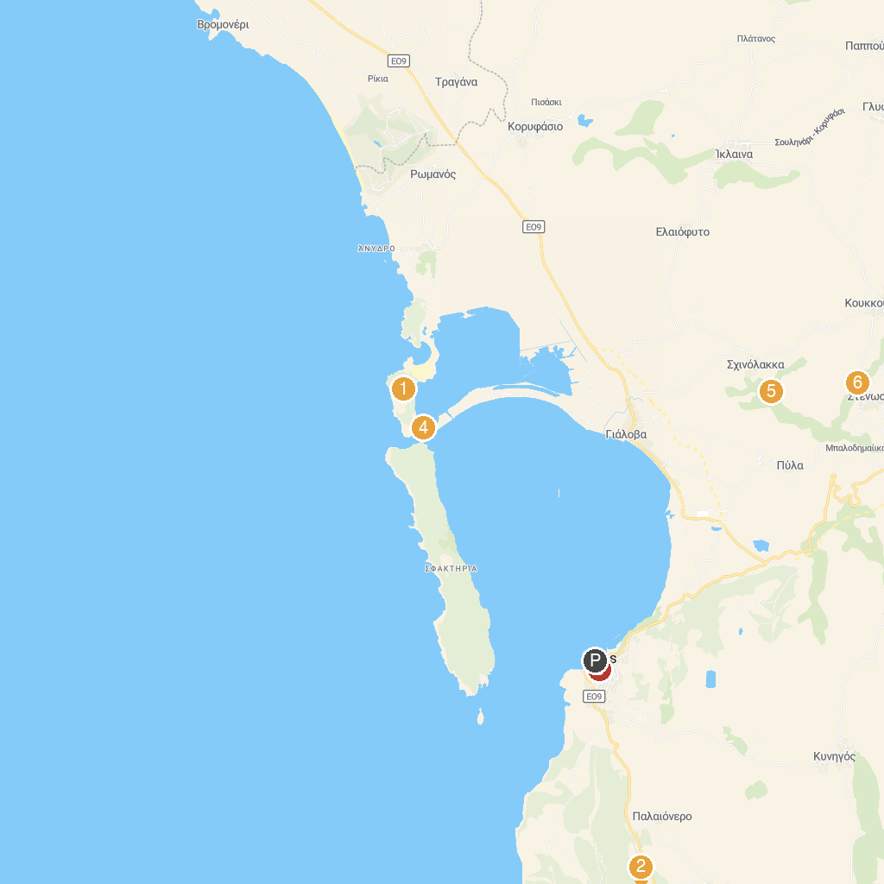
MAP KEY
1. Old Navarino Fortress | 5. Παραλία Πέρασμα Συκιάς
2. Mycenean Palace of Nestor at Pylos | 6. Kalamaris Waterfall
3. Bourtzi of Methoni Castle | 7. Stenosia Waterfalls
4. Pylos Central Square
P. Cruise port / terminal
Map © MapTiler © OpenStreetMap contributors · cruiseports.org

