Qaqortoq, Greenland
A colorful hub of Southern Greenland
🚢 Port of Call · 🎨 Stone Carvings · 🏔️ Southern Fjords · 🏘️ Colorful Houses
✍️ MY DAY IN PORT (FILL IN)
Ship / Date
In port | arrive ______ · all aboard ______
Booked excursion
Notes / meeting point
GETTING ASHORE
- Docking: Dock or tender — confirm with your line
- Local Currency: Greenlandic Krone (DKK)
- Local Language: Greenlandic and Danish
- Best Time to Visit: June to August
GETTING AROUND
- 🚕 Taxi: DKK 50–130 (~$8–20 USD) — Local taxis are available and useful for hilly areas or reaching spots farther afield like Lake Tasersuaq. Agree on the
- 📱 Rideshare: ❌ not available
TOP THINGS TO DO
- Stone and Man carvings walk — A guided walk through the town to see the unique stone carvings and the 'Man' carvings, which are whimsical and artistic…
- Fjord Cruise to the Icebergs — A boat trip from the harbor into the surrounding fjords to witness massive icebergs drifting from the glaciers.
- Hiking to the Overlook — A trek up the rocky hills surrounding the town to get a panoramic view of the colorful houses and the surrounding fjord landscape.
- Visit the Local Museum — Explore the history of the South Greenlandic people and the traditional hunting and fishing practices of the region.
BEST WALKS
- The Artistic Path: Art & Culture — Follow the signs for the stone carvings, which are integrated into the town's natural rock…
- The Harbor Walk: Shopping & Dining — Stroll along the waterfront to visit local craft shops and enjoy a coffee at a local cafe.
- The Hilltop View: Nature & Views — A short but steep climb to the highest point in town for a breathtaking view of the colorful houses…
WEATHER · DAYLIGHT · MONEY
Month | High °F | Low °F | Rainy days
May | 41 | 31 | 9
Jul | 53 | 42 | 10
Sep | 47 | 36 | 12
Daylight: May 5:20AM–10:41PM · Jul 5:02AM–11:16PM · Sep 7:32AM–8:24PM
cruiseports.org/qaqortoq · Confirm terminal & all-aboard time with your ship

Qaqortoq, Greenland — Port Map
Red = walkable sights · Amber = excursions farther out · P = cruise terminal
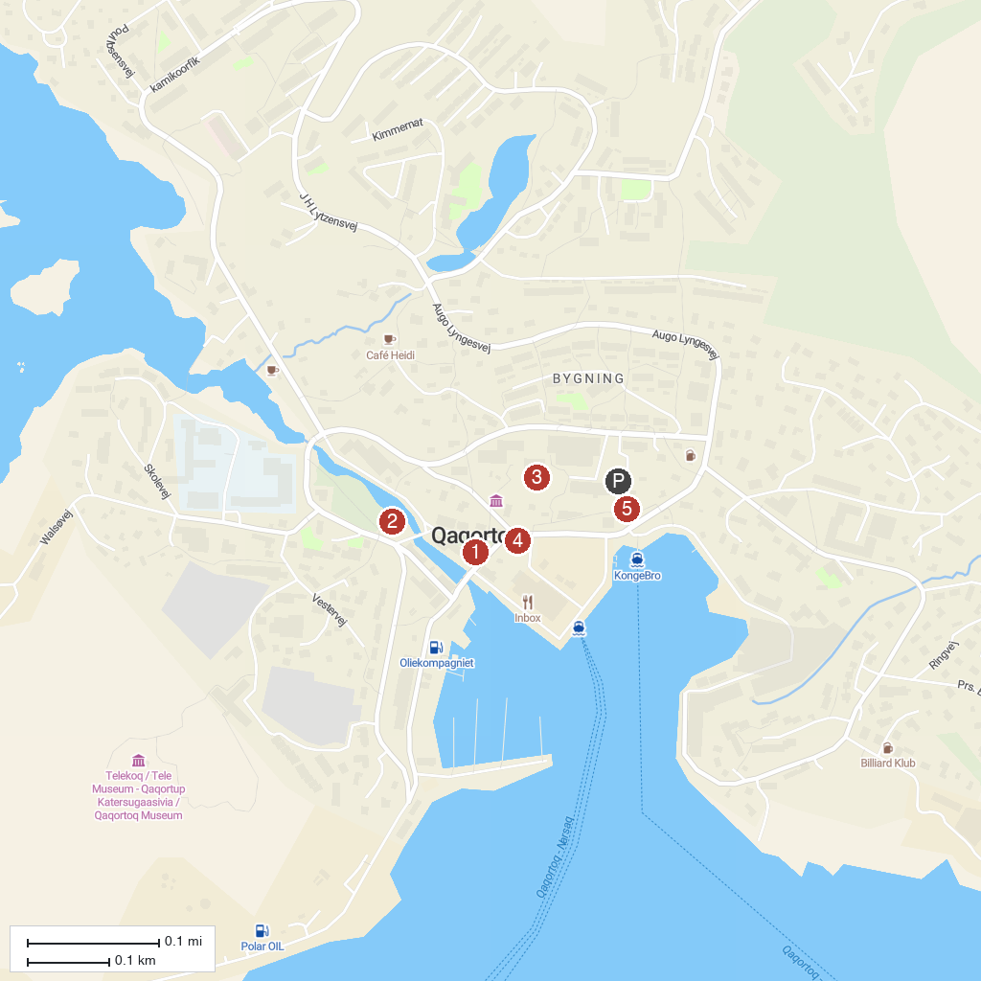
MAP KEY
1. Mindebrønden Fountain | 4. Qaqortoq Museum
2. Church of Our Saviour | 5. Stone & Man Sculpture Trail
3. Gertrud Rasch's Church | 6. Hvalsey Church Ruins
P. Cruise port / terminal
Map © MapTiler © OpenStreetMap contributors · cruiseports.org

