Quepos, Puntarenas, Costa Rica
A former banana port turned eco-tourism capital, Quepos puts you steps from one of the world's most biodiverse national parks — where sloths drape in cecropia trees and capuchin monkeys eye your lunch.
⚓ Tender (no pier) · 🕒 Typical call: 7–9 hrs · 💵 USD widely accepted · 🗣️ Spanish / English spoken · 🦥 Wildlife & Nature
✍️ MY DAY IN PORT (FILL IN)
Ship / Date
In port | arrive ______ · all aboard ______
Booked excursion
Notes / meeting point
GETTING ASHORE
- Docking: Tender to Marina Pez Vela
- Walk to center: 5–10 min from tender dock
- Best For: Manuel Antonio NP, sportfishing, zip-lining
- Don't Miss: Book park tickets online before sailing — they sell out
GETTING AROUND
- 🚕 Taxi: $3–$5 — Official red taxis (marked with a yellow triangle and number) wait at Marina Pez Vela. The short ride to Quepos city cen
TOP THINGS TO DO
- Manuel Antonio National Park — Costa Rica's most visited park packs in four monkey species, two- and three-toed sloths, scarlet macaws, and white-sand cove…
- Damas Island Mangrove Tour — Glide by kayak or motorboat through the intricate canal network of Damas Island estuary.
- Rainforest Zip-lining — Several canopy parks outside Quepos send you flying through the jungle treetops on zip-line circuits with ocean and mountain views.
- Catamaran Snorkel & Sail — Half-day catamaran tours depart right from Marina Pez Vela for dolphin watching, snorkeling off Biesanz Bay, and an open bar.
- Pacific Sportfishing — Quepos is one of the world's top sportfishing destinations, with sailfish, mahi-mahi, roosterfish, and yellowfin tuna in the…
BEST WALKS
- Marina Pez Vela to Downtown Quepos: 0.6 km · 10 min · flat · paved — An easy flat walk along the waterfront from the tender dock into the heart of town.
- Quepos Malecón Waterfront Stroll: 1 km · 15 min · flat · scenic — The Malecón seawall promenade extends from the marina along the harbor, with ocean views, local…
WEATHER · DAYLIGHT · MONEY
Month | High °F | Low °F | Rainy days
May | 83 | 75 | 28
Jul | 82 | 74 | 28
Sep | 82 | 74 | 29
Daylight: May 5:16AM–5:49PM · Jul 5:24AM–6:01PM · Sep 5:26AM–5:36PM
cruiseports.org/quepos · Confirm terminal & all-aboard time with your ship

Quepos, Puntarenas, Costa Rica — Port Map
Red = walkable sights · Amber = excursions farther out · P = cruise terminal
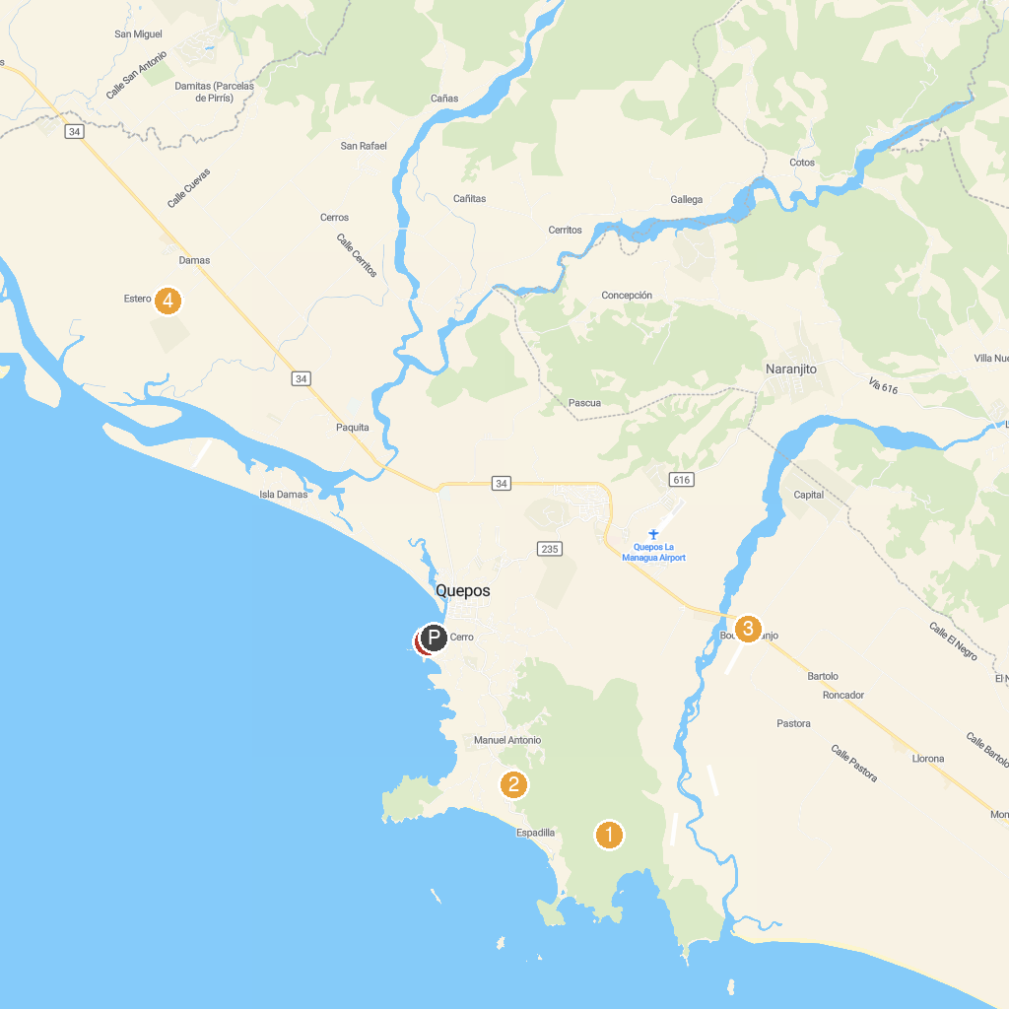
MAP KEY
1. Manuel Antonio National Park | 4. William Mangrove Tours.
2. Zip Coaster | 5. Manuel Antonio Experiences
3. Skydive Costa Rica Quepos
P. Cruise port / terminal
Map © MapTiler © OpenStreetMap contributors · cruiseports.org

