Rastatt, Baden-Württemberg, Germany
One of Germany's most intact Baroque towns, Rastatt was built from scratch in 1700 to rival Versailles — and its grand palace, flat grid streets, and position at the Black Forest's edge still deliver that ambition.
⚓ Docked — Rhine pier (Plittersdorf) · 🕒 Typical call: 6–8 hrs · 💶 Euro (€) · 🗣️ German · 🌲 Black Forest gateway
✍️ MY DAY IN PORT (FILL IN)
Ship / Date
In port | arrive ______ · all aboard ______
Booked excursion
Notes / meeting point
GETTING ASHORE
- Docking: Pier at Plittersdorf (Rhine KM ~340), ~5 km from town center
- Walk to Center: Not walkable from pier — shuttle, bus 232, or taxi (~10 min, €15–20)
- Best For: Baroque architecture, German history, Black Forest day-tripping
- Don't Miss: Residenzschloss Rastatt and the revolutionary-era Freedom Movements museum inside
GETTING AROUND
- 🚕 Taxi: €12–€18 — Taxis available from the Plittersdorf dock to Rastatt city center (~5 km). Standard fare starts at €4.00 with ~€2.20 per
- 📱 Rideshare: ✅ Uber
TOP THINGS TO DO
- Residenzschloss Rastatt Guided Tour — Germany's oldest Baroque residence on the Upper Rhine, built 1697–1707 and modeled on Versailles.
- Schloss Favorite Day Trip — A short drive from the center, this Baroque pleasure palace houses one of Europe's finest collections of Asian and European…
- Baden-Baden Thermal Spa Experience — Just 15 km away, Baden-Baden is Germany's most glamorous spa town — Caracalla Therme or the Roman-Irish Baths at Friedrichsbad…
- Black Forest Edge Walk — Rastatt sits at the western foot of the Black Forest.
- Baden Wine & Flammkuchen Tasting — The Baden wine region surrounds Rastatt; a guided tasting introduces local Spätburgunder (Pinot Noir) and Grauburgunder (Pinot…
BEST WALKS
- Baroque Core Walk: 1.2 km · 20 min · Easy · Free — Walk from Rastatt train station straight up the main axis to the Residenzschloss, then circle back…
- Fortress Walls & Casemates Loop: 1.5 km · 25 min · Easy · Free — Rastatt was also a federal fortress in the 19th century.
WEATHER · DAYLIGHT · MONEY
Month | High °F | Low °F | Rainy days
May | 66 | 50 | 14
Jul | 78 | 62 | 12
Sep | 70 | 55 | 10
Daylight: May 5:45AM–9:02PM · Jul 5:40AM–9:25PM · Sep 7:04AM–7:39PM
cruiseports.org/rastatt · Confirm terminal & all-aboard time with your ship

Rastatt, Baden-Württemberg, Germany — Port Map
Red = walkable sights · Amber = excursions farther out · P = cruise terminal
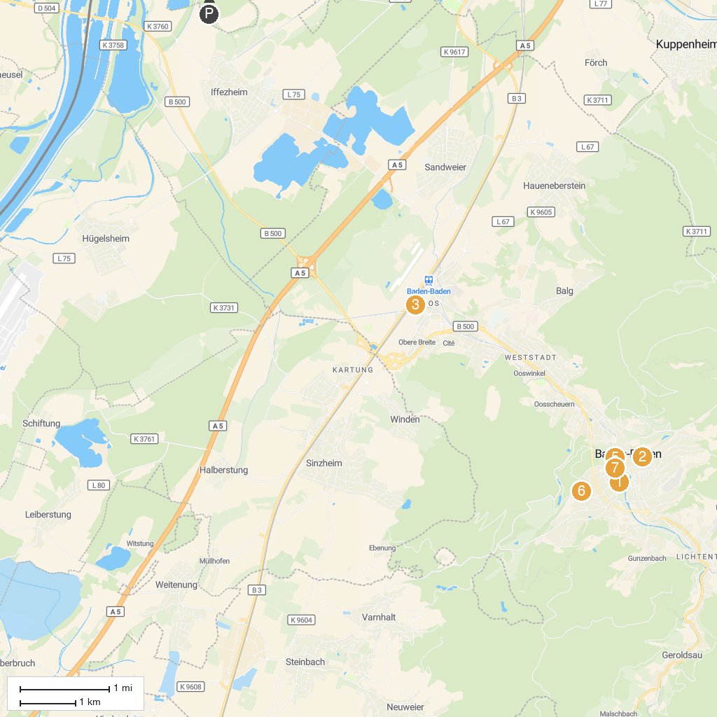
MAP KEY
1. Museum Frieder Burda | 5. Trinkhalle
2. Faberge Museum | 6. Rose Society Garden (New Rose Garden)
3. Frida Kahlo Ausstellung | 7. The Baden-Baden Casino
4. Schiffsanlegestelle Rastatt | 8. Dahliengarten Baden-Baden
P. Cruise port / terminal
Map © MapTiler © OpenStreetMap contributors · cruiseports.org

